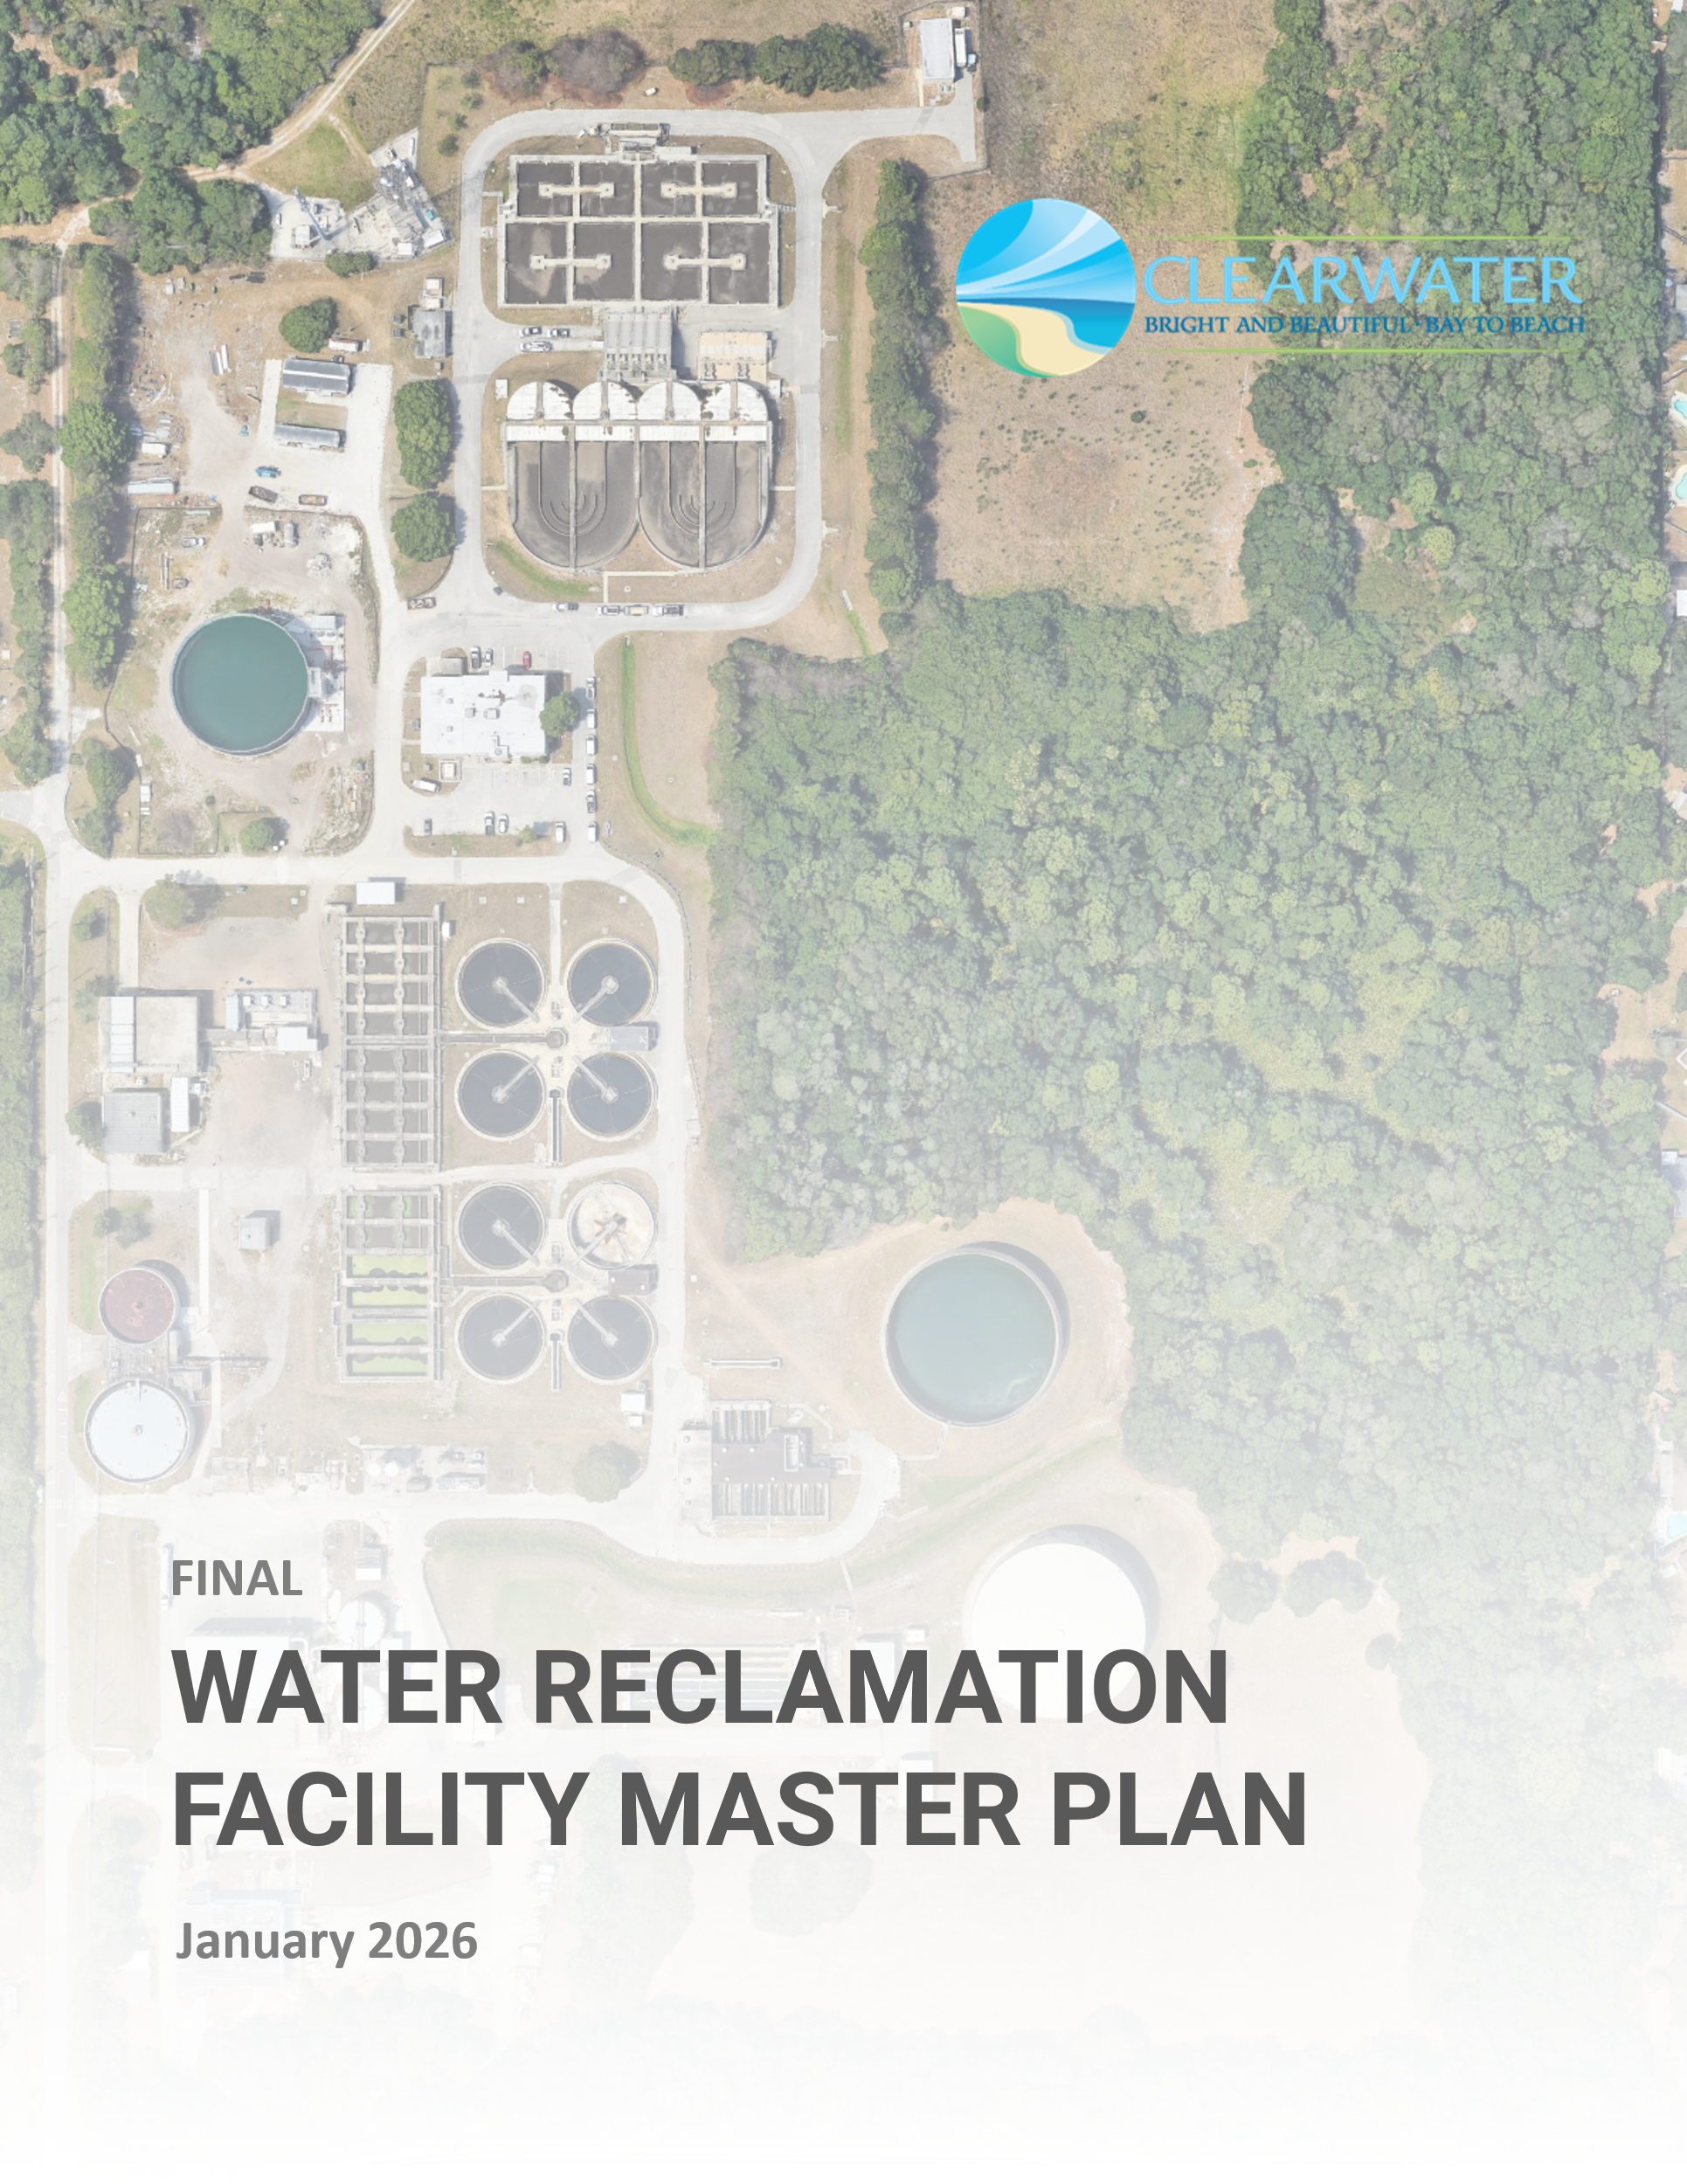
final
Water Reclamation Facilities Master Plan
Technical Memorandum
BLACK & VEATCH PROJECT NO. 408831
City project no. 17-0007-ut
Prepared for
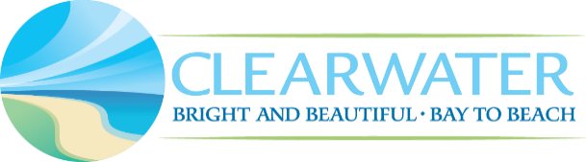
City of Clearwater
9 January 2026
Professional Engineer:
 | Signature | Date
 | Printed Name
 | License No.

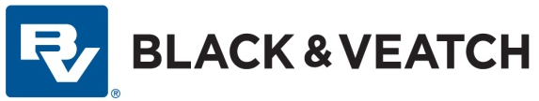

Table of Contents
Executive Summary 1
1.0 Introduction 12
1.1 Strategic Goals and Objectives 12
2.0 Future Water Reclamation Facilities Strategies 15
2.1 Growth and Capacity Projections 15
2.1.1 Historical Gallons per Capita per Day 15
2.1.2 Future Population Projections 16
2.1.3 Treatment Capacity/Load Projections EWRF 17
2.1.4 Treatment Capacity/Load Projections NEWRF 19
2.1.5 Treatment Capacity/Load Projections MSWRF 21
2.2 Renewal and Replacement Planning 23
2.3 Climate Variability/Coastal Hazard Vulnerability Assessment 23
2.3.1 FEMA Flood Zones and Pinellas Vulnerability Assessment Flood Events 23
2.3.2 Storm Surge Flood Events 24
2.3.3 Future Conditions (Sea Level Rise and 100-year Events) 24
2.3.4 Infiltration and Inflow 25
2.3.5 Renewal and Replacement Impacts from Climate Variability and Coastal Hazards 25
2.4 Regulatory Review and Emerging Issues 25
2.5 Biosolids Management Strategy 26
2.5.1 Alternatives Evaluation 26
2.6 Effluent Management Strategy Development 28
2.7 Water Reclamation Facilities Consolidation Evaluation 28
2.7.1 Scenario Development 28
2.7.2 Evaluation Criteria and Weighting 29
2.7.3 Scenario Analysis 32
2.7.4 Cost Estimates 32
2.7.5 Evaluation Results 34
3.0 Existing System Evaluation 39
3.1 Existing System Evaluation Overview 39
3.2 Condition, Building, and Facilities Assessment 39
3.2.1 Detailed Process Facilities Condition Assessment 39
3.2.2 Building and Facilities Assessment 41
3.3 Record Drawing Review and O&M Manual Update 43
3.4 Hydraulic and Pump System Evaluations 43
3.4.1 Hydraulic Profile 43
3.4.2 Pumped Flow System 44
3.5 Treatment Process Model Evaluation 46
3.5.1 BioWin Model Development and Calibration 46
3.5.2 Existing Treatment Capacity Evaluation and Process Optimization 46
3.6 Instrumentation and Controls and Electrical Evaluation 49
3.6.1 Instrumentation and Controls Evaluation 49
3.6.2 Electrical Evaluation 50
3.7 Energy and Chemical Use Baseline 51
4.0 Future Improvements 52
4.1 Future System Configuration Evaluation 52
4.2 Flow Equalization Evaluation 52
4.3 Preliminary and Primary Treatment Expansion Evaluation 53
4.3.1 Headworks 53
4.3.2 Primary Treatment 55
4.4 Biological Treatment Expansion Evaluation 56
4.4.1 Alternative 1 – Base Case (5-Stage Bardenpho) – 32 MGD Peak Flow 56
4.4.2 Alternative No. 2 – MOB System (Nuvoda) Expansion – 32 MGD Peak Flow 59
4.4.3 Alternative No. 3 – Base Case (5-Stage Bardenpho) – 37.33 MGD Peak Flow 62
4.5 Tertiary Treatment Expansion Evaluation 63
4.6 Chlorine Contact Basins Evaluation 64
4.7 Hydraulic System Modifications for Expansion 64
4.7.1 Headworks and Primary Treatment 64
4.7.2 Biological Treatment 65
4.7.3 Tertiary Treatment 65
4.7.4 Chlorine Contact Chambers 65
4.8 Biosolids 67
4.8.1 Anaerobic Digestion 67
4.8.2 Solids Blending and Storage Tanks 70
4.8.3 Biosolids Dewatering 70
4.9 Chemical Optimization 72
4.10 Energy Optimization 73
4.10.1 Aeration System 73
4.10.2 Screw and Internal Recycle Pumps 73
4.10.3 Filter Effluent Pumps 73
4.11 Sustainability Related Improvements 73
4.12 Future Improvement Staffing Evaluation 74
4.13 Control Building Expansion Evaluation 77
4.14 Summary of Future Improvements 79
5.0 Alternative Cost Estimate Evaluation 81
5.1 Project Unit Costs and Assumptions 81
5.1.1 Asset Unit Costs 81
5.1.2 Project Cost Markups and Calculations of Total Project Costs 83
5.2 Alternative Cost Estimation Evaluation Results 84
5.2.1 Alternative No. 1 – Base Case (5-Stage Bardenpho) – 32 MGD Peak Flow 84
5.2.2 Alternative No. 2 – MOB System (Nuvoda) Expansion – 32 MGD Peak Flow 86
5.2.3 Alternative No. 3 – Base Case (5-Stage Bardenpho) – 37.33 MGD Peak Flow 86
5.3 Alternative Cost Estimation Evaluation Near-Term Projects: 5-Year Overview 89
5.4 Alternative Cost Estimate Evaluation Results 91
5.5 Process Option Cost Evaluation 91
5.5.1 Primary Treatment 92
5.5.2 Oxidation Ditch – Aeration 93
5.5.3 Tertiary Treatment 94
6.0 Alternative Selection Process 95
6.1 Evaluation Criteria and Weighting 95
6.2 Alternatives Evaluation Results 98
7.0 Capital Improvement Plan 99
Attachment A. Future WRF Strategies Technical Memorandum A-1
Attachment B. Existing System Evaluation Technical Memorandum B-1
Attachment C. Future Improvements Technical Memorandum C-1
Attachment D. Control Building Expansion Evaluation Technical Brief D-1
Attachment E. Alternative No. 1 Base Case (5-Stage Bardenpho) – 32 MGD Peak Flow Project Summary E-1
Attachment F. Alternative No. 2 – MOB System (Nuvoda) Expansion – 32 MGD Peak Flow Project Summary F-1
Attachment G. Capital Improvement Plan Project Sheets G-1
Attachment H. NEWRF CIP Site Planning H-1

List of Tables
Table 1-1 Strategic Goals and Objectives 13
Table 2-1 Historical Population Estimated (BEBR and TAZ) 15
Table 2-2 EWRF Historical Influent Flow and Loads Summary (2019-2021) 17
Table 2-3 EWRF Influent Peaking Factors, Flows, and Loads Developed from 2019 to 2021 Data 17
Table 2-4 NEWRF Historical Influent Flow and Loads Summary (2019-2021) 19
Table 2-5 NEWRF Influent Peaking Factors, Flows, and Loads Developed from 2019 to 2021 Data 20
Table 2-6 MSWRF Historical Influent Flow and Loads Summary (2019-2021) 21
Table 2-7 MSWRF Influent Peaking Factors, Flows, and Loads Developed from 2019 to 2021 Data 22
Table 2-8 Estimated Impacts from Localized Flooding 23
Table 2-9 Estimated Impacts from Storm Surge 24
Table 2-10 Summary of Biosolids Management Alternatives Evaluation Scores 27
Table 2-11 Shortlisted WRF Consolidation Scenarios 29
Table 2-12 Evaluation Criteria 30
Table 2-13 Life-Cycle Costs by Type and Scenario ($M) 33
Table 2-14 WRF Consolidation Scoring Results 34
Table 2-15 WRF Consolidation Scoring Results Justification 35
Table 3-1 Building Assessment Overview 42
Table 3-2 Hydraulic Profile Evaluation Flows 43
Table 3-3 Pump System Evaluation Flows 44
Table 3-4 Pumped System Evaluation Summary 44
Table 3-5 Summary of Capacity Analysis 46
Table 3-6 Capacity Impacts at Different SVIs 49
Table 3-7 Summary of Recommended Instrumentation and Analyzers 50
Table 4-1 Flow Equalization Storage Required at NEWRF Based on August 2019 Storm Event 53
Table 4-2 Summary of Proposed Screens Sizing at 32 MGD Peak Flow at NEWRF 54
Table 4-3 Proposed Bardenpho Process Sizing 56
Table 4-4 Secondary Clarifier Sizing Summary – Alt. No. 1 – Base Case (5-Stage Bardenpho) – 32 MGD Peak Flow 58
Table 4-5 Nuvoda MOB System Preliminary Design Parameters at MM Flows and Loads 60
Table 4-6 Secondary Clarifier Sizing Summary – Alt. No. 2 – MOB System (Nuvoda) Expansion – 32 MGD Peak Flow 61
Table 4-7 Secondary Clarifier Sizing Summary – Alternative No 3 62
Table 4-8 Recommended Hydraulic Improvements - Alternative No. 2 66
Table 4-9 New Primary Anaerobic Digester - Design Criteria 68
Table 4-10 New Centrifuge Dewatering - Design Criteria 71
Table 4-11 Sodium Hypochlorite Storage Tank Capacity Evaluation 72
Table 4-12 Staffing Evaluation - Benchmark Comparison 76
Table 4-13 Existing Control Building Accommodations 77
Table 4-14 Future Control Building Accommodations 78
Table 4-15 Future Recommended Improvements at NEWRF 79
Table 5-1 Asset Unit Costs (June 2025) 81
Table 5-2 Wastewater Pipe Unit Costs 83
Table 5-3 Project Cost Markups 84
Table 5-4 30-Year Cost per Alternative (2025 Dollars) 91
Table 6-1 Alternatives Evaluation Scoring Criteria and Weighting 96
Table 6-2 Life-Cycle Cost Analysis Summary 98
Table 6-3 Alternative Selection Process Results 98
Table 7-1 Clearwater WRF Master Plan CIP 100

List of Figures
Figure 1-1 City of Clearwater’s Three Water Reclamation Facilities, Basin Areas, and Pump Stations 12
Figure 2-1 Independent Estimation of Historical Dry Weather Flow 16
Figure 2-2 Average Condition Scores per WRF by Discipline 23
Figure 3-1 NEWRF Condition Assessment – Physical Condition Scores 40
Figure 3-2 NEWRF Condition Assessment – Asset Remaining Use Life 41
Figure 3-3 Equivalent AADF Capacity by Unit Process 48
Figure 4-1 Alternatives No. 1 and 2 Site Layout Showing the Proposed Storm Screen and Storm Grit Box Systems at NEWRF 54
Figure 4-2 Alternative No. 3 Proposed Headworks and Storm Screen/Grit System at NEWRF 55
Figure 5-1 Alternative No. 1 Cash Flow with No Annual Inflation (2025 Dollars) 85
Figure 5-2 Alternative No. 2 Cash Flow with No Annual Inflation (in 2025 Dollars) 87
Figure 5-3 Alternative No. 3 Cash Flow with No Annual Inflation (in 2025 Dollars) 88
Figure 5-4 Alternative No. 1 Near-Term Cash Flow 89
Figure 5-5 Alternative No. 2 Near-Term Cash Flow 90
Figure 5-6 Alternative No. 3 Near-Term Cash Flow 90
Figure 5-7 Capital, Operating, and Total Net Present Value Costs for Primary Treatment Options 92
Figure 5-8 Capital, Operating, and Total Net Present Value Costs for Aeration Options 93
Figure 5-9 Capital, Operating, and Total Net Present Value Costs for Tertiary Treatment 94
Figure 7-1 CIP Cash Flow with No Annual Inflation (in 2025 Dollars) 99
Figure 7-2 NEWRF Expansion Site Layout 106

Acronyms and Abbreviations
% Inf | Percent Influent
% TS | Percent Total Solids
AACEI | Association for the Advancement of Cost Engineering International
AADF | Annual Average Daily Flow
ADA | American Disability Act
APRICOT Act | A Prototype Realistic Innovation Community of Today
aSRT | Aerobic Solids Retention Time
AWWA | American Water Works Association
BEBR | Bureau of Economic and Business Research
BESS | Battery Energy Storage System
BFP | Belt Filter Press
BNR | Biological Nutrient Removal
BOD | Biological Oxygen Demand
BOD5 | 5-day Biological Oxygen Demand
C | Contingency
CA | Customer Accounts
cBOD5 | Carbonaceous 5-day Biological Oxygen Demand
CCC | Chlorine Contact Chamber
CFM | Cubic Feet Per Minute
CIP | Capital Improvement Plan
City | City of Clearwater Public Utilities Department
DIP | Ductile Iron Pipe
dlb | Dry Pounds
DMR | Discharge Monitoring Report
DO | Dissolved Oxygen
DWF | Dry Weather Flow
EC | Engineering Cost
EPA | U.S. Environmental Protection Agency
EQ | Equalization
ERP | Emergency Response Plan
EWRF | East Water Reclamation Facility
FDEP | Florida Department of Environmental Protection
FTE | Full-Time Equivalent
gal | Gallon
GHG | Greenhouse Gas
gpcd | Gallons per Capita per Day
gpm | Gallons per Minute
HDPE | High-Density Polyethylene
HGL | Hydraulic Grade Line
HLD | High-Level Disinfection
HLR | Hydraulic Loading Rate
hp | Horsepower
HRT | Hydraulic Retention Time
I&C | Instrumentation and Controls
iCIP | Interactive Capital Improvement Plan
IR | Internal Recycle
kg/m3 | Kilograms per Meter Cubed
lb/d | Pounds per Day
LS | Lift Station
MCCs | Motor Control Centers
MD | Maximum Day
MG | Million Gallons
mg/L | Milligrams per Liter
MGD | Million Gallons per Day
mL/g | Milliliters per Gram
MLSS | Mixed Liquor Suspended Solids
MM | Maximum Month
MMAD | Maximum Month Average Day
MOB | Mobile Organic Biofilm
MSWRF | Marshall Street Water Reclamation Facility
mV | Millivolts
NEWRF | Northeast Water Reclamation Facility
NH3 | Ammonia
NIMBY | Not In My Backyard
NOx | Nitrogen Oxides
NPV | Net Present Value
O&M | Operation and Maintenance
OH&P | Overhead and Profit
ORP | Oxidation-Reduction Potential
PD | Peak Day
PHF | Peak Hourly Flow
POF | Point of Failure
PV | Photovoltaic
R&R | Renewal and Replacement
RAS | Return Activated Sludge
RMF | Regional Management Facility
rpm | Revolutions per Minute
SB64 | Florida House of Representatives Senate Bill 64 (2021)
SCADA | Supervisory Control and Data Acquisition
SLR | Sea Level Rise
SLR | Solids Loading Rate
SOR | Solids Overflow Rate
SPA | State Point Analysis
SSO | Sanitary Sewer Overflow
SVI | Sludge Volume Index
SWFWMD | Southwest Florida Water Management District
TAZ | Transportation Analysis Zone
TKN | Total Kjeldahl Nitrogen
TP | Total Phosphorus
TSS | Total Suspended Solids
TWAS | Thickened Waste Activated Sludge
VFD | Variable Frequency Drive
VSR | Volatile Solids Reduction
WAS | Waste Activated Sludge
wlb | Wet Pounds
WRF | Water Reclamation Facility
WSEL | Water Surface Elevation Level
WW | Wastewater
WWCS MP | Wastewater Collection System Master Plan

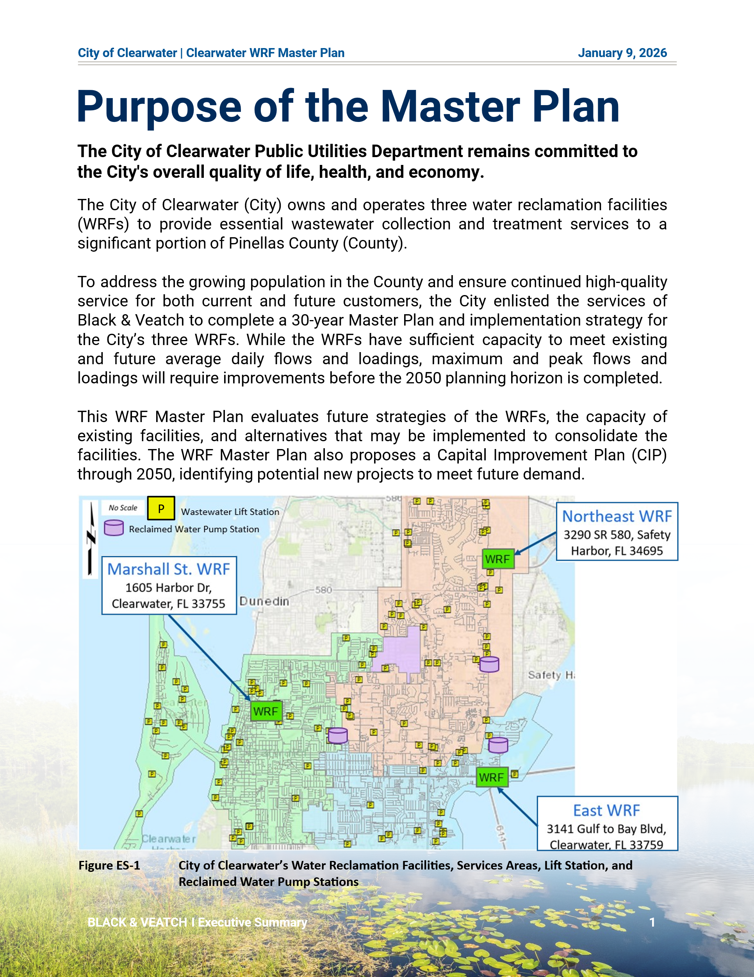
Executive Summary
ss
Text
Text
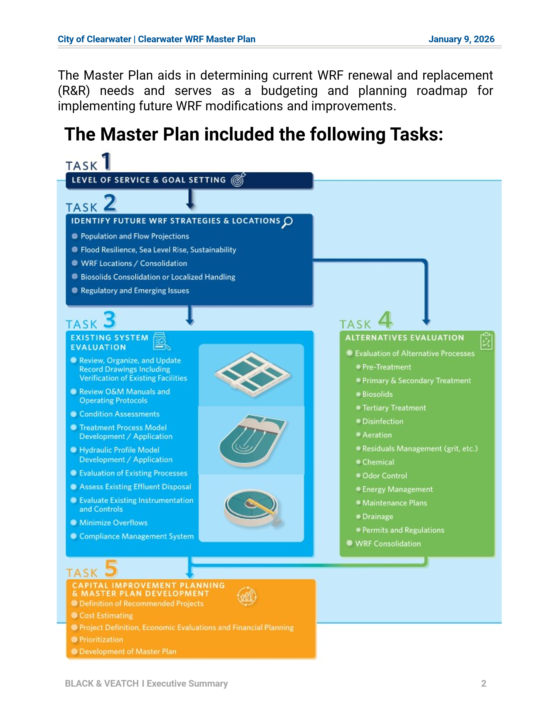
Text
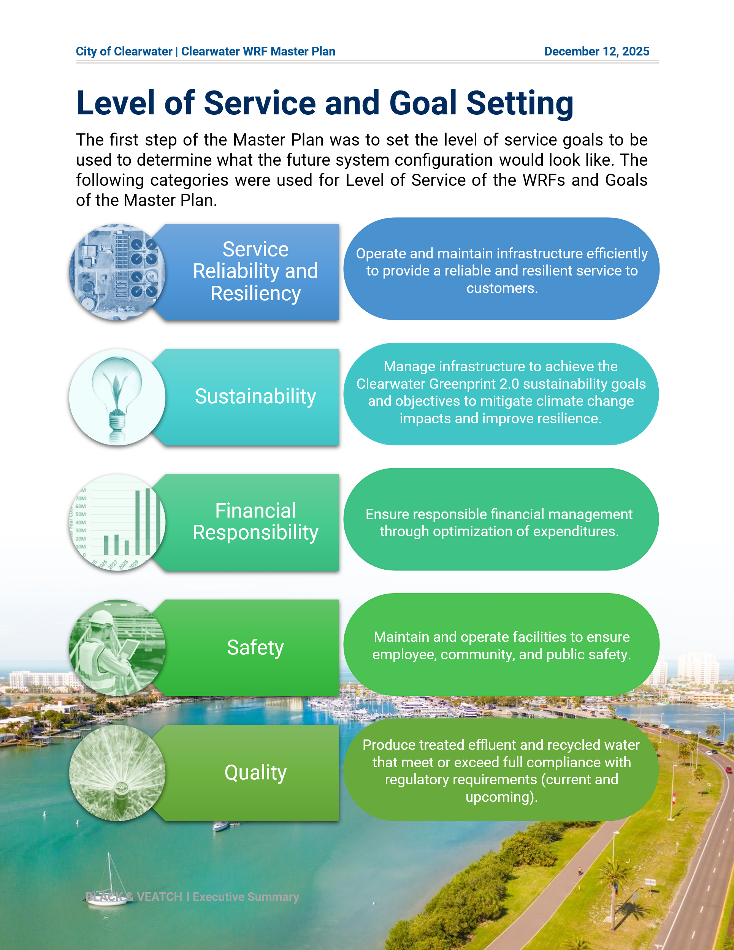
Text
Text
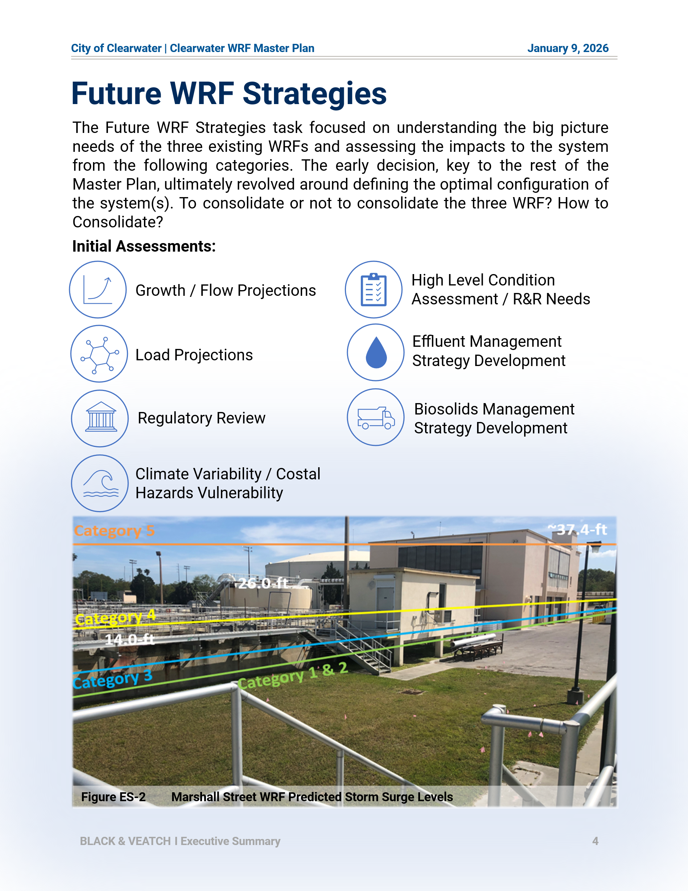
Text
Text
Text
Text
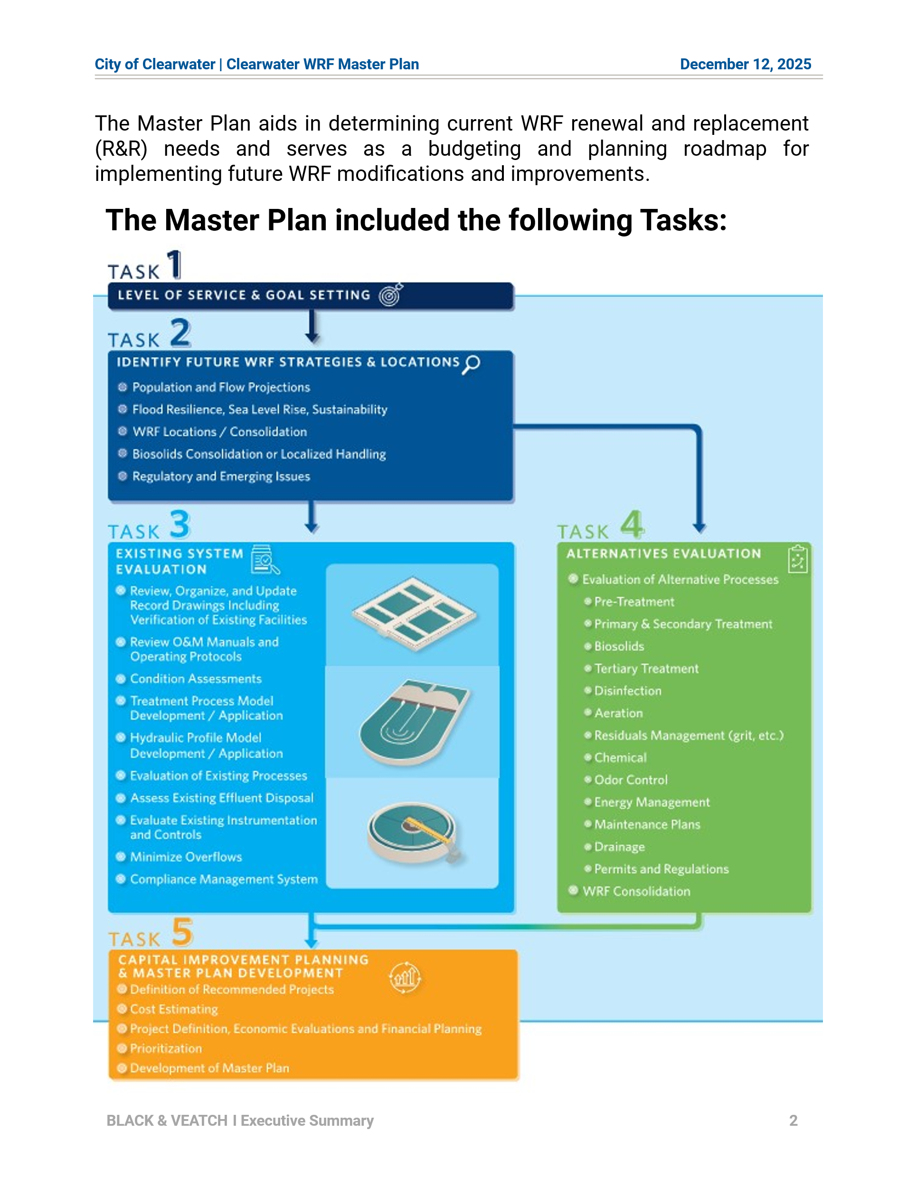

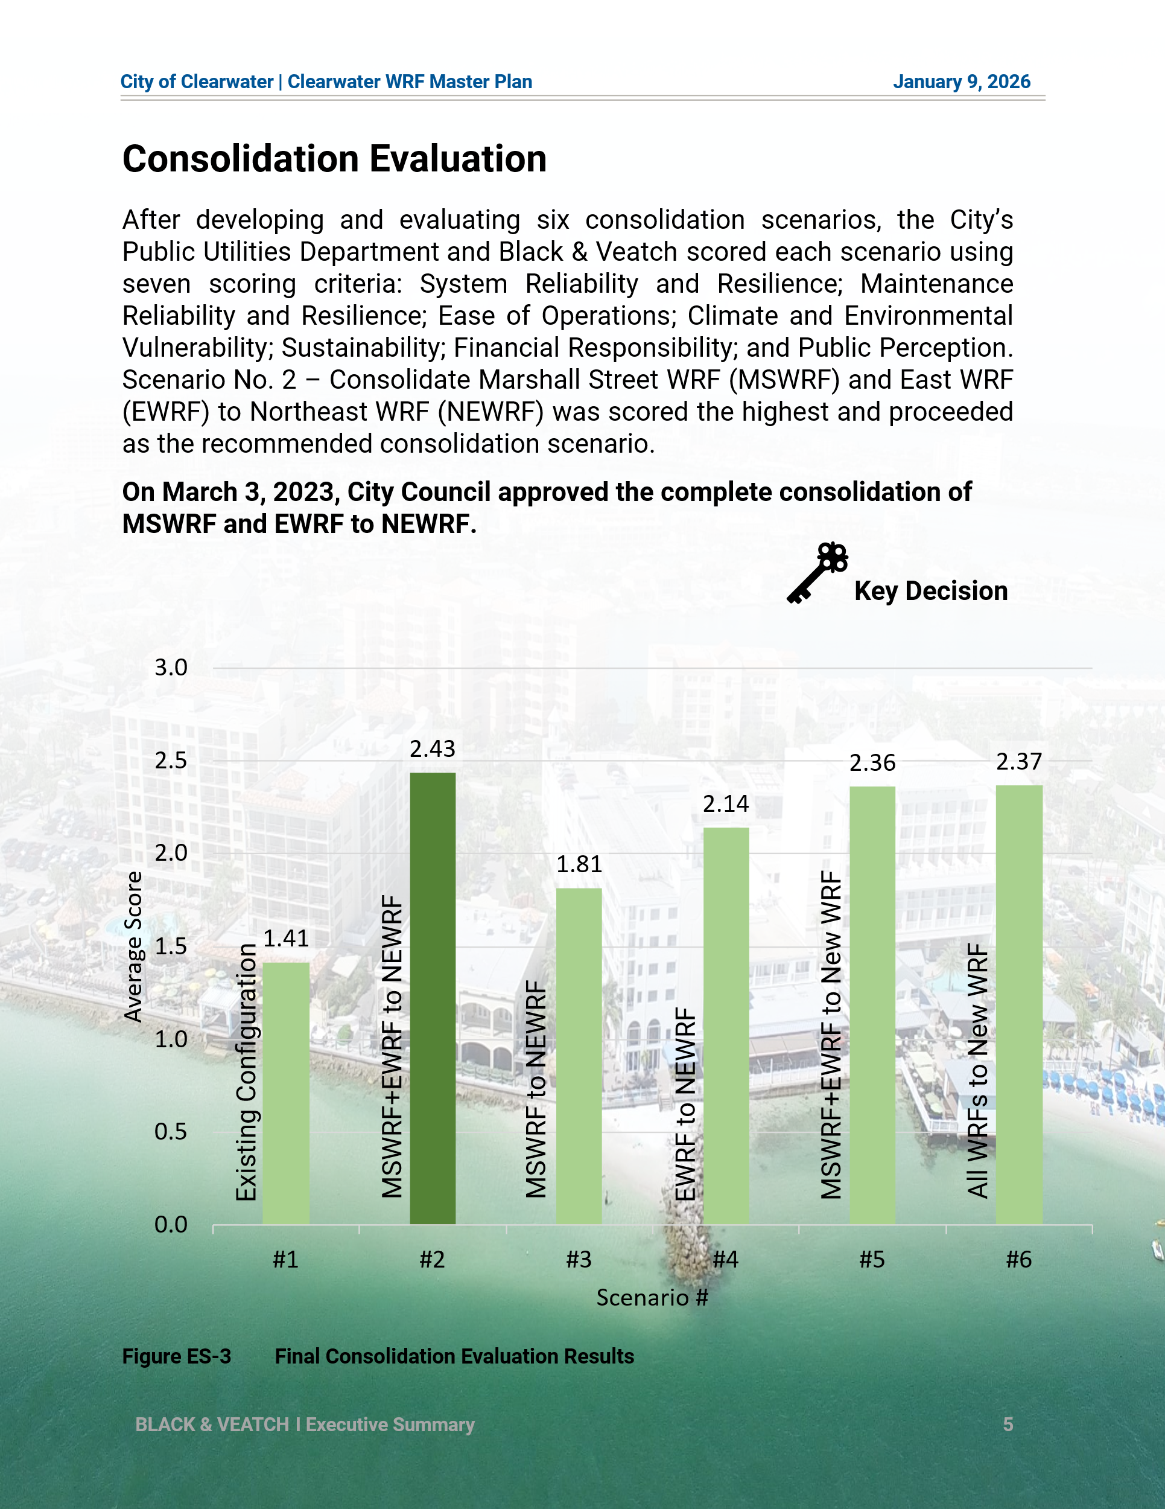

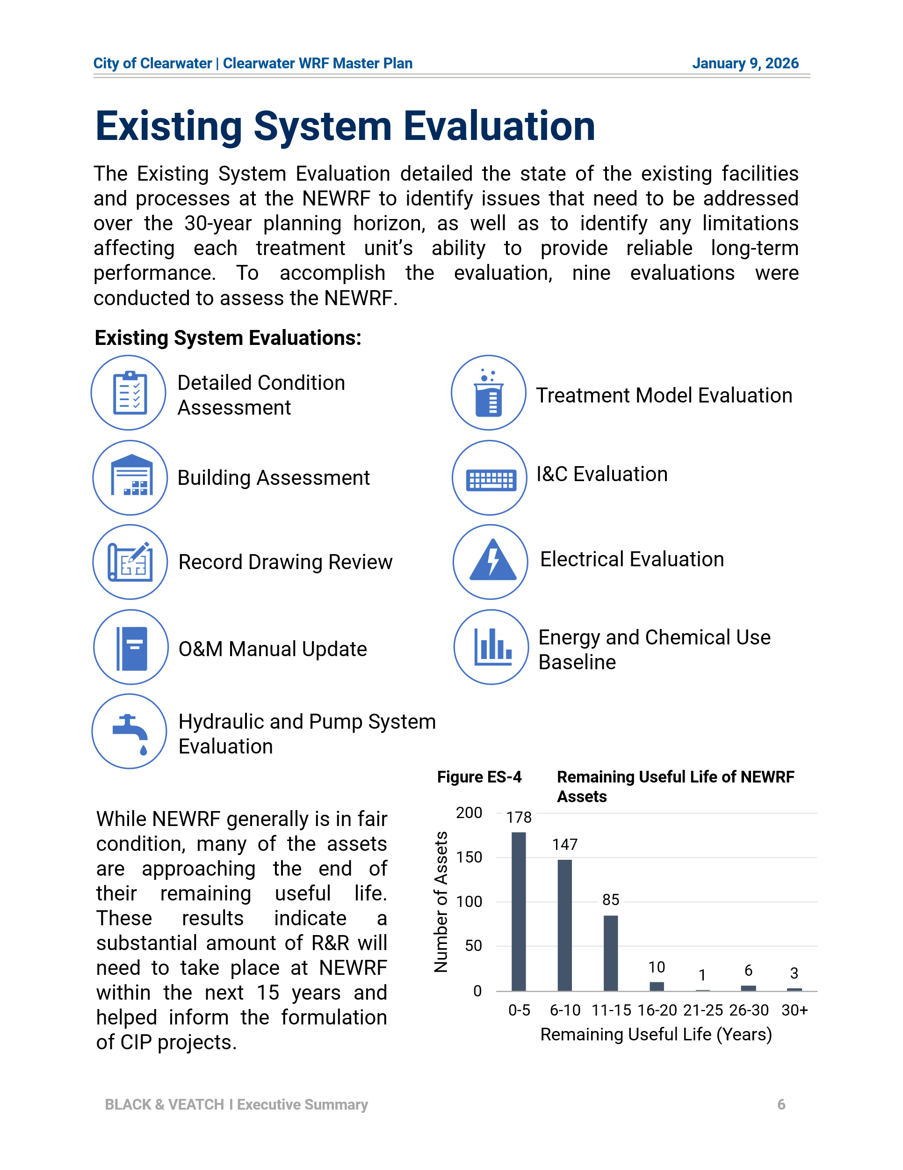
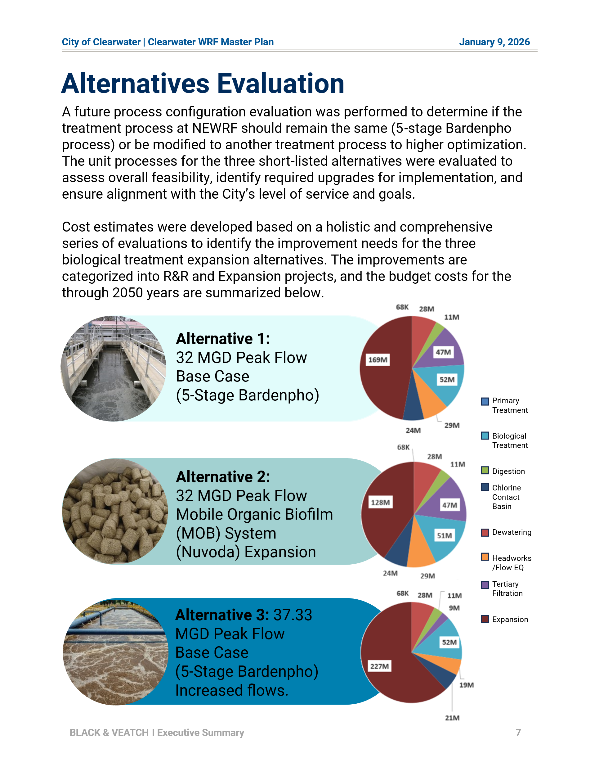
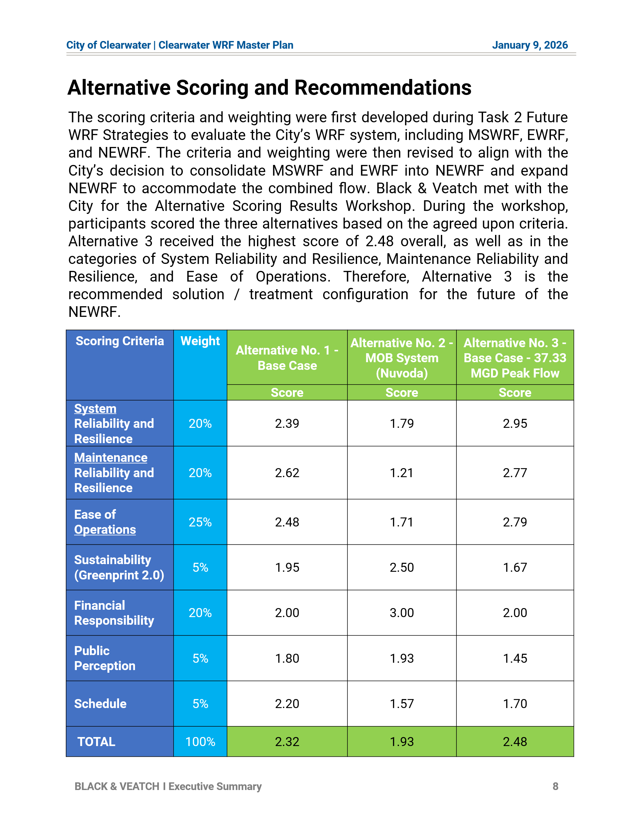
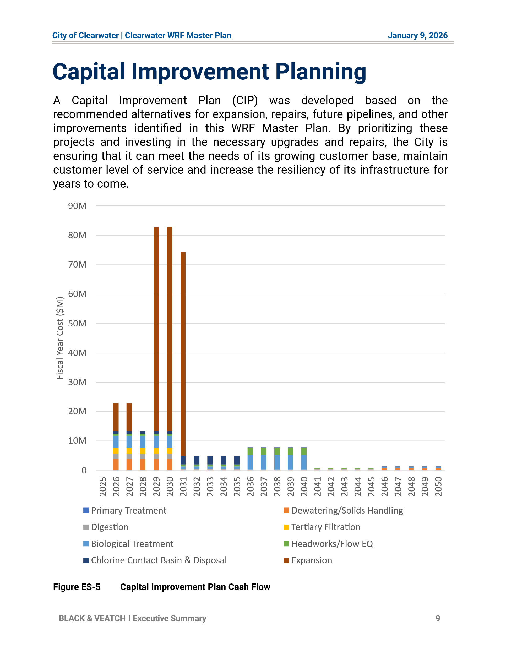
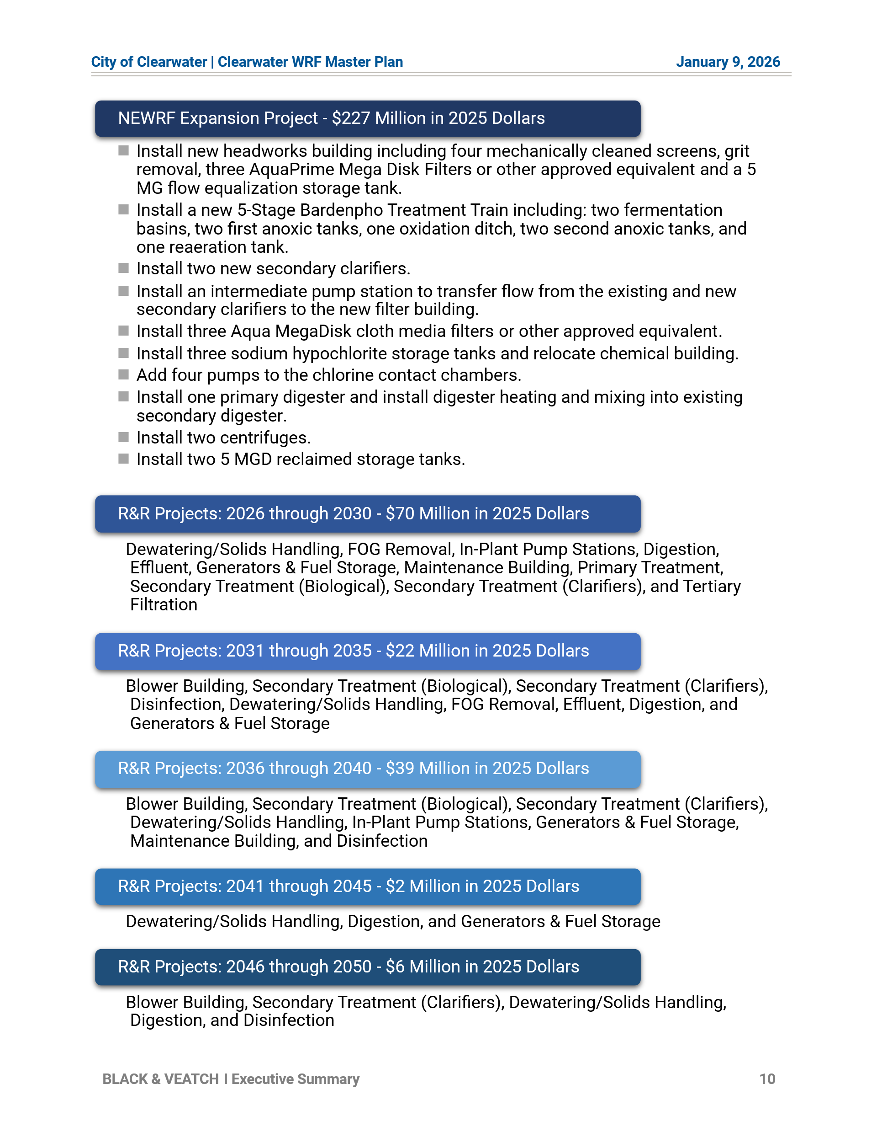
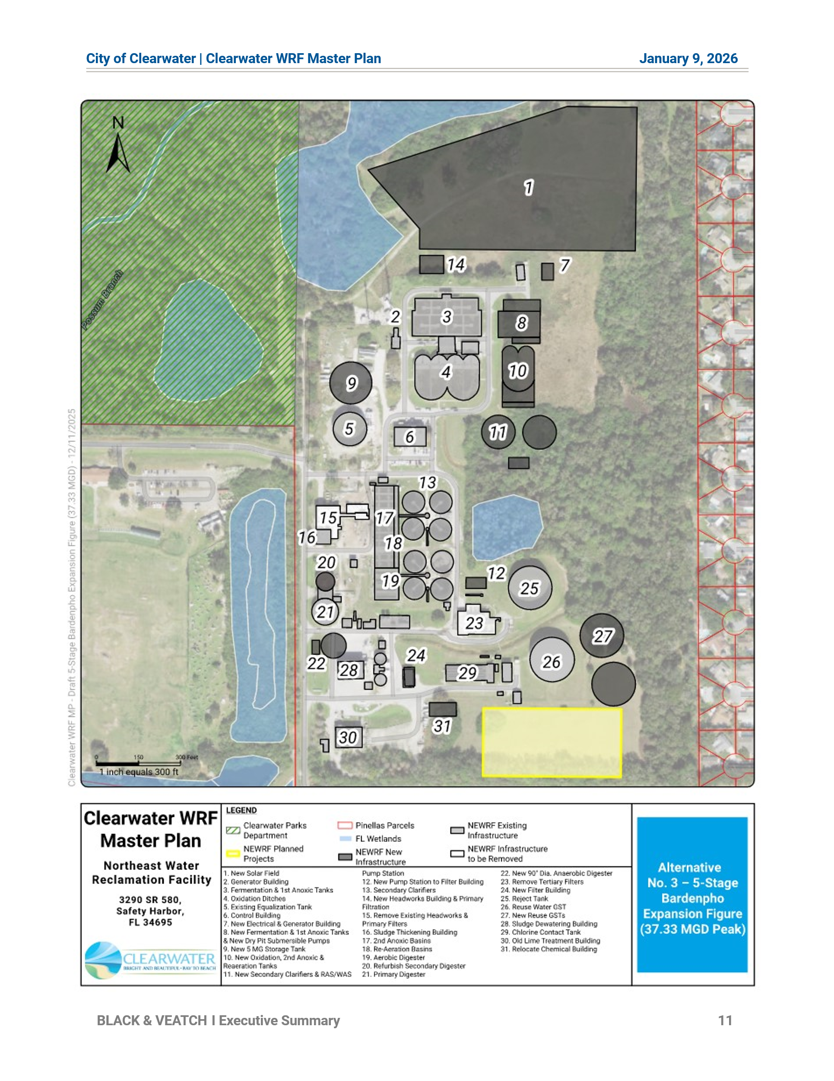
ttt

Introduction
The City owns and operates three water reclamation facilities (WRFs): Northeast (NEWRF), Marshall Street (MSWRF), and East (EWRF). Figure 1-1 shows the location of the three WRFs, their respective service areas, and approximately 78 lift/pump stations owned and operated by the City. The NEWRF also treats flow from the City of Safety Harbor.
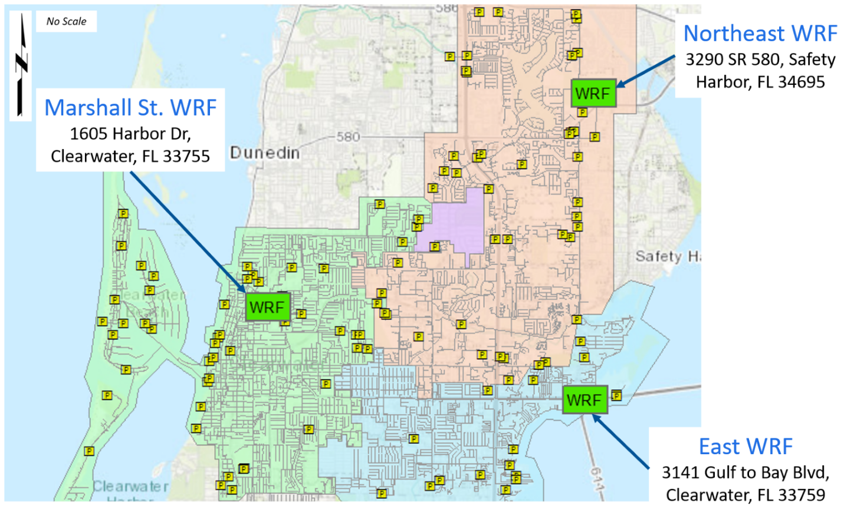
Figure 1-1 City of Clearwater’s Three Water Reclamation Facilities, Basin Areas, and Pump Stations

The City has undertaken the completion of a 30-year Master Plan, Capital Improvement Plan (CIP), and implementation strategy for its three WRFs. The Master Plan serves as a tool to identify current Renewal and Replacement (R&R) needs, and as a roadmap for budgeting and planning future facility modifications, upgrades, and operational and maintenance improvements. It also supports compliance with future regulations, and guides the development of facilities that are efficient, resilient, sustainable, and economical.
As the first step of the Master Planning process, strategic objectives and goals related to the WRFs were identified. The goals and objectives were then used to assess possible future strategies and select the best scenario for the City to evaluate further in the next phases of the Master Plan. This approach enables a detailed assessment of the chosen strategy and provides a clear direction for next steps.

Strategic Goals and Objectives
The City and Black & Veatch collaborated through a series of workshops to identify the overall WRF Master Plan project goals and strategic objectives, which are presented in Table 1-1. The Goal Setting Workshop was held on January 26, 2022, with the goals and objectives finalized during the WRF Master Plan progress meeting on February 16, 2022.
Table 1-1 Strategic Goals and Objectives
Goals | Objectives
- Service Reliability and Resiliency. Operate and maintain infrastructure efficiently to provide a reliable and resilient service to customers. | - Provide high quality, reliable, efficient, and effective water, wastewater, and reclaimed water services in an environmentally sound manner, which will protect the public health and safety.  - Provide, develop, and maintain permanent systems to meet anticipated population growth while providing practical protection to the environment at a cost consistent with the public's ability and willingness to pay.  - Maintain and enhance assets over the long-term at the lowest possible life-cycle cost and acceptable risk.  - Recruit, develop, and retain a competent workforce, and invest in opportunities for professional and leadership development. Support an inclusive and collaborative organization dedicated to continual learning and improvement.  - Implement procedures for institutional knowledge retention.  - Maintain and develop infrastructure to achieve Class I Reliability standards.
- Sustainability. Manage infrastructure and resources to achieve (or surpass) the Clearwater Greenprint 2.0 sustainability goals and objectives to mitigate climate change impacts and improve resilience. | - Proactively maintain and reinvest in infrastructure.  - Assess climate-related risks, including the impacts of sea level rise (SLR), and develop and implement solutions to mitigate these risks.  - Decrease energy consumption, use more renewable energy, and reduce the impact of the built environmental on the natural environment. Evaluate viability of generating energy from local sources (e.g., biogas, turbine generators).  - Support the City in exceeding greenhouse gas (GHG) emissions targets. Reduce Public Utilities’ GHG emissions by 5% below 2007 levels by 2035, and 10% below 2007 emissions levels by 2050.
- Financial Responsibility. Ensure responsible financial management through optimization of expenditures. | - Set priorities and spend money aligned with Strategic Direction.  - Select appropriate solutions to achieve the optimal balance between life-cycle costs, risk, and levels of service and other organizational objectives.  - Optimize use of employees, assets, and resources to minimize Operation and Maintenance (O&M) costs.
- Safety. Maintain and operate facilities to ensure employee, community, and public safety. | - Implement practical and effective solutions and controls to continuously improve processes to manage employee and public safety and align with Occupational Safety and Health Administration standards.  - Maintain a safe environment.  - Proactively identify and manage safety risks effectively.  - Maintain and make timely updates to the Continuity of Operations Plan and Emergency Response Plan to ensure effective emergency preparation, response, and recovery.
- Quality. Produce treated effluent and recycled water that meet or exceed full compliance with regulatory requirements [current and upcoming]. | - Meet or exceed current and future regulatory requirements.  - Implement improvements for performance data collection and analysis. Continuously measure and improve performance.  - Conduct ongoing performance improvements informed by quality management principles, performance monitoring (metrics), utilizing data, and turning data into actionable knowledge.  - Manage public perception by maintaining high quality services and engaging customers.

This Master Plan document is organized into the following sections, a structure that best illustrates the history, findings, recommendations, and next steps for the master planning and CIP process:
- Section 1.0 Introduction
- Section 2.0 Future Water Reclamation Facilities Strategies
- Section 3.0 Existing System Evaluation
- Section 4.0 Future Improvements
- Section 5.0 Alternative Cost Estimate Evaluation
- Section 6.0 Alternative Selection Process
- Section 7.0 Capital Improvement Plan
Previous technical memoranda from this project are attached to this document as well as the CIP project sheets.

Future Water Reclamation Facilities Strategies
To accomplish Task 2 of the Master Plan, all aspects of managing and operating the three WRFs were considered and evaluated at a big picture, order of magnitude level. Aspects assessed included projected growth (flow and load projections), high level R&R needs (condition assessment), environmental impacts (climate variability, coastal hazards), changing regulations, biosolids management, effluent management, and potential consolidation of the facilities. A summary of the evaluation is provided in this section. The full evaluation is included in Attachment A.

Growth and Capacity Projections
The first component of facility management and operation evaluated was growth and capacity by determining the flow and load projections. These items help determine whether the facilities need to be expanded or if the existing facilities have sufficient capacity for the next 30 years.

Historical Gallons per Capita per Day
The first step of calculating the gallons per capita per day (gpcd) was to benchmark the City’s historic service area population. The service area population can be defined as individuals who use the City’s wastewater collection system. The City’s service area population was calculated as follows:
- All individuals within the City of Clearwater and Safety Harbor reported by the University of Florida’s Bureau of Economic and Business Research (BEBR), less users with private wastewater treatment systems (septic users and On Top of the World development).
Total City level annual estimates from BEBR were used to report the historical total City population for Clearwater and Safety Harbor.
Pinellas County transportation analysis zone (TAZ) data from the City and shapefiles from the Wastewater Collection System Master Plan (WWCS MP, City Project No. 17-0006-UT/December 2021) were leveraged to estimate the historic population with private wastewater treatment. The unserved population in 2015 was estimated to be approximately 11,200. This population was held constant throughout the historical period. The historical population is reported in Table 2-1.
Table 2-1 Historical Population Estimated (BEBR and TAZ)
Year | Total City  Population¹ (A) | Total Safety Harbor Population¹ (B) | Unserved Population (Septic and On Top of the World Users)² (C) | City of Clearwater Service Area Population (A + B - C)
2017 | 113,723 | 17,343 | 11,192 | 119,874
2018 | 115,589 | 17,470 | 11,192 | 121,867
2019 | 116,585 | 17,608 | 11,192 | 123,001
2020 | 117,292 | 17,072 | 11,192 | 123,172
2021 | 117,800 | 17,105 | 11,192 | 123,713
- BEBR Population Estimates
- Estimated by selecting TAZ population within areas identified as unserved in the 2021 WWCS MP

To progress, 5 years of historical data from discharge monitoring reports (DMRs) were analyzed and quality controlled. Quality control included filling in null values for NEWRF November 2017 and confirming that none of the historical flows were outliers on an annual basis due to rain. The type of flow projected for the WWCS MP was Dry Weather Flow (DWF). To remain consistent, the DMRs were averaged to report both DWF and annual average flow. The approach used to distinguish DWFs from others was to rank and graph the daily flow for each WRF on a percentile graph (Figure 2-1). Flows less than the 75th percentile were deemed DWF and averaged together to report the historical DWF. The three WRFs combined 5-year DWF and 5-year annual average daily flow (AADF) were averaged to be 11.61 and 12.73 million gallons per day (MGD), respectively.

Figure 2-1 Independent Estimation of Historical Dry Weather Flow

The final step of the historical gpcd analysis was to divide the total City DWF by the historical service area population. The 5-year average total flow per capita was calculated to be 95 gpcd.

Future Population Projections
Three regionally accepted population projections were analyzed to determine which source would be used as the future growth basis within the City. The population projections included the following:
- 2022 BEBR County Level Projections | Downloaded from Website.
- 2019 Southwest Florida Water Management District (SWFWMD) Parcel Level Projections | Downloaded from Website.
- 2019 Pinellas County TAZ Block Level Projections | Provided by City.
The maximum planning year was 2045 for each source. A linear extrapolation was performed for each source to project out to the WRF Master Plan horizon year of 2050. It should be noted that as the gpcd calculated was based on a permanent residential population basis, only the permanent residential population was taken from each population source as opposed to the functional population (e.g., which includes seasonal tourists). Once the permanent population for each source was extracted, it was converted into an annual growth rate. Historical percentages ranged from 0.14% to 1.66%.
After comparing the population projection data sources, it was determined that the differences in growth rates are minimal. All projections indicate low growth rates that fall within the historical range. BEBR cannot be used to complete the independent flow projection as there is no spatial component to the flow projections and it is at the County level. Additionally, there is no data indicating why SWFWMD data is a better source of projections than Pinellas County TAZ. Accordingly, Pinellas County TAZ was selected to complete this independent calculation of the flow projections to align with the final WWCS MP and final Water Master Plan (City Project No. 18-0022-UT/July 2019), which both used TAZ.
Once the Pinellas County TAZ data source was selected, the final step of adding the existing flow to the future flow was performed in ESRI ArcGIS Pro and Microsoft Excel. The WWCS MP projection for 2050 were compared to the population projections from the independent projection, and a 5 percent difference was calculated. Larger differences within each WRF service area are expected, as a citywide gpcd was performed, whereas the WWCS MP developed a unique gpcd per WRF basin based on gravity flowmeters throughout the collection system. Thus, the WWCS MP flows are similar to the independent projections and slightly more conservative and are therefore considered validated.

Treatment Capacity/Load Projections EWRF
Influent AADF, maximum month average day (MMAD), and maximum day (MD) flow data from 2019 to 2021 are presented in Table 2-2. The EWRF operated at approximately 38 percent of the permitted AADF of 5 MGD in 2021. As presented in Table 2-2, the influent flow rates decreased from 2.4 to 1.9 MGD AADF from 2019 to 2021. Similar trends were observed for total suspended solids (TSS), and ammonia (NH₃). Five-day biological oxygen demand (BOD₅) loading decreased in 2020 by 20 percent, later increasing by 16 percent in 2021.
Table 2-2 EWRF Historical Influent Flow and Loads Summary (2019-2021)
Year | Flow (MGD) |  |  | TSS (lb/d) |  |  | BOD₅ (lb/d) |  |  | NH₃ (lb/d) |  |  |  | TP (lb/d)
Year | AADF | MMAD | MD | AADF | MMAD | MD | AADF | MMAD | MD | AADF | MMAD | MD | AADF |  | MMAD | MD
2019 | 2.4 | 3.8 | 6.9 | 3,188 | 3,719 | 5,121 | 3,141 | 3,485 | 4,609 | 533 | 662 | 817 | 66 |  | 80 | 116
2020 | 2.0 | 2.4 | 5.2 | 2,632 | 3,223 | 4,704 | 2,515 | 2,820 | 4,512 | 475 | 536 | 619 | 72 |  | 81 | 111
2021 | 1.9 | 3.0 | 4.6 | 2,330 | 2,626 | 4,175 | 2,990 | 3,610 | 4,414 | 458 | 517 | 573 | 74 |  | 84 | 112
Average | 2.1 | 3.0 | 5.5 | 2,717 | 3,189 | 4,667 | 2,882 | 3,305 | 4,512 | 489 | 572 | 670 | 71 |  | 82 | 113
Maximum | 2.4 | 3.8 | 6.9 | 3,188 | 3,719 | 5,121 | 3,141 | 3,610 | 4,609 | 533 | 817 | 2,100 | 74 |  | 84 | 117

Influent data, peaking factors, and concentrations developed for the EWRF are presented in Table 2-3. Flows and loads are presented under current conditions and at year 2050, which is the end of the planning period.
Table 2-3 EWRF Influent Peaking Factors, Flows, and Loads Developed from 2019 to 2021 Data
Flows and Loads Peaking Factors
Peaking Factors |  | AADF | MMAD | MD
Flow |  | 1.00 | 1.59 | 2.87
BOD₅ |  | 1.00 | 1.21 | 1.79
TSS |  | 1.00 | 1.22 | 1.79
TKN¹ |  | 1.00 | 1.24 | 1.53
NH₃ |  | 1.00 | 1.24 | 1.53
TP |  | 1.00 | 1.22 | 1.77
Current Flows and Loads |  | AADF | MMAD | MD
Flow | MGD | 2.10 | 3.34 | 6.01
BOD₅² | mg/L | 165 | 125 | 103
BOD₅² | lb/d | 2,882 | 3,480 | 5,171
TSS | mg/L | 155 | 119 | 97
TSS | lb/d | 2,717 | 3,327 | 4,856
TKN¹ | mg/L | 39.9 | 31.1 | 21.4
TKN¹ | lb/d | 698 | 867 | 1,071
NH₃ | mg/L | 27.9 | 21.8 | 14.9
NH₃ | lb/d | 489 | 607 | 750
TP | mg/L | 4.0 | 3.1 | 2.5
TP | lb/d | 71 | 86 | 125
Projected Flows and Loads (2050) |  | AADF | MMAD | MD
Flow | MGD | 2.94 | 4.68 | 8.43
BOD₅² | mg/L | 165 | 125 | 103
BOD₅² | lb/d | 4,039 | 4,878 | 7,248
TSS | mg/L | 155 | 119 | 97
TSS | lb/d | 3,808 | 4,663 | 6,807
TKN¹ | mg/L | 39.9 | 31.1 | 21.4
TKN¹ | lb/d | 979 | 1,215 | 1,501
NH₃ | mg/L | 27.9 | 21.8 | 14.9
NH₃ | lb/d | 685 | 851 | 1,051
TP | mg/L | 4.0 | 3.1 | 2.5
TP | lb/d | 99 | 121 | 175
Notes:
- The EWRF only reports influent NH₃ concentrations. Therefore, the influent TKN peaking factors were assumed to be equal to the influent NH₃ peaking factors. In the absence of historical influent TKN data, influent TKN was estimated using a NH₃/TKN ratio of 0.7 based on past project experiences in Florida.
- cBOD₅ /BOD₅ ratio of 0.84 was applied to historical data to account for nitrification inhibitor.

Treatment Capacity/Load Projections NEWRF
Influent AADF, MMAD, and MD flow data from 2019 to 2021 are presented in Table 2-4. The NEWRF operated at approximately 38 percent of the permitted AADF of 13.5 MGD in 2021. As presented in Table 2-4, the influent flow rates ranged between 5.1 and 5.4 MGD AADF between 2019 and 2021. Influent flow rate, TSS, BOD₅, and NH₃ loadings decreased in 2020 but increased in 2021. The influent TP AADF loading increased from 155 pounds per day (lb/d) in 2019 to 202 lb/d in 2021.
Table 2-4 NEWRF Historical Influent Flow and Loads Summary (2019-2021)
Year | Flow (MGD) |  |  | TSS (lb/d) |  |  | BOD₅ (lb/d) |  |  | NH₃ (lb/d) |  |  | TP (lb/d)
Year | AADF | MMAD | MD | AADF | MMAD | MD | AADF | MMAD | MD | AADF | MMAD | MD | AADF | MMAD | MD
2019 | 5.4 | 7.0 | 11.8 | 9,694 | 12,246 | 18,235 | 11,075 | 13,910 | 18,488 | 1,217 | 1,639 | 2,063 | 155 | 193 | 271
2020 | 5.1 | 6.3 | 9.5 | 6,956 | 9,348 | 18,461 | 8,568 | 12,184 | 17,086 | 1,171 | 1,245 | 1,712 | 167 | 189 | 289
2021 | 5.2 | 6.5 | 8.9 | 8,065 | 9,180 | 19,666 | 8,777 | 10,565 | 18,032 | 1,227 | 1,377 | 1,711 | 202 | 225 | 353
Average | 5.2 | 6.6 | 10.1 | 8,238 | 10,258 | 18,787 | 9,473 | 12,220 | 17,869 | 1,205 | 1,420 | 1,829 | 175 | 202 | 304
Maximum | 5.4 | 7.0 | 11.8 | 9,694 | 12,246 | 18,235 | 11,075 | 13,910 | 18,488 | 1,227 | 1,639 | 2,063 | 202 | 225 | 353

Influent data, peaking factors, and concentrations developed for the NEWRF are presented in Table 2-5. Flow and loads are presented under current conditions and at year 2050, which is the end of the planning period.

Table 2-5 NEWRF Influent Peaking Factors, Flows, and Loads Developed from 2019 to 2021 Data
Current and Projected Influent Peaking Factors, Flows, and Loads
Peaking Factors |  | AADF | MMAD | MD
Flow |  | 1.00 | 1.29 | 2.17
BOD₅ |  | 1.00 | 1.42 | 2.05
TSS |  | 1.00 | 1.34 | 2.65
TKN¹ |  | 1.00 | 1.35 | 2.28
NH₃ |  | 1.00 | 1.35 | 1.69
TP |  | 1.00 | 1.24 | 1.75
Current Flows and Loads |  | AADF | MMAD | MD
Flow | MGD | 5.24 | 6.77 | 11.35
BOD₅² | mg/L | 217 | 239 | 206
BOD₅² | lb/d | 9,473 | 13,472 | 19,462
TSS | mg/L | 189 | 196 | 231
TSS | lb/d | 8,238 | 11,070 | 21,864
TKN¹ | mg/L | 39.4 | 41.2 | 41.5
TKN¹ | lb/d | 1,721 | 2,324 | 3,925
NH₃ | mg/L | 27.6 | 28.8 | 21.6
NH₃ | lb/d | 1,205 | 1,623 | 2,042
TP | mg/L | 4.0 | 3.8 | 3.2
TP | lb/d | 175 | 216 | 306
Projected Flows and Loads (2050) |  | AADF | MMAD | MD
Flow | MGD | 5.33 | 6.89 | 11.55
BOD₅² | mg/L | 189 | 239 | 206
BOD₅² | lb/d | 8,387 | 11,928 | 17,232
TSS | mg/L | 189 | 196 | 231
TSS | lb/d | 8,387 | 11,271 | 22,260
TKN¹ | mg/L | 39.4 | 41.2 | 41.5
TKN¹ | lb/d | 1,753 | 2,366 | 3,996
NH₃ | mg/L | 27.6 | 28.8 | 21.6
NH₃ | lb/d | 1,227 | 1,652 | 2,079
TP | mg/L | 4.0 | 3.8 | 3.2
TP | lb/d | 178 | 220 | 311
Notes:
- The NEWRF only reports influent NH₃ concentrations. Therefore, the influent TKN peaking factors were assumed to be equal to the influent NH₃ peaking factors. In the absence of historical influent TKN data, influent TKN was estimated using a NH₃/TKN ratio of 0.7 based on past project experiences in Florida.
- cBOD5 /BOD5 ratio of 0.84 was applied to historical data to account for nitrification inhibitor

Treatment Capacity/Load Projections MSWRF
Influent AADF, MMAD, and MD flow data from 2019 to 2021 are presented in Table 2-6. The MSWRF operated at approximately 56 percent of the permitted AADF of 10 MGD in 2021. As presented in Table 2-6, the influent flow rates decreased from 6.0 and 5.6 MGD AADF from 2019 to 2021. Similar trends were observed for TSS loadings. TP loading increased during this 3-year period. BOD₅ and NH₃ loadings decreased in 2020 then increased in 2021.
Table 2-6 MSWRF Historical Influent Flow and Loads Summary (2019-2021)
Year | Flow (MGD) |  |  | TSS (lb/d) |  |  | BOD₅ (lb/d) |  |  | NH₃ (lb/d) |  |  |  | TP (lb/d)
Year | AADF | MMAD | MD | AADF | MMAD | MD | AADF | MMAD | MD | AADF | MMAD | MD | AADF |  | MMAD | MD
2019 | 6.0 | 8.2 | 19.2 | 7,561 | 9,805 | 13,894 | 7,759 | 9,340 | 12,452 | 1,312 | 1,875 | 2,155 | 163 |  | 220 | 409
2020 | 5.7 | 7.2 | 11.1 | 6,506 | 8,599 | 13,653 | 6,899 | 8,191 | 11,653 | 1,282 | 1,473 | 1,747 | 178 |  | 187 | 268
2021 | 5.6 | 7.5 | 16.5 | 5,102 | 6,438 | 13,880 | 7,435 | 9,111 | 12,402 | 1,342 | 1,550 | 1,879 | 197 |  | 226 | 474
Average | 5.7 | 7.6 | 15.6 | 6,390 | 8,281 | 13,809 | 7,364 | 8,880 | 12,169 | 1,312 | 1,633 | 1,927 | 179 |  | 211 | 384
Maximum | 6.0 | 8.2 | 19.2 | 7,561 | 9,805 | 13,894 | 7,759 | 9,340 | 12,452 | 1,342 | 1,875 | 2,155 | 197 |  | 226 | 474

Influent data, peaking factors, and concentrations developed for MSWRF are presented in Table 2-7. Flow and loads are presented under current conditions and at year 2050 which is the end of the WRF Master Plan planning period.

Table 2-7 MSWRF Influent Peaking Factors, Flows, and Loads Developed from 2019 to 2021 Data
Current and Projected Influent Peaking Factors, Flows, and Loads
Peaking Factors |  |  | AADF | MMAD | MD
Flow |  |  | 1.00 | 1.37 | 3.22
BOD₅ |  |  | 1.00 | 1.23 | 1.69
TSS |  |  | 1.00 | 1.32 | 2.72
TKN¹ |  |  | 1.00 | 1.43 | 2.35
NH₃ |  |  | 1.00 | 1.43 | 1.64
TP |  |  | 1.00 | 1.35 | 2.50
Current Flows and Loads |  |  | AADF | MMAD | MD
Flow | MGD | 5.75 |  | 7.86 | 18.50
BOD₅² | mg/L | 154 |  | 138 | 81
BOD₅² | lb/d | 7,364 |  | 9,024 | 12,439
TSS | mg/L | 133 |  | 129 | 113
TSS | lb/d | 6,390 |  | 8,445 | 17,383
TKN¹ | mg/L | 39.1 |  | 40.9 | 28.5
TKN¹ | lb/d | 1,874 |  | 2,680 | 4,405
NH₃ | mg/L | 27.4 |  | 28.6 | 14.0
NH₃ | lb/d | 1,312 |  | 1,875 | 2,155
TP | mg/L | 3.7 |  | 3.7 | 2.9
TP | lb/d | 179 |  | 241 | 449
Projected Flows and Loads (2050) |  |  | AADF | MMAD | MD
Flow | MGD | 6.28 |  | 8.59 | 20.22
BOD₅² | mg/L | 154 |  | 138 | 81
BOD₅² | lb/d | 8,046 |  | 9,859 | 13,590
TSS | mg/L | 133 |  | 129 | 113
TSS | lb/d | 6,981 |  | 9,227 | 18,992
TKN¹ | mg/L | 39.1 |  | 40.9 | 28.5
TKN¹ | lb/d | 2,048 |  | 2,928 | 4,813
NH₃ | mg/L | 27.4 |  | 28.6 | 14.0
NH₃ | lb/d | 1,434 |  | 2,049 | 2,355
TP | mg/L | 3.7 |  | 3.7 | 2.9
TP | lb/d | 196 |  | 264 | 491
Notes:
- The MSWRF only reports influent NH3 concentrations. Therefore, the influent TKN peaking factors were assumed to be equal to the influent NH3 peaking factors. In the absence of historical influent TKN data, influent TKN was estimated using a NH3/TKN ratio of 0.7 based on past project experiences in Florida.
- cBOD5 /BOD5 ratio of 0.84 was applied to historical data to account for nitrification inhibitor.

Renewal and Replacement Planning
A major expense associated with the WRFs is R&R. The facilities were built in the 1970s and 1980s and have aging assets that need to be rehabilitated or replaced, and two of the facilities are located at sites vulnerable to coastal hazards. A high-level condition assessment was conducted to identify immediate R&R needs at each of the City’s three WRFs. The physical condition assessment was conducted over 2 days, January 4 and 5, 2022. The overall results of the high-level condition assessment demonstrated that all three WRF are in fair condition. However, specific needs and magnitude of improvements vary with respect to each WRF and specific process. Figure 2-2 provides an overview of the average condition scores per WRF by discipline.
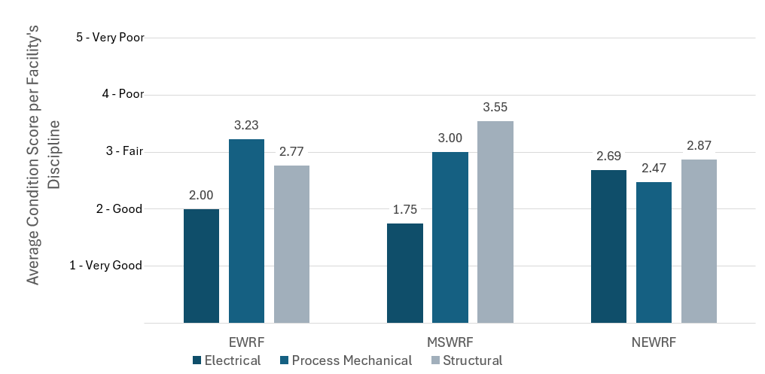
Figure 2-2 Average Condition Scores per WRF by Discipline

Climate Variability/Coastal Hazard Vulnerability Assessment

FEMA Flood Zones and Pinellas Vulnerability Assessment Flood Events
The EWRF and MSWRF are impacted by localized flooding as identified on the Federal Emergency Management Agency Flood Insurance Rate Maps as well as the Pinellas County Sea Level Rise and Storm Surge Vulnerability Assessment – February 2022. The NEWRF is not exposed to these hazards. The estimated impacts from localized flooding are shown in Table 2-8.
Table 2-8 Estimated Impacts from Localized Flooding
Current FEMA and Pinellas Vulnerability Assessment
EWRF | 100-yr FEMA  (2021) | 100-yr Pinellas Vulnerability Study (2018 base) | 500-yr Pinellas Vulnerability Study (2018 base)
Count of equipment inundated | 54 | 39 | 68
Percent of all equipment inundated | 78% | 57% | 99%
Average depth of inundation (feet) | 3.26 | 2.43 | 4.45
MSWRF | 100-yr FEMA  (2021) | 100-yr Pinellas Vulnerability Study (2018 base) | 500-yr Pinellas Vulnerability Study (2018 base)
Count of equipment inundated | 35 | 36 | 97
Percent of all equipment inundated | 34% | 35% | 94%
Average depth of inundation (feet) | 1.58 | 3.44 | 3.55

Storm Surge Flood Events
The EWRF and MSWRF are impacted by flooding on the Pinellas County’s storm surge inundation maps. The NEWRF is not exposed to these hazards. The estimated impacts from storm surge caused by hurricanes are shown in Table 2-9.
Table 2-9 Estimated Impacts from Storm Surge
Estimated Impacts from Storm Surge
EWRF | Category 1 Storm Surge | Category 2 Storm Surge | Category 3 Storm Surge | Category 4 Storm Surge | Category 5 Storm Surge
Count of equipment inundated | 54 | 68 | 69 | 69 | 69
Percent of all equipment inundated | 78% | 99% | 100% | 100% | 100%
Average depth of inundation (feet)¹ | 3.26 | 5.45 | 16.36 | 16.36 | 38.36
MSWRF | Category 1 Storm Surge | Category 2 Storm Surge | Category 3 Storm Surge | Category 4 Storm Surge | Category 5 Storm Surge
Count of equipment inundated | 37 | 99 | 100 | 100 | 100
Percent of all equipment inundated | 36% | 96% | 97% | 97% | 97%
Average depth of inundation (feet)¹ | 4.44 | 4.48 | 10.43 | 15.43 | 37.43
¹Inundation data is from the National Hurricane Center, December 2023

Future Conditions (Sea Level Rise and 100-year Events)
The MSWRF and EWRF face exposure to increases in tidal conditions; however, the existing projections indicate that daily tidal events will remain at the shoreline or adjacent to the facilities until at least 2070 and therefore do not represent increased hazard within the planning period. Tidal events still increase the potential for flooding during coastal events and impacts to the groundwater.
Pinellas County has modeled a 2070 100-year flood event which indicates a tidal height that is 2 feet higher than the current 100-year projection for MSWRF and 2.7 feet higher than the current 100-year projection for EWRF. The increase in SLR and resulting impacts on 100-year flood events would lead to 90 percent of all equipment at both MSWRF and EWRF inundated. The NEWRF is not exposed to these hazards.

Infiltration and Inflow
Due to SLR causing high groundwater levels, the City’s WRFs may experience increased groundwater infiltration during both dry and wet weather. The conveyance and treatment of these extraneous flows leads to increased costs and GHG emissions. Additional measures could be proactively taken to reduce infiltration and inflow into the system. These measures include the following:
- Further implementation of the gravity sewer renewal and replacement program.
- Replacement of gravity sewers with pressure system, e.g., vacuum or low-pressure sewer systems.

Renewal and Replacement Impacts from Climate Variability and Coastal Hazards
Although MSWRF is slightly less exposed to flood events than EWRF, a Category 2 storm surge event or higher will likely inundate large portions of both facilities. Due to climate variability, R&R will need to focus on an adaption strategy to keep the facilities fully operational during a high flood event. Protective R&R strategies include the following:
- Elevating skid-mounted equipment indoors where head space allows.
- Elevating outdoor equipment – pumps and control panels.
- Providing tie-downs for chemical storage tanks.
- Installing protective barriers at building entrances/sealing buildings.
- Sandbagging at building entrances.
- Installing sealed/flood proof control panels.
This information was further used to prepare implementation costs and assess the scenarios for coastal impacts for the consolidation evaluation.

Regulatory Review and Emerging Issues
An analysis was conducted to evaluate potential future regulations that may impact the City’s WRFs and future capital improvement decisions. This evaluation included contacting state and federal regulatory agencies as well as consulting with technical experts on regulations.
Two regulations that may impact or support the City’s WRF strategy include Florida Administrative Code Chapter 62-640 and Senate Bill 64. Brief summaries of each are described below:
- Florida Administrative Code Chapter 62-640 (Biosolids Rule): The biosolids rule revisions were developed to minimize the migration of nutrients, specifically phosphorus, to prevent impairment to waterbodies. The rule revised the method to determine land application rates set by phosphorous concentration and prohibits application of biosolids to land with a seasonal high-water table within 6 inches of the soil surface or depth of the biosolids placement. Compliance of new rules to take place within 1 year for new permits or permit renewals issued after July 1, 2020, and within 2 years of the of the effective date for all permits (June 21, 2023).
- Florida House of Representatives Senate Bill 64 (2021) – Reclaimed Water (SB64): This bill dictates that domestic wastewater utilities that dispose of effluent, reclaimed water, or reuse water by surface water discharge must eliminate non-beneficial surface water discharges by January 1, 2032. The City’s “Surface Water Discharge Plan to Comply with Senate Bill 64” was approved by the Florida Department of Environmental Protection (FDEP) in May 2022 (City Project No. 21-0016-UT).

Biosolids Management Strategy
The City currently produces biosolids at two of its three WRFs (NEWRF and MSWRF). Both these facilities utilize anaerobic digestion to meet pathogen reduction and vector attraction reduction requirements set forth by the U.S. Environmental Protection Agency (EPA) 503 and FDEP Biosolids Rule to produce Class B biosolids. The NEWRF biosolids include the processed sludge from the EWRF. The City has historically relied on Class B land application, but in recent years the contractor has had difficulty identifying suitable sites with the updated Biosolids Rule (FAC 62-640, June 2021) for land application also limiting the available land application area in the region.

Alternatives Evaluation
A screening of solids processing technologies and end-use/disposal practices was conducted to help the City evaluate a broad range of available options to meet changing regulatory requirements. The goal was to eliminate those that are considered unlikely to provide cost effective or reliable solutions for managing the City’s biosolids in the future. Five alternatives were shortlisted as identified in Table 2-10.
Nine criteria were developed and assigned weighting factors by the City based on the drivers and goals for its biosolids management strategy. Each alternative was scored on a scale from 1 to 3 for each criterion, with 1 indicating an inferior or disadvantageous condition, 2 representing a neutral or objective-meeting condition, and 3 reflecting a superior or advantageous condition.
When the analysis was complete for each alternative, the overall scores for each alternative were calculated using the weighting factors. The alternatives, criteria, weighting factors, scores, and weighted total scores are presented in Table 2-10.
Alternative 1B (existing operation with 100 percent of digested biosolids to be hauled to a Regional Management Facility (RMF) for further processing to Class AA) scored the highest for the following reasons:
- It is the lowest cost alternative to achieve Class AA since it does not require installing any new infrastructure.
- Implementation of composting or solar drying at NEWRF may have raised some concerns with the neighboring communities in terms of odor and aesthetics.
- There is lower contract risk than Alternative 1A since the City currently has multiple options for RMF contracts within the region, including a possible facility to be built by Pinellas County in the near future.
The results of the evaluations completed as part of this biosolids study effort indicate that the most appropriate biosolids management strategy for the City is to continue with the current operation while considering contractual and budgetary requirements to contract with a RMF for a long-term basis (Alternative 1B). After the biosolids management strategy was complete, Clearwater’s City Council approved negotiations with Pinellas County to take part in the County’s implementation of a RMF.
Table 2-10 Summary of Biosolids Management Alternatives Evaluation Scores
Evaluation Criterion | Weight | Alternative 1A |  | Alternative 1B |  | Alternative 2 |  | Alternative 3 |  | Alternative 4
Evaluation Criterion | Weight | Class B Land App |  | RMF |  | Composting |  | Solar Dryer |  | Thermal Dryer
Evaluation Criterion | Weight | Average Score | Weighted Score | Average Score | Weighted Score | Average Score | Weighted Score | Average Score | Weighted Score | Average Score | Weighted Score
Financial
Life-Cycle Cost | 14% | 3.0 | 0.4 | 3.0 | 0.4 | 2.0 | 0.3 | 2.0 | 0.3 | 1.0 | 0.1
Social
Public Acceptance | 7% | 1.0 | 0.1 | 2.0 | 0.1 | 2.0 | 0.1 | 2.0 | 0.1 | 3.0 | 0.2
Safety | 14% | 2.0 | 0.3 | 2.0 | 0.3 | 2.0 | 0.3 | 2.0 | 0.3 | 2.0 | 0.3
Product Quality and Program Diversification | 11% | 1.0 | 0.1 | 2.0 | 0.2 | 3.0 | 0.3 | 2.0 | 0.2 | 3.0 | 0.3
Environmental
Regulatory Risk | 13% | 1.0 | 0.1 | 3.0 | 0.4 | 2.0 | 0.3 | 2.0 | 0.3 | 3.0 | 0.4
Contract Risk | 9% | 1.0 | 0.1 | 3.0 | 0.3 | 3.0 | 0.3 | 3.0 | 0.3 | 3.0 | 0.3
Functional
Process Reliability | 12% | 2.0 | 0.2 | 3.0 | 0.4 | 3.0 | 0.4 | 2.0 | 0.2 | 2.0 | 0.2
Operational Complexity and Maintainability | 12% | 3.0 | 0.4 | 3.0 | 0.4 | 2.0 | 0.2 | 2.0 | 0.2 | 2.0 | 0.2
Site Constraints | 8% | 3.0 | 0.2 | 3.0 | 0.2 | 1.0 | 0.1 | 1.0 | 0.1 | 2.0 | 0.2
Weighted Total | 100% |  | 1.9 |  | 2.7 |  | 2.2 |  | 2.0 |  | 2.3

Effluent Management Strategy Development
Effluent management is another major component of managing the WRFs as future effluent options have become more limited because of recent changes in regulations by the Florida Legislature through SB64, which nearly eliminates non-beneficial surface water discharges from the WRFs.
On May 3, 2022, FDEP approved the City’s plan for compliance with SB64 (City Project No. 21-0016-UT). The City’s SB64 plan focused on two strategies for the two points of surface water discharge (near MSWRF and NEWRF + EWRF combined, discharge point near the EWRF).
In summary:
- Through the City’s Master Reuse System permit, (Permit No. FL0186261, issued December 2023) the City will continue to discharge reclaimed water into two stormwater management systems where the water is subsequently withdrawn by users for irrigation purposes. (D-002, Countryside Country Club Pond to Possum Creek to Old Tampa Bay and D-003, Belleair Country Club Pond to Corbet Street Stormwater to Intracoastal Waterway).
- According to the A Prototype Realistic Innovation Community of Today (APRICOT) Act [s. 403.086(8)] allowances, the City will increase the public access reclaimed water utilization at the MSWRF to a minimum of 70 percent with 30 percent backup discharges to Stevenson Creek, a Class III Marine water body.
- The City will increase public access reclaimed water utilization at the EWRF and NEWRF to 90 percent, thus reducing the surface water discharge to 10 percent or less, in compliance with SB64 requirements.
- Increasing public access reclaimed water utilization will be accomplished by adding potential public access reuse customers identified to be located within the City existing Master Reuse System, expanding capacity outside the existing service area, increasing flow to Pinellas County, and/or providing reclaimed water service to Safety Harbor. The City is actively conducting a Water Reuse Master Plan (City Project No. 21-0018-UT).
- Accomplishing 90 percent public access reuse may require implementing the use of another source of water to augment the reclaimed water supply during peak season demands or implementing an aquifer storage and recovery system, if feasible, to balance the seasonal variability in reclaimed water demands.
- The City is also evaluating groundwater replenishment and direct potable reuse at the NEWRF that could help achieve 90 percent reuse if implemented.

Water Reclamation Facilities Consolidation Evaluation
A key task of determining the Future WRF Strategies for further evaluation within the WRF Master Plan was to evaluate scenarios for potentially consolidating three WRFs. The evaluation of the scenarios considered all the major components of managing a WRF: capacity, R&R, regulations, biosolids, effluent management, and costs.

Scenario Development
The scenario development began by creating a broad list of options that included approximately 30 consolidation scenarios. The list was initially developed through brainstorming sessions with and without the City and focused on ideas for consolidation regardless of constraints such as available space or capacity. Further evaluation of the list was conducted, and scenarios were eliminated based on considerations such as expansion availability, new facility considerations, full flow consolidation, overall reasonableness of the breadth of scenarios, City input, and alignment with the City’s Strategic Plan.
After screening based on the above considerations, the shortlisted consolidation scenarios were established as presented in Table 2-11.
Table 2-11 Shortlisted WRF Consolidation Scenarios
Scenario No. | Scenario Name | Description | Total No. of WRFs
1 | Maintain Existing WRFs (Baseline Scenario) | No consolidation. Maintain as three separate WRFs. | 3
2 | All at NEWRF | Complete consolidation. Consolidate all MSWRF and EWRF flow to NEWRF. | 1
3 | MSWRF to NEWRF | Partial consolidation. Consolidate by directing all MSWRF flow to NEWRF. Maintain EWRF where it is currently located. | 2
4 | EWRF to NEWRF | Partial consolidation. Consolidate by directing all EWRF flow to NEWRF. Maintain MSWRF where it is currently located. | 2
5 | MSWRF + EWRF to New WRF | Partial consolidation. Consolidate by directing all MSWRF and EWRF flow to a new WRF. Maintain NEWRF where it is currently located. | 2
6 | All at New Regional WRF | Complete consolidation. Divert all flow from all three WRFs to a new facility at a location that is not one of the existing WRFs. | 1

The scenarios were developed further by performing critical, yet high-level foundational analyses on facility flows, population projections, and wastewater generation rates, which became the basis of assumptions for proceeding further in the evaluation of scenarios (sizing force mains, determining capacity limitations, cost estimating, etc.).

Evaluation Criteria and Weighting
To evaluate the scenarios (particularly for non-economic factors), evaluation criteria were developed from the City’s goals for the WRF Master Plan. Black & Veatch met with the City on May 23, 2022, and June 1, 2022, to thoroughly review and finalize the proposed weighting criteria. The finalized evaluation criteria and weighting as well as the range of available scores is presented in Table 2-12.
Table 2-12 Evaluation Criteria
Criteria | Weight | Score 1  (Least Favorable) | Score 2 | Score 3  (Most Favorable)
System Reliability and Resilience | 22% | Low reliability or resilience of the collection and treatment systems. Consider items such as the following:  - Single point of failure  - Sanitary Sewer Overflow (SSO) elimination  - SWFWMD environmental resource and groundwater replenishment permitting  - Minimum design standards | Medium reliability and resilience of treatment system. Consider items such as the following:  - Single point of failure  - SSO elimination  - SWFWMD environmental resource and groundwater replenishment permitting  - Minimum design standards | High reliability and resilience of the treatment system. Consider items such as the following:  - Single point of failure  - SSO elimination  - SWFWMD environmental resource and groundwater replenishment permitting  - Minimum design standards
Maintenance Reliability and Resilience | 21% | Low maintenance reliability or resilience of the treatment systems. Consider items such as the following:  - Useful life and condition of equipment  - Spare part requirements/costs  - Ability to secure skilled labor/staffing  - Size of equipment and safety  - Automation - requires a lot of maintenance skill and attention. | Medium maintenance reliability or resilience of the treatment systems. Consider items such as the following:  - Useful life and condition of equipment  - Spare part requirements/ costs  - Ability to secure skilled labor/staffing  - Size of equipment and safety  - Automation - requires intermediate maintenance skill and attention. | High maintenance reliability or resilience of the treatment systems. Consider items such as the following:  - Useful life and condition of equipment  - Spare part requirements/costs  - Ability to secure skilled labor/staffing  - Size of equipment and safety  - Automation - requires minimal maintenance skill and attention.
Ease of Operations | 17% | Highly complex system configuration. Consider the following:  - Low capacity to manage resources  - Increased risk of safety and quality incidents  - Number and locations of WRFs and lift stations  - Number of pieces of equipment  - Automation - requires a lot of training and human input. | Intermediate system configuration. Consider the following:  - Medium capacity to manage resources  - Risk of safety and quality incidents remains the same  - Number and locations of WRFs and lift stations  - Number of pieces of equipment  - Automation - intermediate training and input. | Simple system configuration. Consider the following:  - High capacity to manage resources  - Reduced risk of safety and quality incidents  - Number and locations of WRFs and lift stations  - Number of pieces of equipment  - Automation – user friendly. Requires minimal training and human input.
Climate and Environmental Vulnerability | 14% | Potential for significant impacts by climate hazards: flood events, sea level rise, storm surge | Potential for some impacts by climate hazards: flood events, sea level rise, storm surge | Low potential for impacts by climate hazards: flood events, sea level rise, storm surge
Sustainability (Greenprint 2.0 is City’s Sustainability Plan) | 11% | High energy consumption and greenhouse emissions; Does not meet Greenprint 2.0 goals. Consider the following:  - Wastewater (WW) processes and general quantities produced  - Ability to reuse byproducts  - End product disposal (e.g., Senate Bill 64, biosolids) | Medium energy consumption and greenhouse emissions; meets Greenprint 2.0 goals. Consider the following:  - WW processes and general quantities produced  - Ability to reuse byproducts  - End product disposal (e.g., Senate Bill 64, biosolids) | Low energy consumption and greenhouse emissions; exceeds Greenprint 2.0 goals. Consider the following:  - WW processes and general quantities produced  - Ability to reuse byproducts  - End product disposal (e.g., Senate Bill 64, biosolids)
Financial Responsibility | 9% | Highest life-cycle costs [Capital + O&M costs over 30 years] | Average life-cycle costs [Capital + O&M costs over 30 years] | Lowest life-cycle costs [Capital + O&M costs over 30 years]
Public Perception | 6% | Community concerns and lengthy planning and zoning approval process | Minor community concerns or minor planning and zoning approval requirements and/or positive community response | No community or planning and zoning challenges and/or highly positive community response

Scenario Analysis
To fully evaluate the six scenarios, additional detailed assessments were conducted, including analyses of collection system consolidation, treatment consolidation capacity, consolidation impacts to the approved SB64 plan, and considerations for sustainability and GHG emissions.
- Collection System Consolidation Analysis – Identified the improvements needed to transfer flow and reconfigure the existing collection system. Each decommissioned WRF was proposed to become a new master lift station connected via additional force mains to transfer flow to the remaining WRFs. Flow shedding and reconfiguration of the existing system was determined based on risk factors associated with storm surge categories.
- Treatment Consolidation Capacity Analysis – A capacity assessment was performed with the permitted treatment capacities and projected 2050 flows for each WRF to estimate the 2050 AADFs and Peak Hourly Flows (PHFs) at each facility.
- Consolidation Impacts to Approved SB64 Plan – Impacts from consolidation of the WRFs on the approved 2022 SB64 Plan were analyzed to ensure SB64 requirements would continue to be met with each scenario.
- Sustainability and GHG Emissions – GHG emissions were evaluated using historical energy data to compare estimated tons of carbon dioxide per consolidation scenario per year.

Cost Estimates
A net present value (NPV) life-cycle cost analysis for each consolidation scenario was performed using capital, land acquisition, R&R, and annual O&M costs. The methodologies used to develop the cost estimates for each scenario were as follows:
- General Assumptions – Assumptions of parameters including planning horizon, cost estimate level, cost estimate basis, escalation rate, discount rate, contingencies, consolidation construction end year, funding mechanisms, treatment technologies, land acquisition, and biosolids costs were made to develop the capital costs.
- Capital Costs and Land Acquisition Costs – Capital cost estimates were included in the life-cycle costs analysis and spread over the 6-year planning and capital improvement timeline window and applying yearly escalation factors to the costs spread. A salvage value of zero was assumed. No detailed land analysis was performed.
- Annual O&M Costs – O&M costs were based on parameters such as personnel service, WRF energy cost, collection system pumping energy cost, process chemical, professional services, maintenance and internal service, and other miscellaneous costs. All annual operating costs were assumed to remain the same until the end of 2028 for all scenarios.
- R&R Costs – Conceptual level costs of short-term and long-term R&R improvements required at all the WRFs were developed for the six consolidation scenarios. A timeline for R&R of assets was created for each scenario based on the high-level condition assessment. R&R costs were estimated for the entire planning period for existing infrastructure using 4 percent of original installed cost before annual inflation.
- Life-Cycle Costs - The NPV of the capital, land acquisition, annual O&M, and R&R costs were calculated and then combined to calculate the life-cycle costs for each scenario. The life-cycle costs for the six WRF consolidation scenarios are presented in Table 2-13, in 2022 dollars.
Table 2-13 Life-Cycle Costs by Type and Scenario ($M)
Scenario No. | 1 | 2 | 3 | 4 | 5 | 6
Scenario Name | Maintain Existing WRFs | All at NEWRF | MSWRF to NEWRF | EWRF to NEWRF | MSWRF+EWRF to New WRF | All at New Regional WRF
Total No. of WRFs | 3 | 1 | 2 | 2 | 2 | 1
O&M | $495 | $399 | $431 | $462 | $460 | $394
Land Acquisition | - | - | - | - | $51 | $111
Capital Collection System | $7 | $246 | $164 | $82 | $246 | $327
Capital WRFs |  | $115 | $81 | $10 | $105 | $151
R&R | $483 | $222 | $330 | $376 | $437 | $100
Total | $986 | $983 | $1,006 | $931 | $1,299 | $1,083
- All costs expressed in June 2022 million dollars.
- Costs are AACEI Class 5 Classification [-50 percent to +100 percent]
- Biosolids costs are excluded from this analysis since they are the same for each scenario. Biosolids costs are included in the Capital Improvement Plan.

Scenario 4 has the lowest costs and is over 10 percent less than the average costs. Scenarios 1, 2, 3, and 6 are all within 6 percent of the average costs. Scenario 5 is over 20 percent greater than the average costs.

Evaluation Results
The objective of the WRF consolidation evaluation was to arrive at a single Future WRF Strategy to further analyze in Tasks 3 through 5 of the WRF Master Plan project. The strategy is the result of the evaluation process described above and scored below in Table 2-14. Additional justification and discussion supporting the scoring results are summarized in Table 2-15.
Table 2-14 WRF Consolidation Scoring Results
Scoring Criteria | Weight | Recommended Score
Scoring Criteria | Weight | Scenario 1 | Scenario 2 | Scenario 3 | Scenario 4 | Scenario 5 | Scenario 6
Scoring Criteria | Weight | Maintain Existing WRFs | All at NEWRF | MSWRF to NEWRF | EWRF to NEWRF | MSWRF + EWRF to New WRF | All to New Regional WRF
System Reliability and Resilience | 22% | 2.3 | 1.3 | 1.7 | 2.7 | 2.7 | 1.5
Maintenance Reliability and Resilience | 21% | 1.0 | 3.0 | 2.0 | 2.0 | 2.7 | 3.0
Ease of Operations | 17% | 1.0 | 3.0 | 2.0 | 2.0 | 2.5 | 3.0
Climate and Environmental Vulnerability | 14% | 1.0 | 3.0 | 2.0 | 2.0 | 3.0 | 3.0
Sustainability (Greenprint 2.0 is City's Sustainability Plan) | 11% | 1.0 | 2.0 | 1.0 | 1.0 | 2.0 | 3.0
Financial Responsibility | 9% | 2.0 | 2.0 | 2.0 | 3.0 | 1.0 | 1.0
Public Perception | 6% | 1.5 | 3.0 | 2.0 | 2.3 | 1.0 | 1.0
Final Score |  | 1.41 | 2.43 | 1.81 | 2.14 | 2.36 | 2.37

Table 2-15 WRF Consolidation Scoring Results Justification
Scoring Criteria | Justification for Recommended Scores
Scoring Criteria | Scenario 1 | Scenario 2 | Scenario 3 | Scenario 4 | Scenario 5 | Scenario 6
Scoring Criteria | Maintain Existing WRFs | All at NEWRF | MSWRF to NEWRF | EWRF to NEWRF | MSWRF+ EWRF to  New WRF | All to New Regional WRF
System Reliability and Resilience | EWRF remains:  - Located at the least-resilient area of the 3 WRFs.  - Higher susceptibility of SSOs.  - No room for an equalization (EQ) basin at EWRF. | One WRF:  - Minimizes the chances of SSOs.  - Maximizes risk of single Point of Failure (POF)¹. | EWRF remains:  - Located at the least-resilient area of the 3 WRFs.  - Higher susceptibility of SSOs.  - No room for an EQ basin at EWRF. | Two WRFs:  - Lower chances of SSOs.  - Decreases risk of single POF. | Two WRFs:  - Lower chances of SSOs.  - Decreases risk of single POF. | One WRF:  - Minimizes the chances of SSOs  - Maximizes risk of single POF¹.
Maintenance Reliability and Resilience | Three WRFs:  - Highest amount of equipment to be maintained, and most spare parts to be stored.  - Requires the highest amount of skilled labor/staffing.  - EWRF and MSWRF remain: The condition assessment indicated structural condition is more severe than NEWRF.  - Utilizes the existing systems which minimizes useful life and condition of equipment. | One WRF:  - Improvements made to NEWRF will lead to newer treatment system that is all integrated at one plant.  - Requires the lowest amount of skilled labor/staffing.  - Minimizes the amount of equipment to be maintained and spare parts to be stored.  - Size of equipment will not greatly increase because of the existing capacity available at NEWRF. | Two WRFs:  - Moderate amount of equipment to maintain and store (less than Scenario 1)  - Moderate amount of skilled labor/staffing (less than Scenario 1) | Two WRFs:  - Moderate amount of equipment to maintain and store (less than Scenario 1)  - Moderate amount of skilled labor/staffing (less than Scenario 1) | Two WRFs:  - Moderate amount of equipment to maintain and store (less than Scenario 1).  - Equipment at New WRF will have the highest useful life and be in the best condition.  - Moderate amount of skilled labor/staffing (less than Scenario 1) | One New WRF:  - Least amount of equipment to maintain and spare parts to be stored.  - All equipment will be new, have the longest remaining life, and be in the best condition.  - Requires the lowest amount of skilled labor/staffing.
Ease of Operations | Three WRFs:  - Maximizes operational complexity.  - Most difficult to manage during emergency operations.  - Maximizes pieces of equipment.  - If resources are limited, could be challenging and inconvenient to operate at 3 WRF locations but lift stations will still remain throughout entire service area. | One WRF:  - Minimizes operational complexity.  - Most manageable during emergency operations.  - Minimizes pieces of equipment.  - More convenient to manage staff (which may be limited) at 1 WRF instead of 2 or 3. | Two WRFs:  - Medium degree of operational complexity.  - With EWRF remaining, it may be difficult to manage resources and operate the plant there during storm surge.  - More convenient to manage staff (which may be limited) at 2 WRFs instead of 3. | Two WRFs:  - Medium degree of operational complexity.  - MSWRF difficult to manage during storm surge.  - More convenient to manage staff (which may be limited) at 2 WRFs instead of 3. | Two WRFs:  - Medium degree of operational complexity.  - New system may be designed to minimize complexity.  - New WRF location would minimize the difficulty to manage during emergency operations.  - More convenient to manage staff (which may be limited) at 2 WRFs instead of 3. | One WRF:  - Minimizes operational complexity.  - Most manageable during emergency operations.  - Minimizes pieces of equipment.  - Safety concerns reduced due to New WRF.  - More convenient to manage staff (which may be limited) at 1 WRF instead of 2 or 3.
Climate and Environmental Vulnerability | - EWRF remains and is most vulnerable to climate hazards.  - MSWRF remains and is moderately vulnerable to climate hazards. | - NEWRF is the least vulnerable to climate hazards.  - Eliminates the major flood concerns at both EWRF and MSWRF. | - NEWRF is the least vulnerable to climate hazards. EWRF vulnerable to climate hazards. Vulnerability is balanced.  - Mitigates some of the overall vulnerability. | - NEWRF is the least vulnerable to climate hazards. MSWRF vulnerable to climate hazards. Vulnerability is balanced.  - Mitigates some of the overall vulnerability. | - NEWRF is the least vulnerable to climate hazards. New WRF location would be selected at non-vulnerable location.  - Eliminates the major flood concerns at both EWRF and MSWRF. | - New WRF location would be selected at non-vulnerable location.  - Eliminates the major flood concerns at both EWRF and MSWRF.
Sustainability (Greenprint 2.0 is City's Sustainability Plan) | See Section 7.4.4 of Attachment 1 | See Section 7.4.4 of Attachment 1 | See Section 7.4.4 of Attachment 1 | See Section 7.4.4 of Attachment 1 | See Section 7.4.4 of Attachment 1 | See Section 7.4.4 of Attachment 1
Financial Responsibility | See Section 7.5.5 of Attachment 1 | See Section 7.5.5 of Attachment 1 | See Section 7.5.5 of Attachment 1 | See Section 7.5.5 of Attachment 1 | See Section 7.5.5 of Attachment 1 | See Section 7.5.5 of Attachment 1
Public Perception | - City has received some complaints regarding the location of EWRF.  - Most of the public though may be ok with how things are and would not want to change where the plants are.  - No traffic impacts; status quo. | - Reduced complaints about the EWRF location.  - Allows land at MSWRF to be utilized in new way to benefit the public.  - Large collection system improvements required with temporary impacts to traffic in the City. | - City has received some complaints regarding the location of EWRF.  - Allows land at MSWRF to utilized in new way to benefit the public.  - Medium collection system improvements required which may impact traffic in the City. | - Expected to receive minimal complaints about the EWRF location if it's not operating at a WRF, but still may be a major pumping station.  - Medium collection system improvements required with temporary impacts to traffic in the City. | - New WRF:  - Limited availability of sites for new WRF outside residential areas.  - "NIMBY" (not in my backyard) mindset by residents; resistant to changes.  - Large collection system improvements with temporary impacts to traffic in the City. | - New WRF:  - Limited availability of sites for new WRF outside residential areas.  - "NIMBY" (not in my backyard) mindset by residents; resistant to changes.  - Large collection system improvements with temporary impacts to traffic in the City.
- Risk of single POF can be reduced with redundancy and resolved during design.

After developing and evaluating the six consolidation scenarios, Black & Veatch recommended the City proceed with Scenario 2, which scored the highest (most favorable) as a composite of all criteria across all scenarios and anticipates the following benefits:
- Climate and Environmental Vulnerability – NEWRF is least likely to be impacted by climate variability. SLR and storm surge may result in significant inundation at EWRF and MSWRF.
- Capacity and Expansion Capabilities – The existing capacity of NEWRF allows for only one additional treatment train needed to treat the flow from EWRF and MSWRF. The NEWRF property contains adequate room for expansion.
- Public Perception – The property owned by Public Utilities that contains NEWRF provides adequate room for expansion while maximizing the space between the plant and private property. The land at MSWRF and EWRF can be utilized in a new way to benefit the public.
- Biosolids Treatment – NEWRF currently treats thickened sludge from EWRF. Consolidating EWRF to NEWRF reduces hauling of biosolids (saving energy and cost).
The results of the consolidation evaluation were provided to the City and presented to the City Council’s individual members, the City Manager, and Assistant City Manager. On February 27, 2023, the recommendation was presented at the City of Clearwater’s City Council Monthly Meeting. On March 3, 2023, City Council approved the complete consolidation of MSWRF and EWRF to NEWRF. Because of the consolidation decision, the Task 3 Existing System Evaluation shifted the priority to NEWRF, as it will be the only facility remaining after full implementation of the future scenario.

Existing System Evaluation

Existing System Evaluation Overview
The goal of the Task 3 Existing System Evaluation was to summarize the state of the existing facilities and processes at NEWRF to identify issues that need to be addressed over the 30-year planning horizon. Additionally, limitations affecting each treatment process unit’s ability to provide reliable long-term performance were identified. The Task 3 Existing System Evaluation was accomplished through nine separate evaluations, most of which focused exclusively on the NEWRF, reflecting a targeted approach based on the consolidation strategy. The nine evaluations were as follows:
- Detailed Condition Assessment
- Building Assessment (completed at all three WRFs)
- Record Drawing Review
- O&M Manual Update
- Hydraulic and Pump System Evaluation
- Treatment Model Evaluation
- Instrumentation and Controls (I&C) Evaluation
- Electrical Evaluation
- Energy and Chemical Use Baseline
A summary of the evaluation is included in this section. The full evaluation is provided in Attachment B.

Condition, Building, and Facilities Assessment
Detailed condition and building/facilities assessments were performed to establish the foundation for understanding the existing system and condition of assets. The assessments set the baseline for the existing conditions at NEWRF. Occupiable buildings were also assessed at MSWRF and EWRF. The assessments were used to develop a path toward the City’s envisioned 2050 scenario.

Detailed Process Facilities Condition Assessment
The detailed condition assessment built upon the high-level condition assessment performed earlier in the Master Planning process. The purpose of the condition assessment was to understand the condition and performance issues of the existing NEWRF assets in conjunction with the criticality of the equipment for the process to provide reliable long-term treatment. The expected useful lives of assets were developed and compared with the age of the equipment with a risk assessment performed to determine the medium- to long-term asset replacement needs. Replacement needs identified during the condition assessment were later considered in the development of the long-term treatment solution and development of CIP projects.
The detailed condition assessment was performed through the following tasks:
- Development of Data Inventory Collection Plan and Condition Assessment Criteria
- Field Visits
- Asset Data Analysis
- Asset Risk Assessment and Replacement Forecasting
The asset risk assessment and replacement forecasting process included the development of criteria for both the “consequence of failure” and the “likelihood of failure,” along with estimates of expected useful life. These criteria enabled the determination of each asset’s remaining useful life and corresponding risk score. A total of 431 assets were assessed in the following disciplines:
- Civil
- Structural
- Mechanical
- Electrical/I&C
Overall, NEWRF appears to be in fair condition (average score of 3) as illustrated on Figure 3-1. The physical condition scores ranged from 1 (very good) to 5 (very poor).

Figure 3-1 NEWRF Condition Assessment – Physical Condition Scores

The critical facilities scoring a condition score of 5 (very poor) included:
- Bar Screen Control Panel
- Headworks – Electrical Room Equipment
- Grit Removal – Electrical Equipment
- Headworks – Termination Panel
- Northernmost Reject Pump
- Polymer Feed Pump 2 – Motor
The headworks and grit removal equipment were replaced as part of the NEWRF Improvements Project (City Project No. 19-0029-UT, June 2024). In October 2023, the northernmost reject pump was repaired, reinstalled, and in operation according to City staff. The remaining very poor scoring assets are included as near-term R&R projects in the Capital Improvement Plan.
The results of the assets’ remaining useful life assessment are summarized on Figure 3-2.

Figure 3-2 NEWRF Condition Assessment – Asset Remaining Use Life

While NEWRF generally is in fair condition, many of the assets are approaching the end of their remaining useful life. With respect to the future R&R planning, these results indicate a substantial amount of R&R will need to take place at the NEWRF within the next 15 years.
Information gathered during the condition assessment informed the formulation of CIP projects.

Building and Facilities Assessment
The building and facilities assessment was performed as a cursory review of occupiable and emergency buildings at the City’s three WRFs with respect to structural integrity, weathertightness, suitability for current and planned usage, and compliance with current life safety codes. Hurricane (Category 5) protection plantwide for operations and shelter for personnel facilities was also considered. The buildings were assessed by architectural and structural disciplines.
Table 3-1 provides a summary of the occupiable buildings evaluated and findings from the assessment.
Table 3-1 Building Assessment Overview
WRF | Building Description | Findings
EWRF | Control Building | - The building is structurally sound.  - No weathertightness issues were observed during the visual inspection.  - The building contained minor noncompliance issues with current life safety codes.  - Noncompliant with American Disability Act (ADA) requirements.¹  - Contains men’s and women’s showers and lockers and a training room.  - Storage is limited.
MSWRF | Control Building | - The building has minor structural concerns.  - Several minor weathertightness issues were observed.  - The building appears in compliance with current life safety codes.  - Non-compliant with ADA requirements.¹  - No showers/locker rooms; however, they are present on-site at the maintenance building.  - Storage appeared adequate for the building.
MSWRF | Maintenance Building | - The building has minor structural concerns.  - Several minor weathertightness issues were observed.  - The building appears compliant with current life safety codes.  - Non-compliant with ADA requirements.¹  - Contains men’s and women’s showers and lockers.  - Storage area observed to be not readily accessible.
NEWRF | Control Building | - The building is structurally sound but contains a structure issue in the electrical room.²  - No weathertightness issues were observed during the visual inspection.  - The building contained minor noncompliance issues with current life safety codes.  - Non-compliant with ADA requirements.¹  - Contains men’s and women’s showers and lockers.  - There is adequate storage; however, the space is quite full.
- Building was constructed prior to ADA regulations.
- The City indicated these issues will be addressed under City Project 17-0028-UT.

No information was available regarding the designed wind rating for the occupiable buildings analyzed. Because of the applicable codes at the time of construction and overall lack of hurricane-rated windows, many of the buildings were likely not designed to withstand Category 5 hurricane winds and could potentially sustain damage in such conditions. The City’s Emergency Response Plans (ERPs) for EWRF and MSWRF note that the facilities will be evacuated when flooding is imminent and evacuation orders are given. The ERP for NEWRF states that while flooding is less imminent because of the elevation and minimal coastal hazards of the facility, a detailed analysis of the control building is needed to determine the risk category and hurricane category rating.

Record Drawing Review and O&M Manual Update
The NEWRF record drawings were compiled and NEWRF O&M manual reviewed. In addition to better supporting future operations and maintenance of the NEWRF, the compiled record drawings and O&M manual provide information that will support the design and construction of improvements recommended under the 2050 CIP. A site survey was performed at the NEWRF in January 2024 to support development of accurate record drawings reflecting the current site layout and topographic features. The survey provides the latest information on-site to assist in future expansion to the 2050 scenario. The NEWRF O&M manual review allows for an understanding of the City’s current O&M requirements and lays the groundwork for the additional O&M requirements under the consolidation plan.

Hydraulic and Pump System Evaluations
Hydraulic and pump system evaluations were performed to build and implement tools to evaluate current conditions and identify bottlenecks in the existing system.
The tools developed as part of this task included a hydraulic profile and pump system hydraulic calculations for the submersible oxidation ditch feed pumps, screw lift oxidation feed pumps, filter effluent pumps, thickened waste activated sludge (TWAS) pumps, waste activated sludge (WAS) pumps, return activated sludge (RAS) pumps, filter effluent pumps, and high service pumps. The tools were used to evaluate NEWRF under existing and projected future flow conditions.
The results of the evaluations identified current needs to be addressed through CIP planning, and the tools developed support the identification of future improvements NEWRF will need to meet the 2050 scenario and timing for hydraulic expansions.

Hydraulic Profile
The NEWRF flow conditions considered in the hydraulic profile analysis, including RAS flows and Internal Recycle (IR) flows, are presented in Table 3-2.
Table 3-2 Hydraulic Profile Evaluation Flows
Description | Influent Flow (MGD) | Recycle Flows (MGD)
MMAD | 17.4 | 11.48 RAS (85% AADF)  59.4 IR (440%¹ AADF)
AADF | 13.5 | 9.45 RAS (70% AADF)  59.4 IR (440%¹ AADF)
PHF | 27.0 | 13.5 RAS (100% AADF)  59.4 IR (440%¹ AADF)
Minimum | 4.0 | 6.8 RAS (50% AADF)  17.55 IR (130% AADF)²
2050 Projected AADF | 14.55 | 10.19 RAS (70% AADF)  59.4 IR (440%¹ AADF)
- Maximum IR flow was calculated by performing a hydraulic profile of the IR system and iteratively finding the maximum flow before overflowing of the oxidation reactor effluent weir.
- AADF = 13.5 MGD

Based on the developed hydraulic profile, the following were observed:
- For the MMAD and AAD flows, all weirs performed adequately, although the freeboard was less than 1.5 feet in some units.
- The grit chamber effluent weir and second anoxic tank effluent weirs are predicted to be submerged from downstream at the existing design PHF of 27 MGD or above, which would create non-ideal flow split through the weir.
- Flows higher than the design PHF would increase the number and severity of the hydraulic failures.
- For the 2050 projected AADF, no additional hydraulic failures are predicted other than the results provided for the design 13.5 MGD AADF. Where freeboard is less than 1.5 feet in the existing 13.5 MGD AADF flow condition, the 2050 projected AADF will decrease the freeboard marginally.

Pumped Flow System
The flow conditions considered in the pumped flow systems analysis are presented in Table 3-3.
Table 3-3 Pump System Evaluation Flows
Description | Influent Flow (MGD) | Recycle Flows (MGD)
MMAD | 17.4 | 11.48 RAS (85% AADF)  59.4 IR (440% AADF)¹
AADF | 13.5 | 9.45 RAS (70% AADF)  59.4 IR (440% AADF)¹
PHF | 27.0 | 13.5 RAS (100% AADF)  59.4 IR (440% AADF)¹
2050 Projected AADF | 14.55 | 10.19 RAS (70% AADF)  59.4 IR (440% AADF)¹
- Maximum IR flow was calculated by performing a hydraulic profile of the IR system and iteratively finding the maximum flow before overflowing the oxidation reactor effluent weir.

A summary of the pumped flow systems evaluation is provided in Table 3-4.
Table 3-4 Pumped System Evaluation Summary
System | System Function | No. of Pumps | Installed Capacity | Redundancy
High Service Pumps | Reclaimed water distribution pumps. Pumps to the reuse storage tank, Master Reuse System, or EWRF for disposal. | 6 (4 duty, 2 standby) | 25.2 MGD | System redundancy is adequate for MMAD flow at maximum static lift conditions. The future AADF can be achieved; however, higher future MMAD flows will reduce existing pump redundancy.
Submersible Oxidation Ditch Pumps | Pumps wastewater from the first anoxic tank to the oxidation ditches. Serves as a redundant system to the Archimedes screw lifts. | 3 (2 duty, 1 standby) | 40 MGD | The system serves as a redundant system for the screw lift pumps. The 2 duty and 1 standby pumps can deliver over 25% of the MMAD flows (MMAD flow is 88.3 MGD accounting for plant flow, RAS, and IR.). Since these pumps are used to replace the screw pumps during maintenance operations, screw pumps shutdown should be sequenced in that scenario to reduce the amount of flow required to be bypassed through these pumps.
Filter Effluent Pumps | Pumps filter effluent to the chlorine contact chambers (CCCs). | 3 (2 duty, 1 standby) | 29.7 MGD | The pumps were originally designed to pump the plant effluent prior to 2003 when the CCCs were installed. Therefore, redundancy is incorporated into the system, and the existing pumps can deliver the required design AADF and MMAD flows with 2 pumps operating at reduced speed. Future higher flows may require a different pump selection to achieve higher flows and lower head requirements.
RAS Pumps | Pumps RAS from the North and South Pumphouse to the inlet of the fermentation basins. | 4 (1 duty, 1 standby per pumphouse) | 26.8 MGD | System redundancy is adequate for the MMAD, AADF, and future AADF flows.
WAS Pumps | Pumps WAS from the North and South Pump house to the rotary drum thickeners. | 4 (1 duty, 1 standby per pumphouse) | 0.58 MGD | These pumps can meet the existing and future AADF and maintain redundancy, and the assumed MMDF can be met by operating the standby pump.
TWAS Pumps | Pumps TWAS from the rotary drum thickeners to the sludge blending tank or the anaerobic digesters. | 2 (1 duty, 1 standby) | 86.6 gallons per minute (gpm) | System redundancy is limited. Flow ranges based on the differential pressure range available from the pump curves per pump are less than the MMAD and AADF TWAS flows used for the analysis.
Screw Lifts | Pumps wastewater from the first anoxic basin to the oxidation ditches. | 5 (3 duty, 2 standby) | 159.5 MGD | For the AAD and MMAD flows and future AAD, 3 pumps can deliver the required flow transfer, while 2 pumps remain on standby mode. Additional higher flows could be accommodated at the expense of pump redundancy.

Overall, the existing pump stations analyzed met AAD and MMAD flows with varying levels of redundancy, depending on the pump station. Future flows may require additional pump capacity to accommodate changes in the NEWRF flow rate and maintain adequate redundancy.

Treatment Process Model Evaluation
The treatment process model evaluation built a tool to evaluate current conditions, identify existing bottlenecks, and developed treatment related assumptions for the system from historical and sampling data to forecast treatment requirements for the future 2050 scenario.

BioWin Model Development and Calibration
To analyze the existing system, a process model of the NEWRF was developed and calibrated (Level 3) in EnviroSim’s BioWin utilizing industry standard calibration approach documented in Water Environment Research Foundation, 2003. Input from the BioWin model was derived from historical City data and sampling. The NEWRF sampling took place from June 20, 2023, through July 3, 2023. The historical data and sampling results were analyzed and input into the model to confirm calibration.

Existing Treatment Capacity Evaluation and Process Optimization
Process calculations and the BioWin model were used together to determine the reliable treatment capacity of each unit process at NEWRF. Each unit process was evaluated independently utilizing the appropriate mass and hydraulic conditions (e.g., max-month and peak-hour flows and loads) derived from historical data. Class I reliability standards were considered for each unit process.
Table 3-5 summarizes the results of the capacity analysis. Various unit processes at the NEWRF serve a specific role in treatment. As such, different processes and associated components are stressed during different operating conditions such MMAD, Peak Day (PD), and PHF. To help visualize existing capacities of unit processes across the WRF, Figure 3-3 illustrates the equivalent capacity of each unit process expressed in terms of AADF. The unit processes that can currently accommodate projected 2050 AADF of 14.5 MGD are the screening, flow measurement, and alum storage systems; all other unit processes require expansion. It is worth noting that flow EQ and reject systems do not have AADF capacities assigned because they have no inherent “capacity” related to them; however, their presence and use have a tangible impact on treatment performance.
Table 3-5 Summary of Capacity Analysis
Unit Process | Basis of Evaluation | Capacity  (MGD) | Class I Reliability Met | Notes
Screening | PHF | 54 MGD PHF, firm | Y | -
Grit Removal | PHF | 20 MGD PHF, firm | Y | Ability to bypass
Flow measurement | PHF | 43 MGD PHF, firm | - | -
Flow EQ | PHF | - | N¹ | Insufficient reliability for peak-hour flow management
Primary filtration | PHF | 4.8 MGD PHF, firm | Y | -
Biological Nutrient Removal (BNR) Reactors | MMAD | 10.8 MMAD | Y | Limited by final clarifiers
BNR Clarifiers | PHF flow at MMAD Mixed Liquor Suspended Solids (MLSS) | 21.8 PHF | Y | At assessed 8.3 mgd AADF
BNR Aeration | Demand at PD BOD, NH₃ load, Summer | 31 MGD PD | Y | -
Alum Chemical - Storage | 30 days at AADF | 16 MGD AADF | - | -
Tertiary Filtration | 5.0 gpm/sf at PHF flow | 28.5 MGD PHF, firm | Y | -
Disinfection Contact Tank | 15 min Hydraulic Retention Time (HRT) at PHF flow | 36 MGD PHF | Y | Insufficient reliability for peak-hour flows beyond 17.5 MGD
Disinfection - Storage | 30 days at AADF | 4.7 MGD | - | -
Reject System | Site-specific needs | - | Y | Reliability status based on pumping system
- Relates to flow equalization pumping capacity.

Figure 3-3 Equivalent AADF Capacity by Unit Process

The following factors influencing capacity are noted as follows:
- The original plant appears to have been designed for a PHF:AADF peaking factor of 2.0. This is lower than the current PD conditions and therefore is not representative of current conditions. Analysis utilized a PHF:AADF factor of 2.6, which translates to approximately 30 percent more flow at peak conditions. Even with the current flow equalization facilities, this peak hour condition is a challenge.
- Based on review of the July 2022 Clearwater O&M Performance Report, secondary clarifier capacity has been historically assessed via Solids Overflow Rate (SOR) and Solids Loading Rate (SLR) with no consideration for Sludge Volume Index (SVI) values, which are high (155 milliliters per gram [mL/g]). As a general rule, an approximate 15 percent decrease in capacity can be expected for every 10 mL/g increase in SVI. Table 3-6 estimates capacity impacts at different SVIs. As shown, an SVI of approximately 113 mL/g would be required to raise the capacity to 13.5 MGD. This is a realistic/attainable SVI. Alternatively, Clearwater could operate the BNR system at a lower Aerobic Solids Retention Time (aSRT)/MLSS concentration. A MLSS of approximately 2,700 mg/L with a SVI of 155 mL/g would be required to convey 13.5 MGD through the activated sludge system. However, operating at a lower aSRT/MLSS is not recommended because it makes nitrification less reliable.

Table 3-6 Capacity Impacts at Different SVIs
SVI (mL/g) | Estimated Annual Average Capacity (MGD)
155 (Current value used) | 8.3
140 | 10.1
120 | 12.6
113 | 13.5

- The newly constructed primary filters were sized to remove only a fraction of average-day BOD load from the raw wastewater and keep a fraction available to support denitrification within the activate sludge system. While sizing primary treatment system in this way supports the reduction of external carbon demand, it in turn results in higher loading to the activated sludge system and an overall decrease in capacity.
- Operational/optimization opportunities include the following:
  - Implementation of a selective wasting strategy and/or optimization of selector zone operation could lower SVIs and increase capacity of the activated sludge system. Additional analysis could be conducted to identify more detailed solutions.
  - Leveraging the newly constructed flow equalization assets and possibly increasing associated influent pumping capacities to shave off peak-hour flows could increase capacity of the activated sludge system.
Future expansion of NEWRF and the hydraulic analysis related to the expansion is explained further in Section 4.7.

Instrumentation and Controls and Electrical Evaluation
Evaluations of both the I&C and electrical systems at the NEWRF were performed to understand the condition, functionality, and operability of the existing system.

Instrumentation and Controls Evaluation
The I&C evaluation analyzed the current issues and needs relevant to the monitoring and controls system at NEWRF. This included a high-level review of the existing monitoring and controls system focused on the condition, applicability, functionality, appropriateness of physical instruments, and process control methodology. Additionally, an evaluation for the needs of improvements or additional online instrumentation for increasing BNR process efficiency was performed.
Overall, the high-level review found many of the I&C assets to be in good condition and working properly; however, multiple I&C assets are no longer manufactured and appear to be beyond their expected useful life which limits an asset’s reliability and the availability of parts if the asset becomes inoperable.
The process control methodology primarily requires manual manipulation of process components. NEWRF’s supervisory control and data acquisition (SCADA) system has limited controls. The SCADA system has the capability of receiving process-related information; however, because of the inoperability of the SCADA control, manual manipulation is required. Table 3-7 summarizes the existing and recommended instrumentation and analyzers to optimize the existing process. The instrumentation and analyzers recommended are process-specific and provide information to improve the BNR efficiency. Improvements to the BNR efficiency would increase performance monitoring and data collection consistent with the City’s goals for the Master Plan.
Table 3-7 Summary of Recommended Instrumentation and Analyzers
Unit | TSS  (mg/L) | DO  (mg/L) | Temp  (°C) | pH | Flow  (MGD) | NH₃  (mg/L) | NO_{x} (mg/L) | ORP  (mV) | PO4 | MLSS
Influent | X |  | X | X
Primary Effluent | X |  |  |  |  | X
Primary Sludge | X
Anaerobic Zone |  |  |  |  |  |  |  | X
Pre-Anoxic Zone |  |  |  |  |  |  | X
Oxidation Ditch |  | X^{1,2} | X | X |  | X
Post-Anoxic Zone |  |  |  |  |  |  | X
Re-Aeration Zone |  | X |  |  |  |  |  |  |  | X
Secondary Effluent | X |  |  |  | X | X | X |  | X
RAS | X |  |  |  | X
Return Side Stream | X |  |  |  | X | X
- Two online analyzer per oxidation ditch. One handheld analyzer recommended.
- Existing analyzers.
TSS = total dissolved solids; DO = dissolved oxygen; NH3= anhydrous ammonia; NOx= nitrogen oxides; ORP = oxidation-reduction potential; mg/L = milligrams per liter; mV = millivolts.

Electrical Evaluation
The electrical evaluation included analysis of the electrical distribution system and backup power system configuration from the perspective of functionality, reliability, safety, and expandability. The evaluation of the standby generators, switchgear, and motor control centers (MCCs) focused on visual external inspection, analysis of available wiring diagrams, and documentation of the existing system. Additionally, a high-level assessment of the adequacy of the emergency backup power system capacity was performed.
Twenty-two MCCs were visually inspected within 15 process areas. Seven of those process areas provided limited to no availability for expansion of the electrical system. Three process areas contained electrical components in poor condition and at the end of their life expectancy. Several process areas currently house the electrical components in nonconditioned space; conditioned space enclosures can extend the system’s life expectancy.
Seven diesel-fueled engine generators provide the facility’s standby power to various process treatment areas. The standby power exists as an “island” system as each standby generator can only supply power to a single process area. Compared to a centralized backup power system, the “island” standby power system lacks comparable reliability, potentially impacting the facility’s ability to adequately treat wastewater if a single standby generator fails in a critical process area. Depending on the process, if an individual standby generator fails, the plant may not be able to meet FDEP permit requirements, even if all other standby generators are operational. Replacing the existing power distribution system and backup system with a looped distribution system and a single centralized backup power facility, including multiple paralleled standby generators functioning together, would increase the service reliability and resiliency at the plant consistent with the City’s goals for the Master Plan. Such an improvement represents a substantial capital investment and would most appropriately be considered at the time of significant need for rehabilitation/replacement of backup generators and other electrical equipment.

Energy and Chemical Use Baseline
To determine and assess energy and chemical use baselines of the NEWRF, tools were developed by leveraging the equipment inventory and other data gathered during the Master Plan process.
The energy use baseline tool provides an estimated breakdown of the energy consumption at the NEWRF organized by process area and equipment units, considering typical operational strategy. The tool was calibrated by comparison to actual historical energy consumption at the NEWRF.
The chemical use baseline tool provides a summary table that documents a breakdown of chemical consumption by various process components.
These tools set the baseline for energy and chemical use at NEWRF and highlight the impact of energy and chemical use under future conditions. Future conditions at NEWRF alone will have more energy and chemical usage compared to current operations. Thus, it is important to ensure that the energy and chemical usage is optimized for maximum performance and financial responsibility to align with City goals for the Master Plan.

Future Improvements
Task 4 Future Improvements identified the improvements necessary to expand and optimize NEWRF post-consolidation. Prior to evaluating the specific expansion requirements necessary at NEWRF to accommodate additional, future projected flow, a treatment system evaluation was performed to identify if a different treatment process would be beneficial to the future NEWRF configuration.

Future System Configuration Evaluation
Task 4 involved evaluating future process configurations to determine if the treatment process at NEWRF should remain as a 5-stage Bardenpho process or be modified to another treatment process. The evaluation utilized the system’s information, tools, and baselines from the existing system evaluation to select NEWRF’s long-term configuration and operational strategy around which to base CIP development.
The three alternatives evaluated for future improvements include the following:
- Alternative No. 1 – Base Case (5-Stage Bardenpho) – 32 MGD Peak Flow
- Alternative No. 2 – Mobile Organic Biofilm (MOB)™ System (Nuvoda) Expansion – 32 MGD Peak Flow
- Alternative No. 3 – Base Case (5-Stage Bardenpho) Expansion – 37.33 MGD Peak Flow
The expansion evaluations for each alternative were considered to be a separate solution, with only one alternative to be implemented into the final configuration. A summary of the evaluation is provided in this section. The full evaluation is provided in Attachment C.

Flow Equalization Evaluation
A flow equalization evaluation was performed to determine the required flow equalization storage volume at NEWRF that would reduce the likelihood of a SSO during a storm event, based on historical influent flows of the combined wastewater system.
The maximum combined peak flow during a storm event over the past 5 years was determined to be 48.6 MGD. Hourly influent data was collected for each heavy rainfall event from January 2019 through December 2024. The influent data was compared to the WWCS 25-year, 24-hour storm National Oceanic and Atmospheric Administration Atlas 14 data.
Based on the past 5 years of storm data, the influent gradually rises and remains at high flows over an extended period of times. During the March 27, 2025, Future Improvement Workshop, the August 2019 storm was selected as the basis of the flow EQ evaluation. Table 4-1 provides the flow EQ storage required at NEWRF based on the system influent flows experienced from the August 2019 storm event per expansion alternative. The volumes assume no EQ is included at EWRF and MSWRF. Storage, pumping capacity, and force main sizing at the primary lift stations were not included as part of this analysis, but are recommended to be investigated during planning and design.

Table 4-1 Flow Equalization Storage Required at NEWRF Based on August 2019 Storm Event
Alternative | Peak Capacity (MGD) | 2019 Observed Peak Flow (MGD) | EQ Volume Required (MG)
Alternative No. 1 – Base Case (5-Stage Bardenpho) – 32 MGD Peak Flow | 32 | 48.6 | 13
Alternative No. 2 – MOB™ System (Nuvoda) Expansion – 32 MGD Peak Flow | 32 | 48.6 | 13
Alternative No. 3 – Base Case (5-Stage Bardenpho) Expansion – 37.33 MGD Peak Flow | 37.33 | 48.6 | 5

Preliminary and Primary Treatment Expansion Evaluation

Headworks

Existing System
Based on design documents, each existing screen at NEWRF provides an average daily flow of 13.5 MGD, peak capacity of 54 MGD (with both screens in operation), and 27 MGD of firm capacity. The existing screening system meets Class 1 reliability standards for the current flows.
New grit removal facilities were substantially completed in June 2024 (City Project No 19-0029-UT). There are no Class 1 reliability standards specifically for grit systems. However, the system has built-in redundancy at the HeadCell®, grit pump, and classifier. The entire grit treatment process can also be bypassed if necessary. The six grit feed pumps installed provide Class I standards for pumping systems.
Flow is currently measured with a 48-inch Parshall flume and ultrasonic level sensor. In the absence of nameplate data or other design criteria for the existing flume, the rated peak flow was estimated at 43 MGD.

Alternatives Expansion
Assuming under Alternative No.1 – Base Case (5-Stage Bardenpho) – 32 MGD Peak Flow and Alternative No. 2 – MOB System (Nuvoda) Expansion – 32 MGD Peak Flow that EQ basins will be added at NEWRF, the existing firm screening capacity of 27 MGD is not sufficient to process the non-equalized and EQ flows to the plant of 48.6 and 32 MGD, respectively. To provide the required non-equalized and EQ screening capacity, Black & Veatch recommended the following:
- Provide 32 MGD of fine screening capacity (firm) with multi-rake screens, allowing degradation of performance beyond 27 MGD. Leaving the existing two multi-rake units and replacing the manually cleaned screen with a similar mechanically cleaned screen is recommended.
- Any flow above 32 MGD is recommended to be diverted to EQ basins upstream of the headworks structure. This stormwater bypass will also need screening. Once the peak event is subsided, flow will be brought from the EQ basins back to the headworks structure to be processed through the plant. To manage wet weather events, a horizontal storm screen with a peak capacity of 16.6 MGD is proposed.
Table 4-2 lists the recommended screening systems at the NEWRF.
Table 4-2 Summary of Proposed Screens Sizing at 32 MGD Peak Flow at NEWRF
Item | Type / Configuration | Total Number of Units | Capacity, Each | Comments
Mechanically cleaned screens | 60-inch-wide, 6 mm openings, multi-rake units | 3 | 13.5 MGD average, 27 MGD firm capacity  32 MGD firm capacity at reduced capture efficiency  50.5 MGD total installed capacity | 2 screens existing; 1 new unit is proposed
Storm screen | HUBER RoK2 6 mm openings | 1 | 16.6 MGD peak flow | 2 new units proposed (1 duty, 1 standby)

The existing grit removal units have a total capacity of 27 MGD, and the headworks structure does not have space for additional grit units. The combined AADF from all three WRFs is projected to be 14.55 MGD in 2050. At a flow between 27 and 32 MGD, grit performance might be compromised, but the cost to achieve a 5 MGD (32–27 MGD = 5 MGD) expansion on the existing system might not be a cost-effective option. Thus, the City may opt to install a 20 MGD PISTA® VIO™ grit removal unit to be used to remove grit during peak wet weather events. The final decision on the high, storm related peak flow treatment configuration will be determined during design.
Figure 4-1 depicts the proposed headworks layout at NEWRF for Alternatives No. 1 and 2 as described above.
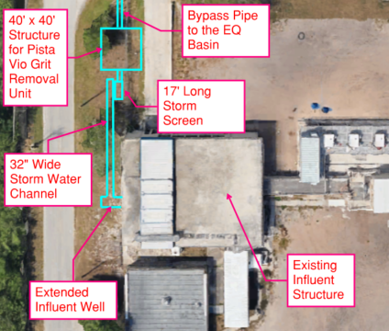
Figure 4-1 Alternatives No. 1 and 2 Site Layout Showing the Proposed Storm Screen and Storm Grit Box Systems at NEWRF
Under the 37.33 MGD peak flow condition of Alt. No. 3 – Base Case (5-Stage Bardenpho) – 37.33 MGD Peak Flow, a new headworks building is proposed due to the hydraulic limitations of the existing headworks building for the proposed peak flow and to improve building resiliency of aging infrastructure in the existing headworks building. Four mechanically cleaned bar screens with 6-millimeter openings are proposed. Three on-duty screening units will handle 37.33 MGD peak flow while one unit will stay on standby. Proposed channels are 5 feet wide. Any flow above 37.33 MGD will be passed through a storm screen and then through a 12 MGD PISTA VIO grit removal unit before flowing into an EQ basin.
Further evaluation will be considered during design to understand the impact of no grit removal in the system to treat high, storm related peak flows. The final decision on the high, storm related peak flow treatment configuration will be determined during design.
The existing HeadCell units currently have three trays per unit. These units can be modified with two additional trays per unit to expand the capacity of each unit to 11.25 MGD. With this modification, the total capacity of the grit removal system will be 45 MGD. Further evaluation can be considered during design to understand if the existing HeadCell units can be refurbished with new trays added.
Figure 4-2 depicts the proposed headworks layout at NEWRF for Alternative No. 3 as described above.
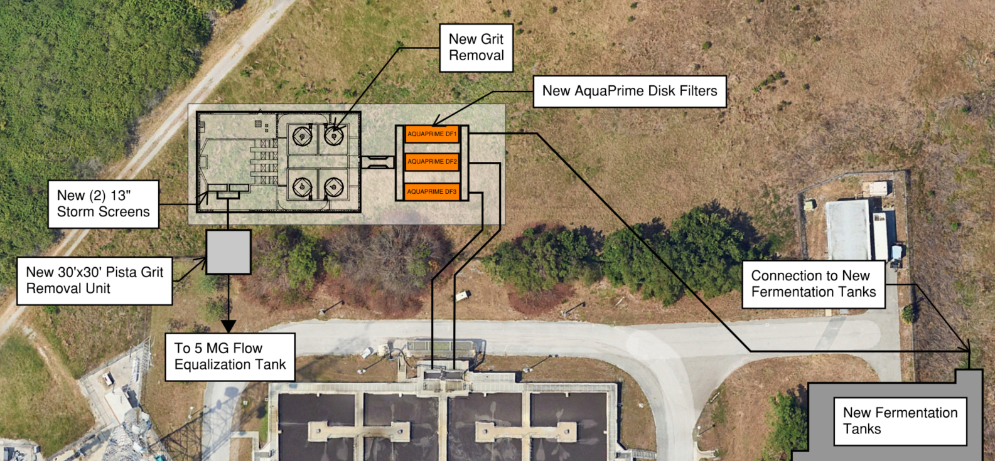
Figure 4-2 Alternative No. 3 Proposed Headworks and Storm Screen/Grit System at NEWRF

Primary Treatment
Primary treatment will be designed for 100 percent of the 20.68 MGD maximum month (MM) flow rate and will be consistent for all three alternatives.
The NEWRF currently has three Salsnes primary filter units, each with a capacity of 2.5 MGD (1,736 gpm). To accommodate for the planned consolidation, a total of 10 units (nine duty and one standby) will be required to treat the increased flow, necessitating the addition of seven additional units. However, installing 10 Salsnes filter units results in a very large footprint and increased equipment maintenance costs. To address these challenges, Black & Veatch evaluated AquaPrime disk filters as an alternative for primary filtration technology. The two filter systems were evaluated based on efficiency, footprint, capacity, maintenance, ease of operation, safety, and sustainability.
Upon analysis, Black & Veatch recommends using AquaPrime disk filters or other approved, equivalent technology for primary filtration to offer higher solids removal efficiency, better hydraulic capacity, and reduced operational complexity. AquaPrime (or other approved, equivalent technology) requires fewer units than the Salsnes system, resulting in a smaller footprint and less maintenance requirements. Additionally, Salsnes filters are generally maintenance intensive and include parts specifically made in Europe, whereas the AquaPrime system requires less mechanical maintenance and are manufactured in Illinois. Further consideration will be made during design to confirm the City’s selection on technology.

Biological Treatment Expansion Evaluation
NEWRF currently utilizes a 5-stage Bardenpho activated sludge process for biological removal of nutrients. To accommodate for the planned consolidation, the three alternatives were evaluated for biological treatment expansion needs.

Alternative 1 – Base Case (5-Stage Bardenpho) – 32 MGD Peak Flow
To expand the facility from 13.5 MGD AADF to 16 MGD AADF, an additional identical process train will be needed. The new train will be located to the east of the existing trains. Although a third identical BNR train can increase treatment capacity by 50 percent, process equipment such as aeration will be sized for 16 MGD AADF for all three BNR trains. The City can implement improvements to the aeration system to increase BNR treatment capacity beyond 16 MGD AADF, as needed, after the 2045 planning horizon. Table 4-3 summarizes the key process sizing criteria for the reactors.
Table 4-3 Proposed Bardenpho Process Sizing
Process/Equipment | Units | Existing | Proposed (Additional)
Fermentation Tank
Number of tanks | - | 4 | 2
Volume, each | gal | 275,000
Volume, total | gal | 1,650,000
Total number of mixers | - | 4 | 2
Type | - | Platform-Mounted Vertical Propeller Mixers
Motor rating, each | hp | 2
First Anoxic
Number of tanks | - | 4 | 2
Volume, each | gal | 440,000
Volume, total | gal | 2,640,000
Total number of mixers | - | 4 | 2
Type | - | Platform-Mounted Vertical Propeller Mixers
Motor rating, each | hp | 5
Intermediate Pump Station
Total number of Archimedes screw pumps | - | 5 | 0
Capacity, each | gpm | 22,150 | -
Motor rating, each | hp | 125 | -
Total number of dry pit submersible pumps | - | 3 | 4
Capacity, each | gpm | 1,030 | 6,900
Motor rating, each | hp | 135 | 300
Total number of jockey pumps |  | 0 | 2
Capacity, each | gpm | - | 2,100
Carousel Oxidation Ditch
Number of tanks | - | 2 | 1
Volume, each | gal | 1,690,000
Volume, total | gal | 5,070,000
Second Anoxic Tank
Number of tanks | - | 10 | 2
Volume, each | gal | 190,740 | 476,850
Volume, total | gal | 2,861,100
Total number of mixers | - | 20 | 2
Type | - | Bridge mounted vertical propeller mixers
Motor rating, each | hp | 1 | 1
Reaeration Tank
Number of tanks | - | 10 | 1
Volume, each | gal | 30,855 | 154,275
Volume, total | gal | 462,825

The current aeration system is comprised of two 125 horsepower (hp), two-speed surface aerators in each of the carrousel oxidation ditches with air provided to the reaeration basins via two 150 hp multistage centrifugal blower units. To expand the aeration system for the oxidation ditches, three alternatives were evaluated:
- Option 1
  - Only surface aerators, two per oxidation ditch – six total.
  - Replace the existing four 125 hp surface aerators with 250 hp surface aerators.
  - No diffused aeration system with blowers would be needed.
- Option 2
  - Combination of surface aerators (2 additional) and fine bubble diffused aeration systems (2,120 per oxidation ditch).
  - Existing surface aerators will be kept in the existing two oxidation ditches and a supplemental diffused aeration system provided which will consist of fine bubble diffusers and multistage centrifugal blowers. Specific blower type will be considered during design.
  - The new oxidation ditches will be equipped with two 125 hp surface aerators and supplemental fine bubble diffused aeration system.
  - The supplemental fine bubble diffused aeration system for the existing and new oxidation ditches will use common multistage centrifugal blowers (three duty, one standby).
- Option 3
  - The surface aerators in the existing two oxidation ditches will be replaced with fine bubble diffused aeration system to provide 100 percent of the process oxygen demand.
  - The new oxidation ditch will be equipped with a fine bubble diffused aeration system (4,158 per oxidation ditch).
  - Mixers will be installed in the new and existing oxidation ditches to provide a minimum of 1 fps velocity for the mixed liquor (four per oxidation ditch).
  - The new and existing oxidation ditches will share common multistage centrifugal blowers (four duty, one standby).
For the reaeration basins, aeration sizing showed that 150 hp per train provided enough capacity to meet the hp required at equalized peak flow.
In addition to aeration evaluations, secondary clarifier capacity was assessed with State Point Analysis (SPA). By considering the major factors affecting clarifier performance (forward flow, MLSS, RAS flow, SVI, and clarifier side wall depth), insight is provided into the full operating envelope and an array of analysis valuable to planning, design, and operation is supported.
The SPA was performed in conjunction with process simulations to evaluate the clarifier capacity. The Daigger 1995 and Daigger and Roper (SVI) Vesilind parameter correlations with SVI were utilized. It is important to note that while each train has a capacity of 6.75 MGD, the evaluation was conducted according to a projected flow rate of 5.33 MGD AADF per train, totaling 16 MGD AADF for three trains. For the new train, Black & Veatch proposed two 120-foot diameter clarifiers to facilitate construction, simplify operation, save on costs, and provide sufficient redundancy. Table 4-4 outlines the sizing of these proposed clarifiers as well as associated process equipment.
Table 4-4 Secondary Clarifier Sizing Summary – Alt. No. 1 – Base Case (5-Stage Bardenpho) – 32 MGD Peak Flow
Process/Equipment | Units | Existing | Proposed
Secondary Clarifiers
Number | - | 8 | 2
Style | - | Circular, center-fed
Diameter | ft | 75 | 120
Side water depth | ft | 12
Surface area, each | ft² | 4,418 | 11,310
Surface area, total | ft² | 57,964
Surface overflow rate, all units in service at equalized peak flow | gpd/ft² | 980
Surface overflow rate, largest unit out of service at 75% of the equalized peak flow | gpd/ft² | 1,050
Solids loading rate, all units in service at equalized peak flow and MLSS of 3,500 mg/L | lbs/day/ft² | 29
Solids loading rate, largest unit of service at equalized peak flow and MLSS of 3,500 mg/L | lbs/day/ft² | 36
Secondary Clarifier Scum Pumps
Number | - | 4 | 2 (1 duty, 1 standby)
Type | - | Pneumatic ejectors
Capacity, each | gpm | 30
RAS Pumps
Number | - | 4 | 2 (1 duty, 1 standby)
Type | - | Flygt Centrifugal
Capacity, each | gpm | 4,700
Motor rating, each | hp | 50
WAS Pumps
Number | - | 4 | 2 (1 duty, 1 standby)
Type | - | Progressive cavity
Capacity, each | gpm | 200
Motor rating, each | hp | 10

Alternative No. 2 – MOB System (Nuvoda) Expansion – 32 MGD Peak Flow
The MOB System is an advanced biological wastewater treatment technology that enhances conventional activated sludge systems. It utilizes mobile biofilm carriers made from naturally occurring, biodegradable organic material, which supports the growth of a robust microbial community. The media core acts as an organically ballasted granular sludge and fixed film hybrid system. The media is retained in the system by a rotary screen that separate the media from the WAS and sends it back to the BNR treatment process. The MOB System is implemented for process intensification and enhancement of treatment efficiency. By intensifying biological treatment in the existing infrastructure, the MOB process allows WRFs to achieve higher treatment capacity and improved effluent quality without the addition of new basins. Nuvoda’s preliminary design parameters for the system, requested by Black & Veatch, is presented in Table 4-5.
Table 4-5 Nuvoda MOB System Preliminary Design Parameters at MM Flows and Loads
Item | Units | Value
MOB System Properties
Fill rate | % | 1.25
Media dry density | kg/m³ | 263
Media specific gravity (wet) | - | 1.056
Carrier media surface area | m² | 1,290,000
Operation Design Parameters
Dissolved oxygen in aerobic basins | mg/L | 2
Minimum velocity for mixing | ft/s | 1.64
Wastewater temperature | °C | 20
RAS | % Inf | 60
WAS - mass flow rate | lb/day | 30,400
Internal recycle | % Inf | 350
External carbon dose | gal/d | 0
Alum/ferric dose | gal/d | 0
MLSS
Biofilm | mg/L | 410
Biocarrier | mg/L | 1,430
Suspended biomass | mg/L | 2,360
Total | mg/L | 4,200
Total suspended growth SRT | days | 5.5
The proposed aeration system for the oxidation ditches, designed to integrate effectively with the Nuvoda MOB system, would include the following components:
- Combination of surface aerators and fine bubble diffused aeration systems.
- Existing surface aerators kept in the existing two oxidation ditches and a supplemental diffused aeration system provided consisting of fine bubble diffusers (3,820 per oxidation ditch) and multistage centrifugal blowers (two duty, one standby).
For the reaeration basins, aeration sizing showed that 150 hp and 320 diffusers per train provide enough capacity to meet the hp required at equalized peak flow.
In addition to aeration evaluations, secondary clarifier capacity was again assessed with SPA utilizing the Daigger 1995 and Daigger and Roper (SVI) Vesilind parameter correlations with SVI. The Nuvoda MOB System promotes the formation of dense, granular sludge, which settles faster and more effectively than traditional sludge. As a result, SVI is expected to decrease, and a lower SVI of 100 mL/g was used for the SPA. In this alternative, MLSS concentration can remain low, as biomass will be retained on Kenaf biocarriers, minimizing settling concerns. To meet the hydraulic demands of this alternative, Black & Veatch proposed adding two new secondary clarifiers, each with a 75-foot diameter, to alleviate hydraulic pressure and prevent flow backups. Table 4-6 outlines the sizing of these proposed clarifiers as well as associated process equipment.
Table 4-6 Secondary Clarifier Sizing Summary – Alt. No. 2 – MOB System (Nuvoda) Expansion – 32 MGD Peak Flow
Process/Equipment | Units | Existing | Proposed (Additional)
Secondary Clarifiers
Number | - | 8 | 2
Style | - | Circular, center-fed
Diameter | ft | 75
Side water depth | ft | 10
Surface area, each | ft² | 4,418
Surface area, total | ft² | 44,180
Surface overflow rate, all units in service at equalized peak flow | gpd/ft² | 1,132
Surface overflow rate, largest unit out of service at 75% of the equalized peak flow | gpd/ft² | 1,056
Solids loading rate, all units in service at equalized peak flow and MLSS of 3,500 mg/L | lb/day/ ft² | 33
Solids loading rate, largest unit out of service at 75% of the equalized peak and MLSS of 3,500 mg/L | lb/day/ ft² | 31
Secondary Clarifier Scum Pumps
Number | - | 4 | 2 (1 duty, 1 standby)
Type | - | Pneumatic ejectors
Capacity, each | gpm | 30
RAS Pumps
Number | - | 4 | 2 (1 duty, 1 standby)
Type | - | Flygt Centrifugal
Capacity, each | gpm | 4,700
Motor rating, each | hp | 50
WAS Pumps
Number | - | 4 | 2 (1 duty, 2 standby)
Type | - | Progressive cavity
Capacity, each | gpm | 200
Motor rating, each | hp | 10
Biomedia Retention Rotary Screen
Number | - | 0 | 6 (3 duty, 3 standby)
Type | - | 500-micron Wedge Wire Drums

Alternative No. 3 – Base Case (5-Stage Bardenpho) – 37.33 MGD Peak Flow
Alt. No. 3 – Base Case (5-Stage Bardenpho) – 37.33 MGD Peak Flow is identical to Alt. No. 1 – Base Case (5-Stage Bardenpho) – 32 MGD Peak Flow, but includes a new headworks and filter building, which will help overcome the hydraulic limits of the existing headworks and allow for a higher peak flow of 37.33 MGD, compared to 32 MGD. Thus, the aeration evaluation will follow that of Alternative No. 1.
A SPA was performed in conjunction with process simulations to evaluate the clarifier capacity. The Daigger 1995 and Daigger & Roper (SVI) Vesilind parameter correlations with SVI were utilized. It is important to note that while each train has a capacity of 6.75 MGD, the evaluation was conducted according to a projected flow rate of 5.33 MGD AADF per train, totaling 16 MGD AADF for three trains. For the new train, Black & Veatch proposes two 120-foot diameter clarifiers. Table 4-7 outlines the sizing of these proposed clarifiers as well as associated process equipment.
Table 4-7 Secondary Clarifier Sizing Summary – Alternative No 3
Process/Equipment | Units | Existing | Proposed
Secondary Clarifiers
Number | - | 8 | 2
Style | - | Circular, center-fed
Diameter | ft | 75 | 120
Side water depth | ft | 12
Surface area, each | ft² | 4,418 | 11,310
Surface area, total | ft² | 57,964
Surface overflow rate, all units in service at equalized peak flow | gpd/ft² | 1,060
Surface overflow rate, largest unit out of service at 75% equalized peak flow | gpd/ft² | 1,115
Solids loading rate, all units in service at equalized peak flow and MLSS of 3,500 mg/L | lbs/day/ ft² | 31
Solids loading rate, largest unit out of service at 75% of the equalized peak flow and MLSS of 3,500 mg/L | lbs/day/ ft² | 38
Secondary Clarifier Scum Pumps
Number | - | 4 | 2 (1duty, 1 standby)
Type | - | Pneumatic ejectors
Capacity, each | gpm | 30
RAS Pumps
Number | - | 4 | 2 (1 duty, 1 standby)
Type | - | Flygt Centrifugal
Capacity, each | gpm | 4,700
Motor rating, each | hp | 50
WAS Pumps
Number | - | 4 | 2 (1 duty, 1 standby)
Type | - | Progressive cavity
Capacity, each | gpm | 200
Motor rating, each | hp | 10

Tertiary Treatment Expansion Evaluation
The NEWRF currently has 12 units of shallow-bed, single media, gravity sand filters. Filters 7 and 8 are out of service due to defective air lines, filters 3 and 9 are losing sand media, filter 5’s backwash/filtrate valve assemblies are corroded, the filter 4 gate valve is leaking, and the 12 fiberglass inlet boxes show deterioration.
Filters are evaluated according to the hydraulic loading rate (HLR). For this type of filter, a peak HLR of less than 5.0 gpm/ft² is recommended. The existing filters will be able to handle AADF conditions, but under the PHF conditions, the HLR exceeds 5.0 gpm/ft². The SLRs were calculated with an effluent TSS target of less than 5 mg/L. The average and peak TSS at the filter influent were assumed to be 15 and 30 mg/L, respectively, based on industry standards.
Class I reliability standards require that the filter system provide at least 75 percent of total design capacity with the largest unit out of service. The existing filters have sufficient capacity to meet Class I reliability for filtration under 24 MGD (75 percent of PHF) flow conditions. Additional reliability can be considered during design, if desired by the City.
The existing filters require expansion because of NEWRF’s existing hydraulic configuration. The filtration capacity expansion alternatives investigated included:
- Expansion using existing technology
- Replacing the existing technology with a cloth media filtration technology
The existing shallow-bed filters have hydraulic bottlenecks and a semi-automated cleaning process. In contrast, the proposed cloth media filters have an automated backwash system requiring less involvement from operators as well as a smaller footprint. It is recommended that the City evaluate the replacement of the existing shallow-bed filters with cloth media filters when the existing filters are near the end of service life, which is estimated to be 2032. Additionally, during design, consideration can be made to use the same filters for primary filtration as tertiary filtration. This consideration has potential savings with respect to spare parts and maintenance costs.

Chlorine Contact Basins Evaluation
The NEWRF is required to meet high-level disinfection (HLD) requirements for unrestricted, public access reclaimed water. The facility has two CCCs and uses liquid sodium hypochlorite for effluent disinfection. The Florida Administrative Codes specify minimum total residual chlorine of 1.0 mg/L and minimum chlorine contact time of 15 minutes for HLD. Existing tankage can provide 15 minutes of contact time for PHFs up to 48 MGD. The existing CCCs have enough capacity to meet the contact time requirement and Class I reliability for PHFs up to 48 MGD.

Hydraulic System Modifications for Expansion
The hydraulic profile model was updated for the future maximum flow of 32 MGD for Alternatives No. 1 and 2 and 37.33 MGD for Alternative No. 3 based on the process and equalization recommendations presented. Although downstream treatment processes affect the upstream water surface elevations, the hydraulic impacts are presented below from upstream to downstream processes for consistency with the previous sections.

Headworks and Primary Treatment
For Alternatives No. 1 and 2, the observed headworks structure’s hydraulic impacts are based on downstream treatment units using gravity flow (i.e., AquaPrime disk filters/other approved technology or primary treatment bypass). As the headworks structure can pass a total flow of 32 MGD without observed overflows with a freeboard at the screens of 0.3 feet, it is recommended that future improvements provide a curb for added freeboard protection. The grit system effluent weir is submerged above 27 MGD; thus, it is recommended the weir be raised 0.5 feet so it may flow freely at 32 MGD.
For Alternative No. 3, a new headworks building is recommended because of the hydraulic limitations of the existing facility. The headwork facility location is recommended to be north of the existing fermentation tanks to optimize the headloss of the system as flow passes through headworks to primary filtration and the biological treatment system. Currently, the existing headworks receives flow from three lift stations (LS), LS-58, LS-42, and LS-53, located in the collection system. LS-46 also pumps into the force main connecting NEWRF to LS-58 and was considered in the evaluation. To relocate the new headworks facility north of the fermentation tanks, collection system piping modifications on the discharge side of the lift stations are needed to reroute the flow to the new location based on a water surface elevation level (WSEL) of 72 feet based on a preliminary gravity hydraulic model of the proposed layout. The collection system hydraulic model was ran using the 25-year, 24-hour 2050 storm event and included updates to the piping configuration rerouted to the new location. The results were compared to the same storm under existing conditions. Model results identified three manholes demonstrating cautionary surcharge depth in the collection system when pumping to the new headworks location; however, no overflows are predicted beyond those already modeled in the existing 2050 model run. The hydraulic modeling and considerations of piping layout and diameter during design supports the feasibility of the new headworks location with respect to the collection system’s capability to transport flow to that location and elevation. Further consideration may be taken with respect to expanding the hydraulic capacity of the existing headworks, as the expanded system will need to tie into the energy grade line of the system. Therefore, limitations of the existing system described below will still apply to an expanded, existing headworks.
As described in Section 4.3.2, AquaPrime disk filters or other approved, equivalent technology are recommended for Alternatives No. 1 and 2 primary treatment. AquaPrime disk filters or other approved, equivalent technology can be installed downstream of the Parshall flume, and the system hydraulics may allow for the filters to operate using gravity flow depending on the final configuration and total headloss at peak flow. If the total Hydraulic Grade Line (HGL) drop required is higher than 2.5 feet between the WSEL downstream of the grit effluent weir and the WSEL at the primary filters effluent channel to fermentation tanks, additional hydraulic modifications or pumping may be required.

Biological Treatment
In Alternative No. 1, an additional 5-stage Bardenpho train would reduce the total flow going through each set of trains and eliminate hydraulic constraints in the existing trains for the new peak flow condition. No hydraulic improvements are foreseen for this option other than the proposed hydraulic components of the new train, including pumping units. The new treatment system would be designed to comply with the existing hydraulic constraints or controlling elevations at the flow splitting points.
The implementation of the MOB system in Alternative No. 2 would not require additional biological reactor units for treatment; however, the existing system has hydraulic limitations that would require the improvements listed in Table 4-8 for adequate hydraulic performance and redundancy considerations.
For Alternative No. 3, the proposed peak facility capacity of 37.33 MGD would require an additional treatment train which would reduce the total flow going through each set of trains by 2.11 MGD. The hydraulic model was updated based on the peak flow condition to observe hydraulic challenges based on the existing system’s configuration. The model identified that the second anoxic tank effluent weir is predicted to be submerged at the future PHF of 24.89 MGD. It is recommended that the weir be raised by 3 inches to eliminate hydraulic challenges without affecting upstream freeboard conditions significantly. Additionally, the secondary clarifier effluent from both the existing secondary clarifiers and the new secondary clarifiers will combine at a new intermediate pump station to convey the flow to the new tertiary filter location. The future pump configuration can be a set of large and smaller pumps: 4 x 9.2 MGD pumps and 2 x 4.9 MGD pumps can be provided for a firm capacity of 37.4 MGD and better control over all flow ranges.

Tertiary Treatment
As described in Section 4.5, replacement of the existing shallow-bed filters with cloth media filters when the existing filters are near the end of service life estimated is the recommended tertiary treatment approach for Alternative No. 1 and 2. Replacement of the existing filter technology with new filters would meet the hydraulic requirements by building the new system elevations to meet the new system head demands. The filtered effluent would be pumped using new pumps to match the new suction and discharge conditions. The specific hydraulic requirements would be developed during the basis of design phase.

Chlorine Contact Chambers
There are six high service pumps installed at the CCC clearwell. Pumps 2, 3, 6, and 7 are rated for 3,500 gpm or 5.04 MGD and 175 feet of head at 1,180 rpm. Pumps 4 and 8 are rated for 1,750 gpm or 2.52 MGD and 175 feet of head at 1,750 rpm.
The analysis for Alternatives No. 1 and 2 shows that under new peak flow conditions, two additional pumps at the designated future locations shall be provided with the same capacity as the large pumps (5.04 MGD), and the smaller existing pumps should be upsized to a capacity of 3.5 MGD each for a total firm capacity of 32.2 MGD.
The analysis for Alternative No. 3 shows that under new peak flow conditions, the future pump configuration can maintain the existing four 5.04 MGD pumps and add four 5.75 MGD pumps, two of which would replace the existing smaller pumps.
Table 4-8 Recommended Hydraulic Improvements - Alternative No. 2
Observation | Recommendation
Influent weir for fermentation tanks is submerged at the peak flow condition. | The existing influent gate located downstream of the weir can be widened from 4 feet to 6 feet. This eliminates the weir drowning condition.
The existing screw pumps and submersible oxidation ditch pumps provide a firm capacity of 127.6 MGD. At peak flow, the plant flow, plus IR and RAS, are not expected to exceed 112 MGD. | No improvements needed.
Effluent weir for the oxidation ditches (El. 69.00 feet) is submerged at the peak flow condition. The flow split was modeled using 10 out of 10 units in service. | The weir can be raised to 69.50 feet, and at this elevation, the weir would flow freely at 32 MGD. The available freeboard would be 1 foot and considered acceptable.
Effluent weir for the second anoxic and reaeration tanks is submerged at peak condition, and freeboard is observed at 0.8 foot. The flow split was modeled using 10 out of 10 units in service. | The weir can be raised to 64.4 feet and at this elevation, the weir would flow freely at 32 MGD. The available freeboard would be 1.6 feet and considered acceptable. It is worth noting that the influent is controlled via 24-inch telescoping valves which appear to be normally submerged and may not provide even flow split through the units. Even flow split may not be feasible because it can raise the HGL and cause freeboard issues upstream.
Weirs for the final clarifiers (crest El. 63.25 feet) are submerged at 27 MGD.  Additionally, it was observed that the existing clarifier flow splitter structure does not effectively split the flow evenly into the clarifiers. | Two additional clarifiers can be added to improve the hydraulic conditions on both the influent and effluent components of the clarifiers and reduce the hydraulic impacts on upstream units (second anoxic and reaeration tanks).  Future improvements can be considered for providing effective flow split amongst the units.
Clarifiers 1 through 4 are connected to the north RAS pump house. Clarifiers 5 through 8 are connected to the south RAS pump house. There are two pumps per pump station: 1 duty, 1 standby. The capacity of each pump is 4,700 gpm or 6.7 MGD and 29 feet of head at 1,190 revolutions per minute (rpm). The future RAS flows would require additional RAS pumping capacity for the new clarifiers. | For two new additional clarifiers under the Nuvoda treatment option, a new RAS station is required with two 3.2 MGD pumps: 1 duty, 1 standby. The total firm capacity of 6.7 MGD at each of the existing RAS stations, plus 3.2 MGD at the new RAS station, would provide a combined firm capacity of 16.6 MGD.
Clarifiers 1 through 4 are connected to the north WAS pump house. Clarifiers 5 through 8 are connected to the south WAS pump house. There are two pumps per pump station: 1 duty, 1 standby. The capacity of each pump is 200 gpm. | For two new additional clarifiers under the Nuvoda treatment option, a new WAS station is required with two 200 gpm pumps.

Biosolids
The NEWRF uses anaerobic digestion to stabilize the solids generated in the water reclamation process. The stabilization process reduces the volatile solids concentration, and as a result, the pathogen concentration in the material. The digested solids can meet EPA and FDEP Class B Pathogen Reduction Requirements. These requirements, in combination, with meeting the required quality characteristics allow the resulting biosolids to be used in agricultural land application programs. The digested biosolids are currently dewatered and managed by a third-party contractor.
Attachment 1 evaluated four biosolids management alternatives. The City selected direct thermal drying of stabilized, dewatered biosolids cake in association with an RMF.
To participate in the regional drying facility, the City will reinitiate anaerobic digestion at the NEWRF and continue dewatering to deliver a stabilized, dewatered cake to the drying facility. The City intends to use the methane generated during the digestion process to heat the digesters and generate electricity for use on-site.
The subsequent sections provide information regarding the solids handling improvements that are required to manage the additional solids generated following the expansion of NEWRF. The following processes were evaluated to determine if they required expansion or upgrading:
- Anaerobic Digestion
- Solids Blending
- Dewatering

Anaerobic Digestion
The NEWRF currently has a primary and secondary digester to stabilize its solids. The existing primary digester is currently being refurbished. The smaller, secondary digester, which is not heated or mixed, is also currently off-line, but will be refurbished and brought back online following the upgrades to the existing primary digester.
The City would like to avoid primary solids thickening as part of the solids handling improvements. To determine if the City can avoid thickening the primary solids, the required capacity of the anaerobic digestion system was estimated with and without primary solids thickening.
The required available primary digestion capacity, with the largest digester off-line is 1,326,000 gallons with primary solids thickening and 1,777,000 gallons without primary solids thickening.
It is recommended that a second 1,260,000-gallon primary digester be constructed to complement the existing primary digester that is being refurbished. It is also recommended that digester heating and mixing be incorporated into the scope of the restoration of the existing secondary digester. This will allow the secondary digester to serve as a primary digester in the future when one of the two larger digesters is off-line. The two larger primary digesters will provide a combined volume of 2,520,000 gallons. The MM HRT with the two large digesters online will be 21 days. The design criteria for the anaerobic digestion system including the anticipated performance (based on a Volatile Solids Reduction [VSR] of 38 percent) are shown in Table 4-9.
Table 4-9 New Primary Anaerobic Digester - Design Criteria
Equipment | Units | Value
MM Solids Generation
Primary solids | dlb/d | 17,500
WAS | dlb/d | 21,300
Total | dlb/d | 38,800
WAS Thickening
Thickening capture rate | % | 95
Thickened WAS | dlb/d | 20,200
Total | dlb/d | 37,700
Solids Production
Primary solids, total solids | % TS | 3.0
Thickened WAS, total solids | % TS | 5.0
Dry solids volume | gpd | 69,900
Thickened WAS volume | gpd | 49,000
Total | gpd | 118,500
HRT
MM design year HRT | days | 15
Required volume | gal | 1,777,000
Estimated HRT average annual design year solids generation | days | 19.5
Proposed Digester Volume
Number of new primary digesters | - | 1
Number of existing primary digesters | - | 1
Conversion of secondary digester to primary digester | - | 1
Total number of primary digesters at buildout | - | 3
Volume of existing primary digester | gal | 1,260,000
Volume of new primary digester | gal | 1,260,000
Volume of converted secondary digester to primary digester | gal | 658,000
Total digester volume | gal | 3,178,000
Volumetric Loading of Volatile Solids
Water Environment Federation recommended volatile SLR | lb/d/ft³ | 0.12 to 0.16
Volatile Solids Concentration
Primary solids | % | 82.8
Thickened WAS | % | 76.8
MM volatile solids loading
Primary solids, volatile solids | dlb/d | 14,500
Thickened WAS, volatile solids | dlb/d | 15,500
Total MM VS | dlb/d | 30,000
MM Volatile Solids Loading
Existing anaerobic digester (1.26 MG) (168,450 ft³) | lb/d/ft³ | 0.18
Large anaerobic + converted secondary digester (1.92MG) (256,420ft³) | lb/d/ft³ | 0.12
Diameter | ft | 90
Side water depth | ft | 26.5
Volume | gal | 1,260,000
Digester Performance
Performance estimated at 38% and 50% VSR
Lower VSR used to calculated solids loading for dewatering
At 50% VSR
Fixed solids to digestion | dlb/d | 7,700
Volatile solids to digestion | dlb/d | 30,000
Fixed solids following digestion | dlb/d | 7,700
Volatile solids following digestion | dlb/d | 15,000
Total digested solids | dlb/d | 22,700
Anticipated volume | gal/d | 118,500
Anticipated solids concentration | % | 2.3
At 38% VSR
Fixed solids to digestion | dlb/d | 7,700
Volatile solids to digestion | dlb/d | 30,000
Fixed solids following digestion | dlb/d | 7,700
Volatile solids following digestion | dlb/d | 18,600
Total digested solids | dlb/d | 26,300
Anticipated volume | gal/d | 118,500
Anticipated solids concentration | % | 2.7

Solids Blending and Storage Tanks
Currently, the NEWRF has two solids holding tanks. Each tank has a 40-foot diameter and 16.5-foot side water depth. The volume of each tank is 155,100 gallons. The tanks were refurbished in 2021 and commissioned in 2022. The tanks will provide storage prior to digestion and dewatering with one of the tanks used to blend the primary solids and WAS before the solids are fed to the anaerobic digesters. The volume of the combined unthickened primary solids and TWAS will be approximately 118,500 gpd. The second tank is used to store digested solids prior to dewatering.
The City may want to consider other storage configurations with the two tanks prior to digestion or dewatering to enhance their overall operational flexibility. The addition of a second primary digester paired with the refurbished secondary digester would provide flexibility prior to the dewatering process.

Biosolids Dewatering
NEWRF currently uses a single centrifuge and two, 2-meter belt filter presses (BFPs) to dewater their solids. The BFPs are used to provide backup capacity to the centrifuge. It is anticipated that a centrifuge dewatering system will remain the primary dewatering process.
The City prefers to operate the dewatering system in a single shift, 5 days each week and anticipates 7 hours of active dewatering per shift. The remaining hour in the shift will be used for dewatering system start up and shut down. Thus, Black & Veatch considered two dewatering system configurations to provide dewatering capacity to meet shift preferences:
- Install two additional centrifuges, similar in size to the existing centrifuge to provide adequate dewatering capacity for the MM design year loading with all three centrifuges operating. The existing BFPs would be used to provide system redundancy.
- Install two additional centrifuges large enough to provide adequate dewatering capacity for the MM design year loading with the two new centrifuges operating. The existing centrifuge and an increase in dewatering shift duration would provide redundancy when one of the large centrifuges is offline for maintenance.
Based on the condition of the existing BFPs and the flexibility of installing new equipment following removal of the BFPs, it is recommended that the City install the two larger centrifuges, 2,450 dlbs/op hr each and extend the operating hours when a larger centrifuge needs to be off-line, and the facility is nearing the design year loading rates.
While the equipment sizing has been based on a 35-operating hour per week schedule, it is recommended that City consider at least two single shift operating schedules; 7 or 8 hours of operation per shift. That will allow the City to determine if the shift length impacts the final centrifuge sizing. Additionally, to optimize equipment sizing, the City may consider that the NEWRF dewatering equipment be operated 8 hours each of 5 dewatering days during MM design year conditions.
The new centrifuges will be located in the current dewatering building or in a structure adjacent to it with the existing BFPs removed to provide additional space for the centrifuges.
The design criteria for the recommended dewatering improvements are presented in Table 4-10.

Table 4-10 New Centrifuge Dewatering - Design Criteria
Equipment | Units | Value
Biosolids Dewatering
MM digested biosolids to dewatering
Anticipating 38% VSR
Digested Biosolids | dlb/d | 26,300
Total Solids Concentration | % | 2.7
Anticipating 50% VSR
Digested Biosolids | dlb/d | 22,700
Total Solids Concentration | % | 2.2
Estimated Average VSR | % | 44
Digested Biosolids | dlb/d | 24,500
Total solids concentration | % | 2.5
Operating days per week | days | 5
Operating shifts per operating day | shifts | 1
Operating hours per shift | hr | 7
Operating hours per week | op hrs/wk | 35
Dewatering Capacity Requirement
Biosolids to dewatering | dlb/ op day | 34,300
 | dlb/ op hr | 4,900
 | wlb/ op hr | 200,000
 | gal/op hr | 24,000
 | gpm/op hr | 400
Existing Dewatering Equipment Capacity
Number of centrifuges | - | 1
Centrifuge capacity | gpm/op hr | 150
 | dlb/hr | 1,800
Total Existing Dewatering Equipment Capacity
Existing centrifuge | dlb/hr | 1,800
Existing BFPs (used to back up centrifuge) | dlb/hr | 2,880
Total existing dewatering capacity | dlb/hr | 4,680
New Dewatering Equipment
Number of centrifuges |  | 2
Centrifuge capacity | dlb/op hr | 2,450
Total solids to dewatering | % | 2.5
Centrifuge capacity | wlb/ op hr | 98,000
Centrifuge capacity | gpm/op hr | 200
Total Dewatering Capacity
Total existing centrifuge capacity | dlb/op hr | 1,800
Two new dewatering centrifuges | dlb/op hr | 4,900
Total dewatering capacity | dlb/op hr | 6,700
MM design year dewatering requirement | dlb/op hr | 4,900
Required Operating Hours with One Large Centrifuge Offline
Biosolids to dewatering | dlb/week | 171,500
Existing centrifuge capacity | dlb/op hr | 1,800
New centrifuge capacity | dlb/op hr/ea. | 2,450
Total dewatering capacity | dld/op hr | 4,250
Required operating hours with one large centrifuge offline | hr | 40.4

Chemical Optimization
Chemical optimization at NEWRF was studied to identify potential capacity needs. The facility currently has two 8,600-gallon sodium hypochlorite storage tanks with a total volume of 17,200 gallons. Based on review of chemical use data starting from January 1, 2022, through December 20, 2022, the sodium hypochlorite feed rate is 636 gpd. The NEWRF’s average daily flow rate for this period was 5 MGD, so the sodium hypochlorite feed rate was estimated to be 2,035 gpd for 16 MGD AADF, meaning the existing storage tanks have capacity to store only 8.5 days of chemical at the current demand. Recommended sizing criteria for sodium hypochlorite chemical storage is 30 days at average-day use, thus additional sodium hypochlorite storage tanks are needed. The capacities of the hypochlorite storage tanks are shown in Table 4-11.
Table 4-11 Sodium Hypochlorite Storage Tank Capacity Evaluation
Parameter | Units | Value
Parameter | Units | Existing | Proposed
Sodium hypochlorite feed rate | gpd | 2,035
Storage time at 16 MGD AADF | day | 30
Recommended sodium hypochlorite storage | gal | 61,056
Number of existing tanks | — | 2 | 3
Each tank volume | gal | 8,600 | 17,200
Total tank volume | gal | 68,800

Energy Optimization
An energy optimization study evaluated the City's current energy usage, focusing on key equipment at NEWRF: surface aerators, screw pumps, IR pumps, and filter effluent pumps. These components were chosen for their significant energy consumption.

Aeration System
The facility's surface aerators are currently located in the oxidation ditches in the northern portion of the NEWRF. The facility's re-aeration blowers are in the blower building, in the central west region of NEWRF.
The results of the energy evaluation of the aeration technologies discussed in Section 4.4 are presented in Attachment C, with the City’s selected option identified in Section 5 of this report.

Screw and Internal Recycle Pumps
The facility's northern region contains five screw pumps, with an average of two used daily. Each pump has a capacity of 32 MGD, lifting water 18 feet, and features an 84-inch diameter, 125 hp motor, and constant speed drive.
East of the screw pumps are the unused IR pumps, installed as a bypass during screw lift rehabilitation. There is space for eight submersible pumps, but only three are installed, each with Variable Frequency Drives (VFDs), a 125 hp motor, and a total head of 35 feet.
The annual energy cost (in 2025 dollars) of the screw pumps and IR pumps is $88,000 and $136,000, respectively. Energy use can be further reduced by installing VFDs or multi-speed drives to better match the required capacity. Therefore, no changes are needed to move the flow to the IR station.

Filter Effluent Pumps
The filter effluent pumps are located in the southern part of the facility. The current system utilizes three pumps that were installed for previous flow conditions. Currently, one pump is used to meet the average flow conditions of 5.5 MGD.
The proposed system will include four pumps at 8 MGD and two pumps at 4 MGD. However, only two pumps at 8 MGD will be needed to meet the daily average flow conditions.
The annual energy cost (in 2025 dollars) of the existing system and proposed system is $47,000 ($8,500 per MGD) and $24,000 ($1,500 per MGD), respectively. The proposed improvements will reduce the head from 67 feet to the required 25 feet. When pumps are due for replacement, the City should consider pumps that better match operating conditions, as the current pumps are running at the end of their efficiency curve.

Sustainability Related Improvements
The City has adopted the Greenprint Plan to promote community sustainability. The plan was updated in 2021 with Clearwater Greenprint 2.0, focusing on climate change mitigation and community resilience. The report stresses the importance of evaluating risks and implementing adaptation measures to protect critical equipment and structures from flooding. The Envision Framework administered by the Institute for Sustainable Infrastructure is recommended for sustainable infrastructure improvements, offering guidelines for systemic change in planning and design as well as sustainability and resilience indicators to ensure long-term viability, cost-effectiveness, and positive impacts on the community and environment.
As part of this WRF Master Plan (PN 17-0007-UT), a climate vulnerability assessment was conducted for the City’s WRFs to evaluate flooding risks. The assessment considered FEMA flood zones, storm surge inundation maps, and future scenarios related to sea level rise and 100-year flood events. The EWRF and MSWRF are particularly vulnerable to flooding, with critical equipment at risk of damage. Adaptation strategies are recommended to protect equipment and ensure operational resilience during flood events, such as elevating equipment, installing protective barriers, and implementing flood walls. Recommendations also include elevating skid-mounted equipment, providing tie-downs for tanks, and installing watertight floor hatches to minimize flood damage and reduce downtime.
Special consideration for flood mitigation was considered. For EWRF and MSWRF, temporary flood mitigation was reviewed as part of the consolidation decision. For NEWRF, specific flood mitigation techniques were reviewed to recommend a more resilient system for future operations. The following is an overview of the recommendations provided.
- MSWRF – A temporary perimeter flood barrier is recommended, with Tiger Dam suggested for 3--foot-high barriers and Muscle Walls for 6-foot-high barriers. Detailed deployment procedures and cost estimates are provided for each option.
- EWRF – Similar to the MSWRF, a 6-foot-high barrier is proposed, with Muscle Walls identified as the recommended solution for ease of deployment and cost-effectiveness.
- NEWRF – Flood mitigation measures are detailed to safeguard critical infrastructure and enhance facility resilience. Specific recommendations for structural flood mitigation are provided in the document.
- Opinion of Probable Construction Cost – Estimated construction costs for flood protection options at each facility are outlined, with Tiger Dam and Muscle Wall identified as cost-effective solutions for the MSWRF and EWRF, respectively.
In addition to planning for coastal hazards resiliency, a cursory review was performed for various renewable energy generation, storage, and management technologies to reduce net energy usage and GHG emissions. Digester gas utilization was concluded to be the most feasible renewal energy application with benefits of the technology including GHG emissions reductions and potential revenue from renewable identification numbers with renewable gas injection to the grid. However, high upfront capital costs are associated with the technology and digester gas utilization typically require regular maintenance to ensure proper operation.
Photovoltaic (PV) solar and battery energy storage system (BESS) technologies were also explored for potential net benefits. A thorough review of energy bills and tariffs revealed no economic viability for BESS while ground mount PV solar was identified as a feasible option, though not profitable. Further coordination with Duke Energy as well as a detailed review of the connection of the solar array into the NEWRF electrical system is recommended.

Future Improvement Staffing Evaluation
As part of this WRF Master Plan, a benchmarking study was used to provide a staffing evaluation for the City’s WRFs. This benchmark comparison utilized the American Water Works Association (AWWA) “2022 Benchmarking Performance Indicator for Water and Wastewater Utilities: Survey Data and Analysis Report” (AWWA report). The AWWA report provided benchmark comparisons between utility operations within similar regions, populations, and as utilities on a nationwide scale. The 2022 report represents the performance results for the fiscal year 2021. The benchmarking process can be an indicator to determine if efficiencies need to be evaluated; however, it is important to remember that a specific performance metric may not be an indication of good or bad overall performance.
The 2022 AWWA report provided five regional divisions for the nationwide states and the Canadian and Guam regions. The state of Florida is identified with Region II. The complete benchmark comparison with Region II data is presented in Table 4-12. Compared to the Region II and wastewater utility, the current level of staffing is near the upper staffing percentile (75th percentile) for operations. However, for collections, the City is near the lower level of staffing percentile (25th percentile). When compared to the population, operations are still above the 75th percentile, but collections are closer to the median. The current staffing level aligns with the median when calibrated for the future of the facility. However, reallocating may balance the staff and allow for both divisions to be in the median for all the benchmarks.
Increasing the number of operators on staff is justified since the NEWRF will be expanding in size. A natural increase in workload will occur for the operators at the expanded facility. Through natural attrition of operators retiring and changing careers, the number of current operators would decrease, leaving the City with the appropriate number of operators to properly run the plant. The two decommissioned facilities will be converted to primary lift stations. These lift stations will be monitored on SCADA at the NEWRF; however, it would be beneficial for the operators to perform regular daily inspections on these facilities. If there is an excess number of operations staff after the decommissioning of the EWRF and MSWRF plants and the completion of the expanded NEWRF facility, another option would be to reclassify the excess operators (based on seniority) to wastewater collection technicians, or water/reclaimed water distribution operators.
The City would also greatly benefit by having a wastewater process engineer on staff. This will allow them to have instant access to an engineering perspective when needed. A staff engineer will be able to analyze the additional data stemming from the expanded plant to assist the chief operator. A staff engineer will be able to work with the operators to improve plant processes when difficult situations arise or during startups of new systems. A staff engineer would help the City with contracted projects and could be able to perform project management duties.
Table 4-12 Staffing Evaluation - Benchmark Comparison
Performance Indicator | City Rate | 75th Percentile | Median | 25th Percentile | Utility Count
Region II
Wastewater operators filled vacancies | 39.6% | 43.0% | 28.8% | 23.1% | 29
Collection technicians | 24.1% | 39.5% | 32.6% | 24.3% | 29
Wastewater processed per Full-Time Equivalent (FTE) | 0.137 | 0.23 | 0.18 | 0.16 | 31
Wastewater processed per FTE (future) | 0.16 | 0.23 | 0.18 | 0.16 | 31
Population 50,001 – 100,000
FTE treatment | 39.6% | 42.3% | 32.3% | 22.2% | 11
FTE collections | 24.1% | 39.1% | 26.1% | 23.1% | 11
FTE turnover rate | 13.94 | 8.6% | 12.2% | 21.7% | 7
FTE predictive retirement eligibility | 5.1% | 16.3% | 20.4% | 24.5% | 6
MGD per FTE | 0.137 | 0.24 | 0.16 | 0.11 | 9
Wastewater Utility
FTE treatment | 39.6% | 42.0% | 30.6% | 13.8% | 11
FTE collections | 24.1% | 40.5% | 27.8% | 22.9% | 12
MGD per FTE | 0.137 | 0.22 | 0.17 | 0.14 | 11
MGD per FTE (future) | 0.16 | 0.22 | 0.17 | 0.14 | 11
Customer Accounts (CA) 100,000 - 500,000
CA per FTE | 382 | 677 | 480 | 374 | 49
FTE turnover rate | 13.94 | 5.6% | 8.2% | 13.3% | 35
Predictive retirement eligibility | 5.1% | 8.9% | 15.8% | 24.0% | 29
MGD per FTE | 0.137 | 0.25 | 0.20 | 0.14 | 46
MGD per FTE (future) | 0.16 | 0.25 | 0.20 | 0.14 | 46

Control Building Expansion Evaluation
A control building expansion evaluation was performed to review the existing space and recommend accommodation for additional staff following consolidation. Based on a review of the City’s organization chart from April 30, 2025, there are 78 FTEs supporting the WRFs. Currently, 28 of the FTEs are located at NEWRF; therefore, NEWRF will need to accommodate 50 additional staff members.
Table 4-13 provides an overview of the existing control building accommodations.
Table 4-13 Existing Control Building Accommodations
Control Building Room | Approximate Existing Size (square feet, SF) | Notes
Reception | 175 SF
Control Room | 600 SF + 1,100 SF | Larger modified space includes storage of various items.
Supervisor’s Office | 240 SF | Shared Office
Office 1 | 185 SF
Office 2 | 170 SF
Break Room | 530 SF | Includes vending machines, refrigerators, microwave; ice machine outside.
Laboratory | 208 SF | Additional Laboratory refrigerators and Sample Prep area are currently happening in MCC room on first level.
Storage Rooms | 110 SF + 90 SF + 40 SF + 130 SF
Men’s Locker Room | 460 SF
Electrical Room | 900 SF | Includes additional Laboratory refrigerators; power project currently in progress (City Project No. 17-0028-UT).
Maintenance Workshops and Workstations | 1,250 SF + 475 SF | Double height space. Includes separate Break Room area.
Maintenance Foreman’s Office | 100 SF
Blower Bay | 2,315 SF | Double height space; Includes main generator for plant.
Total | 9,078 SF

Based on a series of workshops, Table 4-14 provides an overview of the future control building accommodations. Further evaluation is recommended to confirm the feasibility to expand the existing control building or construct a new control building on site. The Control Building Expansion Evaluation technical brief is included in Attachment D.

Table 4-14 Future Control Building Accommodations
Control Building Room | Required Size, Square Feet (SF) | Notes
Reception | 125 SF
Control Room | 4,750 SF | 26 – 6ft benching stations and 5 – 8ft x 8ft workstations. Space for 4 separate teams in workstation area. Includes small conference room and private phone booth space.
Supervisor’s Office | 175 SF
Office 1 | 120 SF
Office 2 | 120 SF
Office 3 | 120 SF
Conference/Training Room | 425 SF | Doubles as emergency sleeping area.
Break Room | 600 SF | Doubles as emergency sleeping area.
IT and Data Room | 275 SF total
Restrooms | 300 SF + 300 SF | More accommodations for men than women but maintain minimum plumbing fixture counts for women based on occupancy count per floor.
Men’s Locker Room | 900 SF
Women’s Locker Room | 300 SF
Lactation Room | 85 SF
Janitor Rooms | 100 SF + 100 SF | 2 rooms total.
Electrical Rooms | 300 SF + 300 SF
Laboratory | 1,400 SF | Office room with space for 3 workstations; DI (deionized) water system room.
Maintenance Workshops and Workstations | 1,750 SF
Maintenance Foreman’s Office | 120 SF
Storage | 2,400 SF | Suggest mezzanine storage to maximize building footprint.
Total | 15,065

Summary of Future Improvements
Table 4-15 summarizes the recommended future improvements at NEWRF for all three alternatives.
Table 4-15 Future Recommended Improvements at NEWRF
Process | Alternative 1 – 5-Stage Bardenpho Expansion  (32 MGD Peak) | Alternative 2 – Nuvoda Expansion (32 MGD Peak) | Alternative 3 – 5-Stage Bardenpho Expansion  (37.33 MGD Peak)
Mechanical bar screens | Replace manually cleaned screen with Huber mechanically cleaned screen. Add a storm screen for flow above 32 MGD. | Replace manually cleaned screen with Huber mechanically cleaned screen. Add a storm screen for flow above 32 MGD. | Install new headworks building including four mechanically cleaned screens. Add a storm screen for flow above 37.33 MGD.
Grit removal | Add a Pista Vio Grit Removal unit for flow above 32 MGD. | Add a Pista Vio Grit Removal unit for flow above 32 MGD. | Add a Pista Vio Grit Removal unit for flow above 37.33 MGD.
Headworks hydraulics | Influent channel – Install concrete curb for added freeboard protection.  Grit System Effluent Weir – Raise weir to 68.5 ft. | Influent channel – Install concrete curb for added freeboard protection.  Grit System Effluent Weir – Raise weir to 68.5 ft. | New headworks building to be designed to hydraulically tie into fermentation tanks.
Primary filtration | Install three AquaPrime Mega Disk Filters or other approved, equivalent technology for 80% TSS removal. | Install three AquaPrime Mega Disk Filters or other approved, equivalent technology for 80% TSS removal. | Install three AquaPrime Mega Disk Filters or other approved, equivalent technology for 80% TSS removal.
Flow equalization | 13 MG of storage | 13 MG of storage | 5 MG of storage
Fermentation | Install two additional tanks, 275,000-gal volume with platform-mounted vertical propeller mixer. | Widen existing influent gate downstream of influent weir from 4 feet to 6 feet. | Install two additional tanks, 275,000-gal volume with platform-mounted vertical propeller mixer.
First anoxic | Install two additional tanks, 440,000-gal volume with platform-mounted vertical propeller mixers. | No improvements needed. | Install two additional tanks, 440,000-gal volume with platform-mounted vertical propeller mixers.
Oxidation ditches | Install one additional tank, 1,690,000-gal volume. Refer to Section 5.1.1 for aeration considerations. | Raise weir to 69.5 feet. | Install one additional tank, 1,690,000-gal volume.
Second anoxic | Install two additional tanks, 476,850-gal volume with bridge mounted vertical propeller mixers. | No improvements needed. | Install two additional tanks, 476,850-gal volume with bridge mounted vertical propeller mixers.
Reaeration | Install one additional tank, 154,275-gal volume. | Raise weir to 64.4 feet. | Install one additional tank, 154,275-gal volume.  Raise existing effluent weir 3-inches.
Secondary clarifiers | Install two additional 120-foot secondary clarifiers. | Install two additional 75-foot secondary clarifiers. A new RAS station is required with two 3.2 MGD pumps: 1 duty and 1 standby. The total firm capacity of 6.7 MGD at each of the existing RAS stations, plus 3.2 MGD at the new RAS station, would provide a combined firm capacity of 16.6 MGD. | Install two additional 120-foot secondary clarifiers.
Tertiary filters | Two more units of shallow-bed HydroClear filters or three units (12 disk/filter) of Aqua MegaDisk cloth media filters or other approved, equivalent technology. | Two more units of shallow-bed HydroClear filters or three units (12 disk/filter) of Aqua MegaDisk cloth media filters or other approved, equivalent technology. | Three units (12 disk/filter) of Aqua MegaDisk cloth media filters or other approved, equivalent technology.
Tertiary filters effluent pump station | Install four 8.0 MGD pumps and two 4.0 MGD pumps. | Install four 8.0 MGD pumps and two 4.0 MGD pumps. | Install an intermediate pump station to transfer flow from secondary clarifiers to new filter building consisting of four 9.2 MGD pumps and two 4.9 MGD pumps.
Sodium hypochlorite storage | Install three 17,200-gal storage tanks. | Install three 17,200-gal storage tanks. | Install three 17,200-gal storage tanks and relocated chemical building.
Chlorine contact chambers | Install two additional pumps at 5.04 MGD capacity each and upgrade smaller existing pumps to 3.5 MGD. | Install two additional pumps at 5.04 MGD capacity each and upgrade smaller existing pumps to 3.5 MGD. | Add four 5.75 MGD pumps (two of which would replace the existing smaller pumps) and maintain existing four 5.04 MGD pumps.
Anaerobic digestion | Refurbish existing primary and secondary digester. Install one 1,260,000-gal primary digester. Install digester heating and mixing into the existing secondary digester. | Refurbish existing primary and secondary digester. Install one 1,260,000-gal primary digester. Install digester heating and mixing into the existing secondary digester. | Refurbish existing primary and secondary digester. Install one 1,260,000-gal primary digester. Install digester heating and mixing into the existing secondary digester.
Sludge dewatering | Install two 2,450 dlb/op hr centrifuges. | Install two 2,450 dlb/op hr centrifuges. | Install two 2,450 dlb/op hr centrifuges.

Alternative Cost Estimate Evaluation
In Task 3 of the WRF Master Plan, Black & Veatch identified 431 assets nearing their end of useful life. In Task 4, improvements were suggested to be implemented into the NEWRF to improve its operational capacity. To address all proposed improvements for the NEWRF, Black & Veatch organized the improvements into projects for each alternative – collections of one or more improvements which can be completed in the same timeframe within the same process area of NEWRF. Probable project costs were prepared for each project with projects prioritized by planning year.

Project Unit Costs and Assumptions
The unit costs were developed to allow an estimate of the design and construction costs for each project and to enable the City to easily update planning-level opinions of probable costs in the future. The unit costs are based on Black & Veatch cost estimating research, vendor proposals, and recent Florida wastewater projects.
Additional detail for each project cost is included in the Detailed Costs of the Interactive Capital Improvement Plan (iCIP) spreadsheet developed as part of this Master Plan.

Asset Unit Costs
Table 5-1 summarizes the recommended unit costs for the assets necessary for the NEWRF improvements. Unit costs are the same for all three alternatives except for the last three rows of the table – the pilot study (Alternative No. 2 only), Nuvoda media screen (Alternative No. 2 only), and new headworks building with screens and grit removal (Alternative No. 3 only).
Table 5-1 Asset Unit Costs (June 2025)
Description | Unit Cost | Unit | Cost per Unit
Blower | $3,500 | hp | $/hp
MCC | $75,000 | each | $/each
Centrifuge | $800 | dry-lb/hr | $/dry-lb/hr
Chopper Mixing Pump | $5,500 | hp | $/hp
Rotamix Pump | $55,000 | each | $/each
Pump | $5,500 | hp | $/hp
Concrete Tank | $1 | gal | $/gal
Steel Tank | $4 | gal | $/gal
Boiler (Digestion) | $400,000 | each | $/each
Combustion Air Fan | $7 | CFM | $/CFM
AC Fan | $1,100 | each | $/each
Heat Exchange Pump | $19,300 | each | $/each
Heat Exchanger | $200,000 | each | $/each
Recirculation Pump | $8,400 | hp | $/hp
Grinder (digestion) | $2,500 | hp | $/hp
Sludge Pump | $169,500 | each | $/each
Chemical Feed Pump | $16,000 | each | $/each
HDPE Chemical Storage Tank | $3 | gal | $/gal
Gate | $30,800 | each | $/each
Sampler | $40,000 | each | $/each
High Service Pump | $1,300 | hp | $/hp
High Service Motor/Pump Motor | $2,500 | each | $/each
Odor Control System | $250,000 | mgd | $/mgd
Generator | $780 | KW | $/KW
Fuel Storage Tank | $4 | gal | $/gal
Mechanical Bar Screen | $303,400 | each | $/each
Clarifier | $3,400 | ft-diameter | $/ft-diameter
Disk Filter | $1,300,000 | each | $/each
Sub Pump | $9,800 | hp | $/hp
Civil Work - Building Rehab | $200 | SF | $/SF
Electrical Equipment | $600 | KW | $/KW
Panelboard | $3,200 | each | $/each
Classifier | $50,000 | each | $/each
Flow Diversion Structure | $25,000 | each | $/each
Switches | $220 | each | $/each
Switch Gear | $147,500 | each | $/each
Aerator | $500 | hp | $/hp
Tank Mixer | $23,100 | hp | $/hp
Ejector | $1,200 | each | $/each
Splice Box | $500 | each | $/each
iQ Pump Controller | $2,000 | each | $/each
VFD | $18,300 | each | $/each
Programmable Logic Controller | $58,300 | each | $/each
Valve | $140 | inch | $/inch
Filter Structure | $19,100 | each | $/each
Chemical Storage Stainless Steel Tank | $10 | gal | $/gal
Radiator | $24,900 | each | $/each
Wet Well | $27,200 | ft-diameter | $/ft-diameter
Concrete (Non tank) | $200 | CY | $/CY
Storm System | $100 | CY | $/CY
Shallow Bed Sand Filter | $900,000 | each | $/each
Electrical Costs - Expansion | $600,000 | each | $/each
I&C - Expansion | $255,900 | each | $/each
Pilot Study (Alternative No. 2 Only) | $750,000 | each | $/each
Nuvoda Media Screen (Alternative No. 2 Only) | $300,000 | each | $/each
New Headworks Building with Screens and Grit Removal (Alternative No. 3 Only) | $25,000,000 | each | $/each

Table 5-2 summarizes the recommended cost per linear foot for all the wastewater pipes being considered for NEWRF. These unit costs apply to all the pressure pipe improvements and replacements planned for Alternatives 1, 2, and 3.
Table 5-2 Wastewater Pipe Unit Costs
Diameter (in) | Material | Source | Wastewater Pipe Unit Cost ($/ft)¹ | $/in/ft
2 | DIP | Calculated | $120 | $60
6 | DIP | Calculated | $363 | $60
8 | DIP | Calculated | $484 | $60
10 | DIP | Calculated | $605 | $60
12 | DIP | Calculated | $726 | $60
16 | DIP | Calculated | $968 | $60
18 | DIP | Calculated | $1,089 | $60
20 | DIP | Calculated | $1,210 | $60
24 | DIP | Calculated | $1,452 | $60
30 | DIP | Calculated | $1,815 | $60
36 | DIP | Calculated | $2,178 | $60
- Assumed average depth of 3 feet.

Project Cost Markups and Calculations of Total Project Costs
Each cost opinion will include markups as part of the overall project cost. The iCIP Tool allows these markups to be customized for each individual project. These values were reviewed during the CIP Validation Workshop conducted on July 2, 2025. Table 5-3 outlines the procedure and default values recommended for cost markups. General assumptions, cost factors, and detailed cost estimates can be found in the iCIP spreadsheet tool.

Table 5-3 Project Cost Markups
Markup/Total | Default | Calculation
Subtotal |  | Subtotal of all Itemized Cost Estimates
General Conditions and Requirements | 24% | = GC&R % * Subtotal
Contractor Overhead and Profit (OH&P) | 12% | = OH&P % * Subtotal
Bond and Insurance | 5% | = B&I % * Subtotal
Total Construction Cost |  | = Subtotal + General Conditions & Requirements + Contractor OH&P + Bond & Insurance
Contingency (C) | 60% | = C % * Total Construction Cost
Engineering Cost (EC) | 20% | = EC % * (Total Construction cost + Contingency)
Total Project Cost |  | = Total Construction Cost + Contingency + Engineering Cost

Alternative Cost Estimation Evaluation Results
The iCIP spreadsheet was created for each alternative proposed for NEWRF for project and cost estimation purposes. Each iCIP categorized the proposed projects by type, timeline, and driver. When organized by project type, the projects are categorized within the spreadsheet according to the specific process area within NEWRF to which they most directly impact. Organization by project timeline can be accomplished to view the entire, 30-year CIP timeline or only the near-term, 5-year timeline. When organized by project driver, the projects are categorized within the spreadsheet by the general reason behind the implementation of those improvements, which fall either into the Expansion or R&R category.

Alternative No. 1 – Base Case (5-Stage Bardenpho) – 32 MGD Peak Flow
For Alternative No. 1, the cost estimation evaluation total project cost is $358 million (in 2025 dollars), and when including a 4 percent annual inflation rate beginning in 2025, the CIP total project cost is $462 million. There were 43 projects created of which 42 are R&R related. The total project cost includes estimated costs for planning/design as well as construction. For the R&R projects, planning and construction costs are evenly spread across the project timeline. For the singular expansion project, planning costs will occur at the project start year while construction costs are assumed to occur at the start of construction for each project. A summary of the individual projects and associated costs for Alternative No. 1 are provided in Attachment E.

The required cash flow needs over the planning period (in 2025 dollars) are shown in below on Figure 5-1.
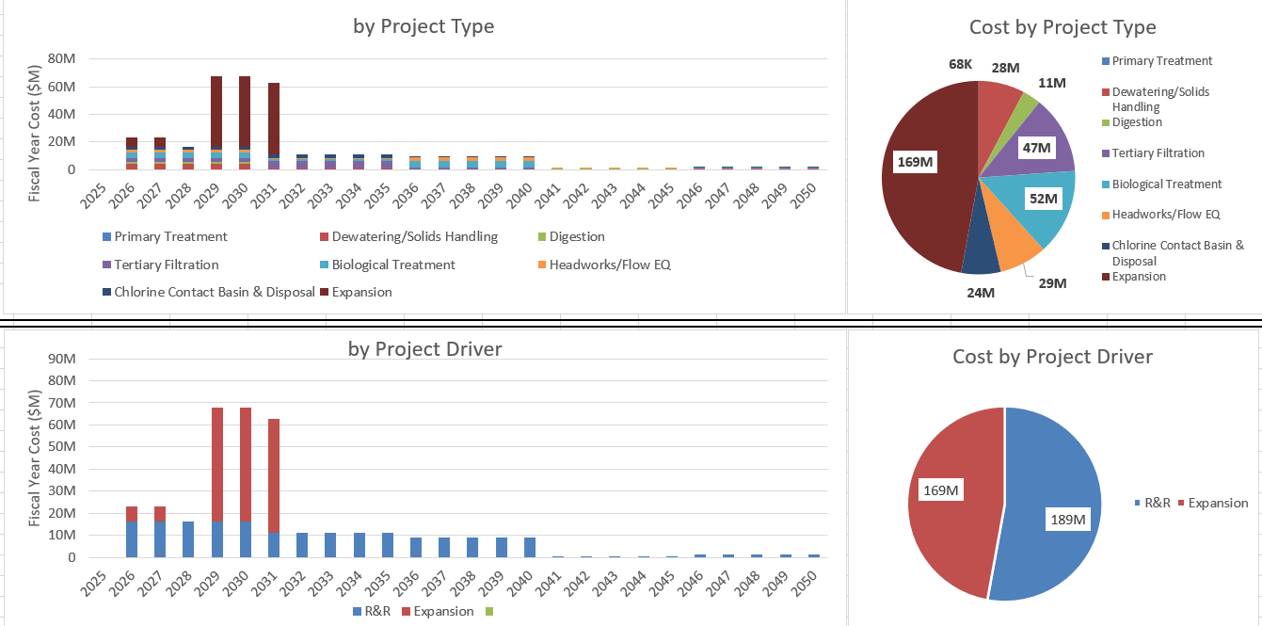
Figure 5-1 Alternative No. 1 Cash Flow with No Annual Inflation (2025 Dollars)

Alternative No. 2 – MOB System (Nuvoda) Expansion – 32 MGD Peak Flow
For Alternative No. 2, the CIP total project cost is $316 million (in 2025 dollars), and when including a 4 percent annual inflation rate beginning in 2025, the CIP total project cost is $417 million. There were 43 projects created of which 42 are R&R related. All projects recommended are included in the iCIP spreadsheet that has been provided to the City. The total project cost includes estimated costs for planning/design as well as construction. For the R&R projects, planning costs and construction costs are evenly spread across the project timeline. For the expansion project, planning costs will occur at the project start year while construction costs are assumed to occur at the start of construction for each project. A summary of the individual projects and associated costs for Alternative No. 2 are provided in Attachment F.

Alternative No. 3 – Base Case (5-Stage Bardenpho) – 37.33 MGD Peak Flow
For Alternative No. 3, the CIP total project cost is $366 million (in 2025 dollars), and when including a 4 percent annual inflation rate beginning in 2025, the CIP total project cost is $468 million. There were 37 projects created of which 36 are R&R related. All projects recommended are included in the iCIP spreadsheet that has been provided to the City. The total project cost includes estimated costs for planning/design as well as construction. For the R&R projects, planning costs and construction costs are evenly spread across the project timeline. For the expansion project, planning costs will occur at the project start year while construction costs are assumed to occur at the start of construction for each project.

The required cash flow needs over the planning period (in 2025 dollars) are shown on Figure 5-2.
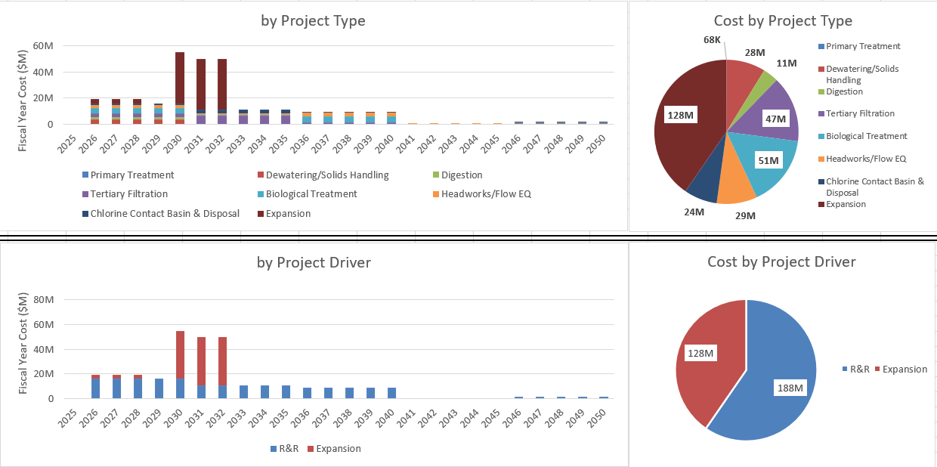
Figure 5-2 Alternative No. 2 Cash Flow with No Annual Inflation (in 2025 Dollars)

The required cash flow needs over the planning period (2025 $) are shown below on Figure 5-3.
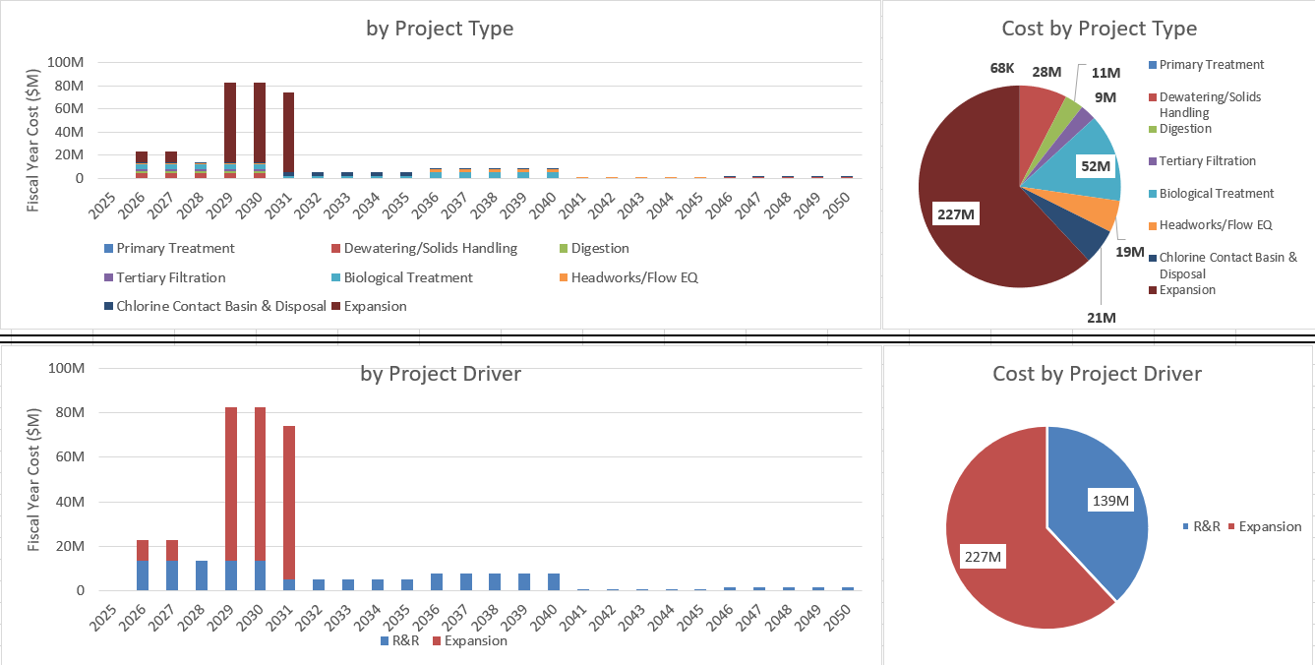
Figure 5-3 Alternative No. 3 Cash Flow with No Annual Inflation (in 2025 Dollars)

Alternative Cost Estimation Evaluation Near-Term Projects: 5-Year Overview
Short-term projects (FY 2026-2030) focus on new infrastructure additions to the wastewater systems due to consolidation as well as extensive rehabilitation and replacement of existing infrastructure to maximize service and reliability.
For Alternative No. 1, shown on Figure 5-4, the total 5-year cost is $198 million (in 2025 dollars) or $229 million with 4 percent annual inflation.
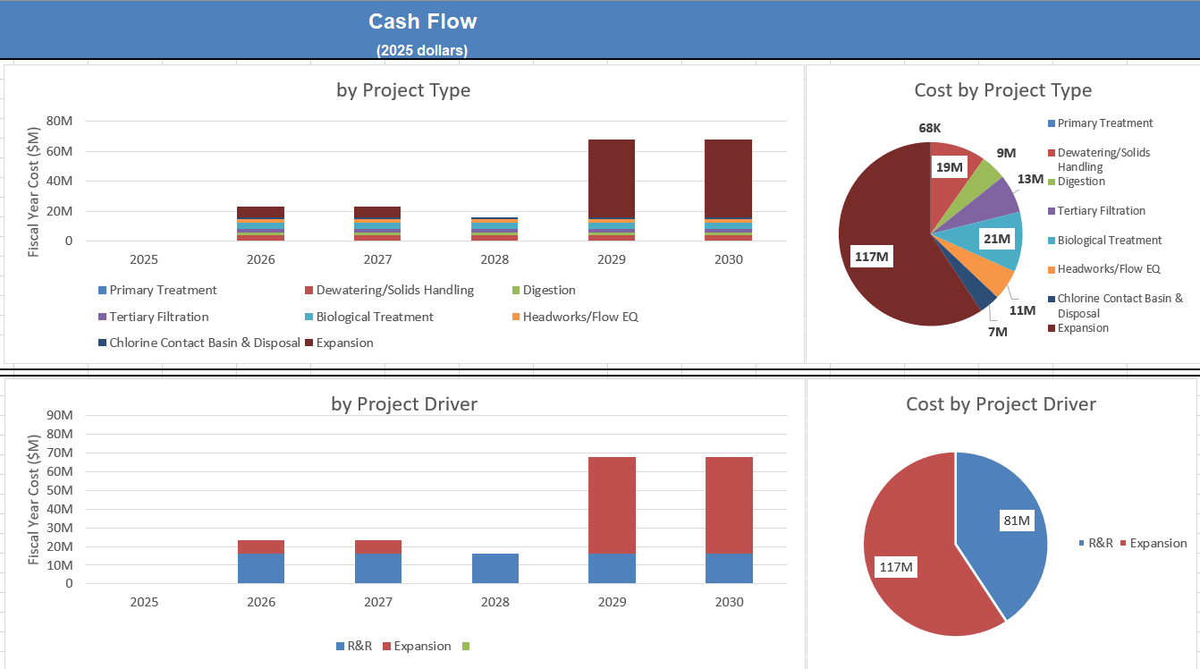
Figure 5-4 Alternative No. 1 Near-Term Cash Flow

For Alternative No. 2, shown on Figure 5-5, the total 5-year cost is $129 million (in 2025 dollars) or $149 million with 4 percent annual inflation.
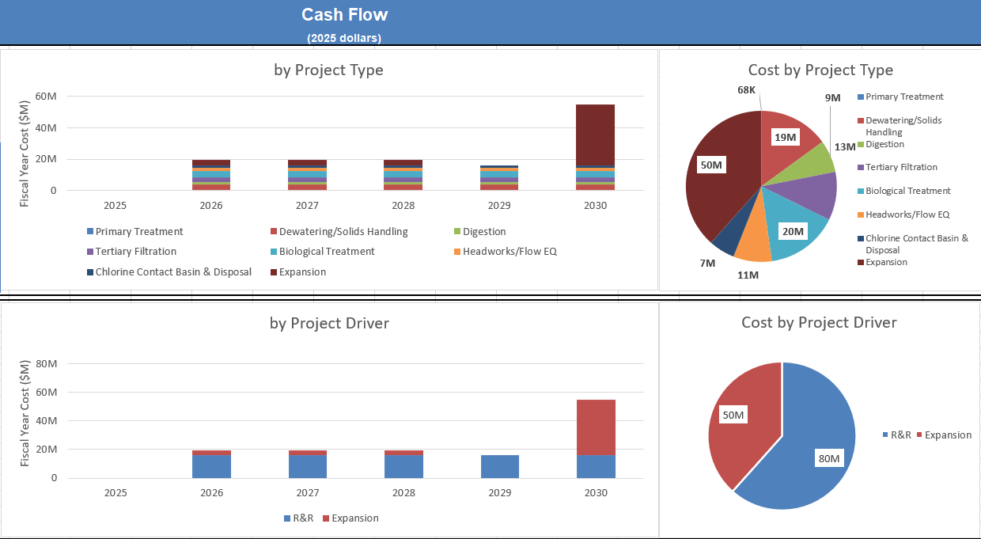
Figure 5-5 Alternative No. 2 Near-Term Cash Flow
For Alternative No. 3, shown on Figure 5-6, the total 5-year cost is $224 million (in 2025 dollars) or $261 million with 4 percent annual inflation.
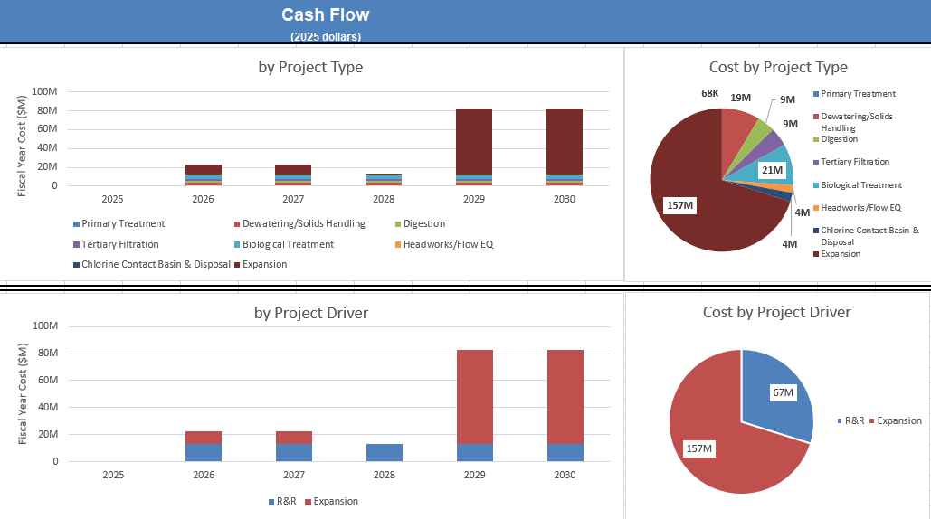
Figure 5-6 Alternative No. 3 Near-Term Cash Flow

Alternative Cost Estimate Evaluation Results
Table 5-4 provides an overview of the 30-year costs for each alternative in 2025 dollars.
Table 5-4 30-Year Cost per Alternative (2025 Dollars)
Cost Description | Alt. 1 – Base Case (5-Stage Bardenpho) – 32 MGD Peak Flow | Alt. 2 – MOB System (Nuvoda) Expansion – 32 MGD Peak Flow | Alt. 3 – Base Case (5-Stage Bardenpho) – 37.33 MGD Peak Flow
Total R&R Cost¹ | $189 M | $188 M | $139 M
Total Expansion Cost¹ | $169 M | $128 M | $227 M
Total 30 Year Cost¹ | $358 M | $316 M | $366 M
¹Costs in 2025 dollars.

Process Option Cost Evaluation
Section 4.0 provides an overview of three treatment process option evaluations comparing the existing infrastructure at the NEWRF to new treatment processes were performed. The process evaluations considered future, consolidated flows and NEWRF expansion requirements. The processes evaluated are listed below.
- Primary Treatment – Salsnes Filters vs. AquaPrime MegaDisk Cloth Media Filters
- Oxidation Ditch – Aeration Technologies
  - Upsize surface aerators
  - Combination of surface aerators, blowers, and a fine bubble diffused aeration system
  - Combination of banana blade mixer, blowers, and fine bubble diffused aeration system
- Tertiary Filtration – Shallow Bed Sand Filters vs. Aqua-Aerobics MegaDisk Cloth Media Filters

Conceptual, Class 5 (-50% to +100%) capital, O&M and 20-year net present value (NPV) costs were developed to compare each process option. The conceptual costs and Black & Veatch’s recommendation on technology are provided in the subsequent sections.

Primary Treatment
Section 4.3.2 provides an overview of the two primary treatment options considered for expansion. Figure 5-7 provides the primary treatment capital, operating, and total NPV costs.
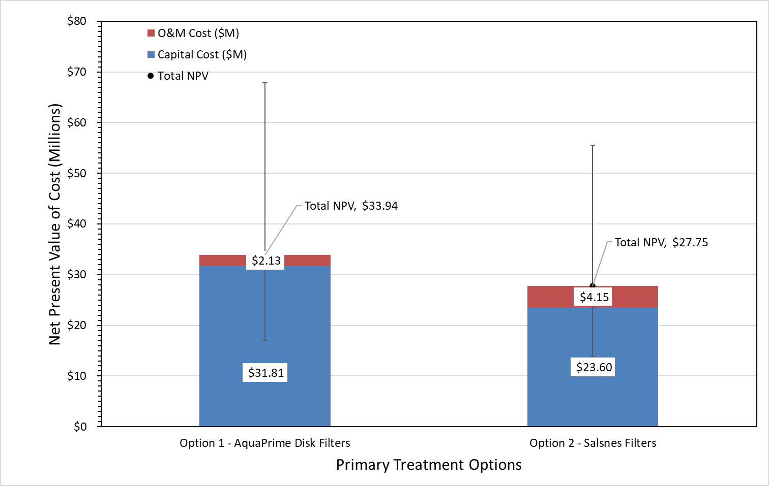
Figure 5-7 Capital, Operating, and Total Net Present Value Costs for Primary Treatment Options
Black & Veatch recommends replacing the Salsnes system and using AquaPrime disk filters or other approved, equivalent technology for primary filtration. While the NPV cost for AquaPrime is higher than Salsnes filters, the AquaPrime system offers higher solids removal efficiency, better hydraulic capacity, and reduced operational complexity. It requires fewer units than the Salsnes system, resulting in a smaller footprint and less maintenance requirements. Additionally, Salsnes filters generally have a life expectancy of 20 years. At the time of the NEWRF Expansion completion (estimated 2031), the Salsnes filters will be halfway through their expected useful life. Additionally, Salsnes filters are generally maintenance intensive and include parts specifically made in Europe.

Oxidation Ditch – Aeration
Section 4.4 provides an overview of the three oxidation ditch aeration options considered for expansion. Figure 5-8 provides the aeration capital, operating, and total NPV costs.
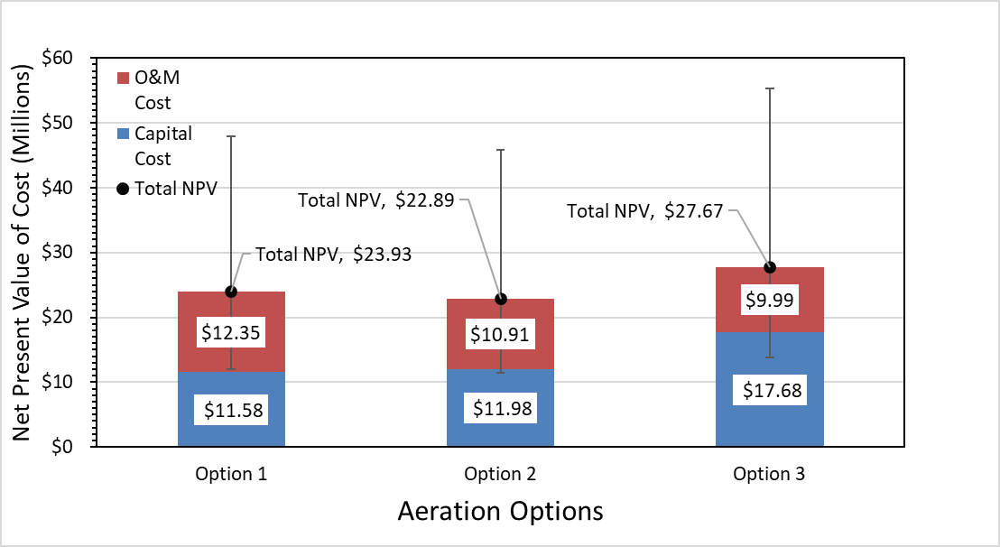
Figure 5-8 Capital, Operating, and Total Net Present Value Costs for Aeration Options
Black & Veatch recommends proceeding with the installation of Option 2 (combination of surface aerators, blowers, and diffused aeration) during the NEWRF expansion. This option provides balance between the capital and operating costs while meeting the treatment requirements necessary at NEWRF.

Tertiary Treatment
Section 4.5 provides an overview of the tertiary treatment expansion options. Figure 5-9 provides the tertiary treatment capital, operating and total NPV costs.
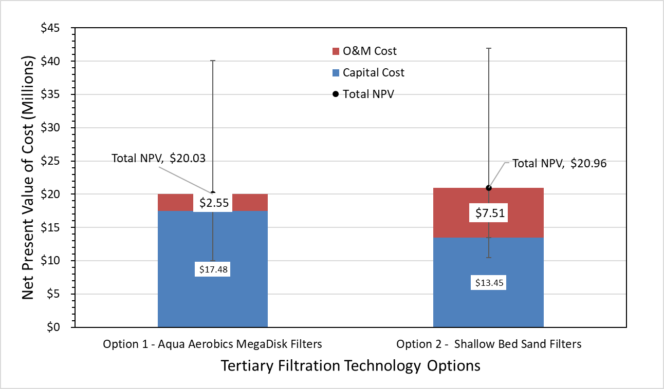
Figure 5-9 Capital, Operating, and Total Net Present Value Costs for Tertiary Treatment
For the new tertiary treatment, Black & Veatch recommends the Aqua-Aerobics MegaDisk Cloth Media Filters. The existing shallow-bed filters have hydraulic bottlenecks and a semi-automated cleaning process. In contrast, the proposed cloth media filters have an automated backwash system requiring less involvement from operators. Moreover, expansion of filtration capacity using the existing technology would require a larger footprint than the cloth media filters. Additionally, during design, consideration can be made to use the same filters for primary filtration as tertiary filtration. This consideration has potential savings with respect to spare parts and maintenance costs.

Alternative Selection Process
In addition to developing CIPs based on the three NEWRF expansion alternatives, Task 5 also included a scoring evaluation to select which alternative will proceed as the City’s recommended CIP.

Evaluation Criteria and Weighting
The scoring criteria and weighting were originally developed during Task 2 Future WRF Strategies to evaluate a system perspective of the City’s WRF including MSWRF, EWRF, and NEWRF. The scoring criteria and weighting were then revised to reflect the City’s decision to consolidate MSWRF and EWRF to NEWRF and expand NEWRF to accept the consolidated flow. The original scoring criteria developed during Task 2 evaluated NEWRF, MSWRF, and EWRF as components of the City’s collective wastewater system, considering the benefits and challenges of the consolidation alternatives presented at that stage. Following the approval of the consolidation decision, Task 4 shifted focus to the necessary expansion at NEWRF. Since the decommissioning of EWRF and MSWRF, along with collection system modifications to reroute flow, would occur regardless of the selected expansion alternative, the scoring criteria were revised to specifically assess the NEWRF expansion scenarios.
The City and Black & Veatch met on July 17, 2025, to discuss the scoring criteria, definitions, and weighting presented in Table 6-1.

Table 6-1 Alternatives Evaluation Scoring Criteria and Weighting
Scoring Criteria | Weight | Numeric Score Explanation
Scoring Criteria | Weight | 1 | 2 | 3
System Reliability and Resilience | 20% | Low reliability or resilience of the water reclamation facility. Consider items such as:  - Redundancy.  - Source supplier of material (Supply chain, material shortages, transportation delays, price volatility).  - Recovery Capability (i.e., equipment failure, toxic shock).  - Expansion technology has limited Florida implementations. | Medium reliability or resilience of the water reclamation facility. Consider items such as:  - Redundancy.  - Source supplier of material (Supply chain, material shortages, transportation delays, price volatility).  - Recovery Capability (i.e., equipment failure, toxic shock). | High reliability or resilience of the water reclamation facility. Consider items such as:  - Redundancy.  - Source supplier of material (Supply chain, material shortages, transportation delays, price volatility).  - Recovery Capability (i.e., equipment failure, toxic shock).  - Expansion technology frequently used and successful in Florida.
Maintenance Reliability and Resilience | 20% | Low maintenance reliability or resilience of the treatment systems. Consider items such as:  - Useful life and condition of equipment.  - Spare material/part requirements / costs.  - Ability to secure skilled labor / staffing.  - Size of equipment and safety.  - Requires new technology.  - High complexity of routine monitoring and control.  Automation requires a lot of maintenance skill and attention. | Medium maintenance reliability or resilience of the treatment systems. Consider items such as:  - Useful life and condition of equipment.  - Spare material/part requirements / costs.  - Ability to secure skilled labor / staffing.  - Size of equipment and safety.  Automation requires intermediate maintenance skill and attention. | High maintenance reliability or resilience of the treatment systems. Consider items such as:  - Useful life and condition of equipment.  - Spare material/part requirements / costs.  - Ability to secure skilled labor / staffing.  - Size of equipment and safety.  - Does not require new technology.  - Low complexity of routine monitoring and control.  Automation requires minimal maintenance skill and attention.
Ease of Operations | 25% | Highly complex system configuration. Consider:  - Low capacity to manage resources.  - Increased risk of safety and quality incidents.  - Number of pieces of equipment.  - High Volume of Flow Equalization Storage Required.  - Pilot Testing Required (Includes risk that new/unproven technology may fail to perform as expected).  Automation requires a lot of training and human input. | Intermediate system configuration. Consider:  - Medium capacity to manage resources.  - Risk of safety and quality incidents remains the same.  - Number of pieces of equipment.  Automation intermediate training and input. | Simple system configuration. Consider:  High capacity to manage resources.  - Reduced risk of safety and quality incidents.  - Number of pieces of equipment.  - Low Volume of Flow Equalization Storage Required.  - No Pilot Testing Required (Reduces risk for technology to perform as expected).  Automation user friendly. Requires minimal training and human input.
Sustainability (GreenPrint 2.0) | 5% | High energy consumption and greenhouse emissions; Does not meet Greenprint 2.0 goals. | Medium energy consumption and greenhouse emissions; meets Greenprint 2.0 goals. | Low energy consumption and greenhouse emissions; exceeds Greenprint 2.0 goals.
Financial Responsibility | 20% | Life-cycle costs are greater than $4.00/1,000 gal  [Capital + O&M Costs over 30 yrs] | Life-cycle costs between $3.75 - $3.99/1,000 gal  [Capital + O&M Costs over 30 yrs] | Life-cycle costs are less than 3.74/1,000 gal  [Capital + O&M Costs over 30 yrs]
Public Perception | 5% | Requires significant environmental impact (i.e., tree removal, wetland relocation). | Requires minor environmental impact (i.e., tree removal, wetland relocation). | Requires no environmental impact (i.e., tree removal, wetland relocation).
Schedule | 5% | Adds 1 year to consolidation timeline. | Aligns with consolidation timeline. | Shortens consolidation timeline.

Alternatives Evaluation Results
On August 22, 2025, Black & Veatch met with the City for the Alternative Scoring Results Meeting. During the workshop, each participant scored the three alternatives based on the scoring criteria and numeric scoring explanation presented in Table 6-1. Scoring used whole numbers from 1 to 3, where 1 was considered less favorable and 3 considered more favorable. Participants were allowed to assign the same number to different alternatives within the same scoring criteria. The Financial Responsibility criterion was scored using calculations of the life-cycle cost analysis for each alternative, respectively. The results of the life-cycle cost analysis that informed the scoring for the Financial Responsibility criterion are summarized in Table 6-2.
Table 6-2 Life-Cycle Cost Analysis Summary
NPV of Cost (in Millions – 2025 Dollars) | Alternative 1 –  Base Case (5-Stage Bardenpho) – 32 MGD Peak Flow | Alternative 2 –  MOB System  (Nuvoda) Expansion – 32 MGD Peak Flow | Alternative 3 – Base Case (5-Stage Bardenpho) – 37.33 MGD Peak Flow
O&M | $158 | $158 | $158
Capital NEWRF | $169 | $128 | $227
R&R | $190 | $189 | $140
Total NPV | $517 | $474 | $525
Life-Cycle Cost in $/1,000 gal | $3.91 | $3.59 | $3.97

The alternative scoring results presented in Table 6-3 include the average score from each participant and conclude that Alternative No. 3 will be selected for implementation. Alternative No. 3 received a score of 2.48, ranking highest overall as well as in the criteria for System Reliability and Resilience, Maintenance Reliability and Resilience, and Ease of Operations.
Table 6-3 Alternative Selection Process Results
Scoring Criteria | Weight | Alternative No. 1 –  Base Case (5-Stage Bardenpho) – 32 MGD Peak Flow | Alternative No. 2 –  MOB System  (Nuvoda) Expansion – 32 MGD Peak Flow | Alternative No. 3 – Base Case (5-Stage Bardenpho) – 37.33 MGD Peak Flow
System Reliability and Resilience | 20% | 2.39 | 1.79 | 2.95
Maintenance Reliability and Resilience | 20% | 2.62 | 1.21 | 2.77
Ease of Operations | 25% | 2.48 | 1.71 | 2.79
Sustainability (GreenPrint 2.0) | 5% | 1.95 | 2.50 | 1.67
Financial Responsibility | 20% | 2.00 | 3.00 | 2.00
Public Perception | 5% | 1.80 | 1.93 | 1.45
Schedule | 5% | 2.20 | 1.57 | 1.70
TOTAL SCORE |  | 2.32 | 1.93 | 2.48

Capital Improvement Plan
A Capital Improvement Plan (CIP) was developed based on the recommended alternatives for expansion, repairs, future pipelines, and other improvements identified in this WRF Master Plan. By prioritizing these projects and investing in the necessary upgrades and repairs, the City is ensuring that it can meet the needs of its growing customer base, maintain customer level of service and increase the resiliency of its infrastructure for years to come. The evaluations and scoring performed during the Master Plan identified Alternative No. 3 – Base Case (5-Stage Bardenpho) – 37.33 MGD Peak Flow to provide the highest system and maintenance reliability and resilience. Therefore, the CIP focuses on improvements necessary to expand NEWRF to 16 MGD AADF and 37.33 MGD peak flow while considering R&R improvements based on aging infrastructure.
As part of Task 5 of the Master Plan, Black & Veatch has developed an iCIP spreadsheet. This is a modular tool which organizes the costs associated with the expansion planned for NEWRF across the proposed 30-year timeline of the Master Plan. The iCIP can be easily modified by the City as the implementation process evolves over the course of NEWRF’s expansion. Table 7-1 provides an overview of the CIP. Figure 7-1 provides an overview of the CIP cash flow with no annual inflation in 2025 dollars.

Figure 7-1 CIP Cash Flow with No Annual Inflation (in 2025 Dollars)
Figure 7-2 provides a site layout for the future expansion improvements at NEWRF.
The full CIP is outlined in the iCIP spreadsheet provided to the City. In addition to the iCIP spreadsheet, project sheets were developed for each alternative. The project sheets are provided in Attachment G
Additionally, site layouts in 5-year increments outlining the improvement areas for R&R and expansion projects are provided in Attachment H.
Table 7-1 Clearwater WRF Master Plan CIP
Project Name and Description | Project Scope | Project Cost  (in 2025 Dollars)
NEWRF Expansion | - Install new headworks building including four mechanically cleaned screens.  - Install three AquaPrime Mega Disk Filters or other approved, equivalent technology for 80% TSS removal.  - Install a 5 MG flow equalization storage tank.  - Install a new 5-Stage Bardenpho Treatment Train including: two 275,000-gal fermentation basins with platform-mounted vertical propeller mixers, two 440,000-gal first anoxic tanks with platform-mounted vertical propeller mixers, one 1,690,000 oxidation ditch, two 476,580-gal second anoxic tanks with bridge mounted vertical propeller mixers, one 154,275-gal reaeration tanks.  - Install two new 120-foot secondary clarifiers.  - Install an intermediate pump station to transfer flow from the existing and new secondary clarifiers to the new filter building. Pump station should include four 9.2 MGD pumps and two 4.9 MGD pumps.  - Install three Aqua MegaDisk cloth media filters or other approved, equivalent technology.  - Install three 17,200-gal sodium hypochlorite storage tanks and relocated chemical building.  - Add four 5.75 MGD pumps to the chlorine contact chambers.  - Install one 1,260,000-gal primary digester and install digester heating and mixing into existing secondary digester.  - Install two 2,450 dlb/op hr centrifuges.  - Install two 5-MG reclaimed water storage tanks. | $226,731,200
2026-2030 Dewatering/Solids Handling R&R | Scope: Asset replacement for the NEWRF Dewatering/Solids Handling processes due to end of asset useful life.  Description: Replace the following assets as part of planned removal and replacement (R&R) due to asset end of useful life: Chopper Mixing Pumps (PMP-033, PMP-034), Chopper Mixing Pump Motors (MTR-079, MTR-080), Rotamix Pumps (PMP-031, PMP-032), MCC-13, Sub Pump (PMP-035), Poly Feed Pumps (PMP-043, PMP-044, PMP-045), Poly Feed Pump Motors (MTR-046, MTR-047, MTR-048) | $3,741,400
2026-2030 FOG Removal R&R | Scope: Asset replacement for the NEWRF FOG Removal processes due to end of asset useful life.  Description: Replace the following assets as part of planned removal and replacement (R&R) due to asset end of useful life: Odor Control Pump (PMP-080), FOG Pump 1 (PMP-077), Red Pump 1 and 2 (PMP-078, PMP-079), East Tank B (TNK-017) | $11,296,100
2026-2030 In-Plant Pump Stations | Scope: Asset replacement for the NEWRF In-Plant Pump Stations due to end of asset useful life.  Description: Replace the following assets as part of planned removal and replacement (R&R) due to asset end of useful life: Pump Station #2 Sub Pump 1 and 2 ( PMP-029, PMP-030), Pump Station #3 pump 1, 2, and 3 Motors (MTR-059, MTR-095, MTR-096), Pump Station 3 Pumps 1, 2, and 3 (PMP-061, PMP-062, PMP-063), | $4,265,300
2026-2030 Digestion R&R | Scope: Asset replacement for the NEWRF Digestion processes due to end of asset useful life.  Description: Replace the following assets as part of planned removal and replacement (R&R) due to asset end of useful life: Boiler (BOIL-001), Combustion Fan (FAN-001), West and East Heat Exchange Pumps (PMP-040,PMP-041), South and North Recirculation Pumps (PMP-067, PMP-068), South and North Recirculation Pump Motors (MTR-042, MTR-081), Recirculation Pump 1 and 2 (PMP-037, PMP-038), Recirculation Pump 1 and 2 Motors (PMP-036, PMP-039), Secondary Digester (TNK-005), North and South Grinder Motor (MTR-043, MTR-082), North Grinder (GCP-405), North Sludge Pump (PMP-069), North Sludge Pump Motor (PMP-042) | $8,931,800
2026-2030 Effluent R&R | Scope: Asset replacement for the NEWRF Effluent processes due to end of asset useful life.  Description: Replace the following assets as part of planned removal and replacement (R&R) due to asset end of useful life: Reclaim Water Building Electrical Assets (ELEC-014), High Service Pumps 3, 4, 5, and 6 (PMP-057, PMP-060, PMP-056, PMP-059, PMP-055, PMP-058), High Service Pumps 3, 4, 5, and 6 Motors (MTR-055, MTR-058, MTR-054, MTR-057, MTR-053, MTR-056), North Pump (PMP-074), Middle Pump (PMP-075), South Pump (PMP-076) | $4,458,500
2026-2030 Generators & Fuel Storage R&R | Scope: Asset replacement for the NEWRF Generators and Fuel Storage due to end of asset useful life.  Description: Replace the following assets as part of planned removal and replacement (R&R) due to asset end of useful life: North Twin Electrical (ELEC-003) | $1,621,100
2026-2030 Maintenance Building R&R | Scope: Asset replacement for the NEWRF maintenance building due to end of asset useful life.  Description: Replace the following assets as part of planned removal and replacement (R&R) due to asset end of useful life: Maintenance Building Electrical Equipment (ELEC-013) | $2,160,400
2026-2030 Primary Treatment R&R | Scope: Asset replacement for the NEWRF Primary Treatment Processes due to end of asset useful life.  Description: Replace the following assets as part of planned removal and replacement (R&R) due to asset end of useful life: Flow Diversion Structure (FLUM-001) | $67,800
2026-2030 Secondary Treatment Biological R&R | Scope: Asset replacement for the NEWRF Secondary Treatment Biological processes due to end of asset useful life.  Description: Replace the following assets as part of planned removal and replacement (R&R) due to asset end of useful life: Inlet Gate (GATE-030), Outlet Gate (GATE-031), Tanks 2, 3, and 4 East Slide Gates (GATE-039, GATE-040, GATE-041), Tanks 1, 2, 3, and 4 Structure (TNK-001, TNK-002, TNK-003, TNK-004), Fermentation Basin Mixers 1 and 2 (MIX-003, MIX-004), Fermentation Basin 2 Mixers 3 and 4 (MIX-001, MIX-002), Basin 2 Gates 1 and 2 (GATE-001, GATE-002), Basin 1 Gates 2 (EAST and WEST) (GATE-003, GATE-004), Basin 1 Gate 3 (GATE-005), First Anoxic Tank 1 Mixers 1 and 2 (MIX-005, MIX-006), First Anoxic Tank 2 Mixer 4 (MIX-007), West Side Inlet Gate (GATE-029) Gate to South Clarifiers (GATE-042), East Side Gate of Anoxic Basin 9 (GATE-043), Second Anoxic Basins 1-10 Mixers ( MIX-016, MIX-017, MIX-018, MIX-019, MIX-020, MIX-021, MIX-022, MIX-023, MIX-024, MIX-025, MIX-026, MIX-027, MIX-028, MIX-029, MIX-030, MIX-031, MIX-032, MIX-033 MIX-034, MIX-035), Second Anoxic Basins 1-8 Gates (GATE-016, GATE-017, GATE-018, GATE-019, GATE-020, GATE-021, GATE-022, GATE-023, GATE-024, GATE-028), Switches (ELEC-001), Switch Gear (ELEC-033), Ox Ditch 1 and 2 Gates (GATE-014, GATE-015), Oxidation Ditch Aerators 1-4 (AER-001, AER-002, AER-003, AER-004), West Isolation Gate (GATE-011), Pumps 1-5 (PMP-001, PMP-002, PMP-003, PMP-004, PMP-005), Sub Pump Panel (ELEC-002), Sub Pumps 1-3 (PMP-006, PMP-007, PMP-008) | $19,841,500
2026-2030 Secondary Treatment Clarifiers R&R | Scope: Asset replacement for the NEWRF Secondary Treatment Clarifiers due to end of asset useful life.  Description: Replace the following assets as part of planned removal and replacement (R&R) due to asset end of useful life: Clarifiers 1-8 Mixers (MIX-008, MIX-009, MIX-010, MIX-011, MIX-012, MIX-013, MIX-014, MIX-015), North RAS Electrical Equipment (ELEC-004), North and South Clarifier Ejectors (PMP-014, PMP-015, PMP-016, PMP-017), South WAS Pumps 1 and 2 (PMP-020, PMP-021) | $1,144,600
2026-2030 Tertiary Filters R&R | Scope: Asset replacement for the NEWRF Tertiary Filters due to end of asset useful life.  Description: Replace the following assets as part of planned removal and replacement (R&R) due to asset end of useful life: Reject Storage Tank (TNK-015) | $9,475,200
2031-2035 Blower Building R&R | Scope: Asset replacement for the NEWRF Blower Building due to end of asset useful life.  Description: Replace the following assets as part of planned removal and replacement (R&R) due to asset end of useful life: Blowers 1 and 2 (BLW-001, BLW-002), Blowers 1 and 2 Motors (MTR-077, MTR-078) | $2,842,600
2031-2035 Secondary Treatment Biological R&R | Scope: Asset replacement for the NEWRF Secondary Treatment Biological processes due to end of asset useful life.  Description: Replace the following assets as part of planned removal and replacement (R&R) due to asset end of useful life: MCC-20 (MCC-20), Screw Pump 5 (GATE-010), Gates (GATE-013), Pumps 2-5 (MTR-006, MTR-007, MTR-008, MTR-009), Sub Pump Piping (PIPE-002) | $1,008,100
2031-2035 Secondary Treatment Clarifiers R&R | Scope: Asset replacement for the NEWRF Secondary Treatment Clarifiers due to end of asset useful life.  Description: Replace the following assets as part of planned removal and replacement (R&R) due to asset end of useful life: North and South Pump House (PIPE-003, PIPE-004), RAS South (MTR-023, PMP-018, MTR-024, PMP-019), WAS North (PMP-012, PMP-013, MTR-015, MTR-016) | $789,100
2031-2035 Disinfection R&R | Scope: Asset replacement for the NEWRF Disinfection processes due to end of asset useful life.  Description: Replace the following assets as part of planned removal and replacement (R&R) due to asset end of useful life: Sampling Pump (PMP-083), Disinfection Gates 1, 2, and 3 (GATE-032, GATE-033, GATE-034), Sodium Hypochlorite Storage Tank 1 and 2 (TNK-010, TNK-011), Sodium Bisulfate Tank #1 (TNK-012) | $409,200
2031-2035 Dewatering/Solids Handling R&R | Scope: Asset replacement for the NEWRF Dewatering/Solids Handling processes due to end of asset useful life.  Description: Replace the following assets as part of planned removal and replacement (R&R) due to asset end of useful life: Centrifuge Panels (ELEC-031), Pump 1 and 2 (PMP-027, PMP-028), Electrical Panels (ELEC-010) | $258,000
2031-2035 FOG Removal R&R | Scope: Asset replacement for the NEWRF FOG Removal processes due to end of asset useful life.  Description: Replace the following assets as part of planned removal and replacement (R&R) due to asset end of useful life: Blower (BLW-003), Tank A (TNK-016), Natural Gas Tank (TNK018) | $1,638,400
2031-2035 Effluent R&R | Scope: Asset replacement for the NEWRF Effluent processes due to end of asset useful life.  Description: Replace the following assets as part of planned removal and replacement (R&R) due to asset end of useful life: Plant Reuse Pump Station Piping (PIPE-009) and Reuse Storage Tank (TNK-013) | $14,554,100
2031-2035 Digestion R&R | Scope: Asset replacement for the NEWRF Digestion processes due to end of asset useful life.  Description: Replace the following assets as part of planned removal and replacement (R&R) due to asset end of useful life: Digester Building Piping (PIPE-007) and South Grinder (GCP 406) | $289,300
2031-2035 Generators and Fuel Storage R&R | Scope: Asset replacement for the NEWRF Generators and Fuel Storage due to end of asset useful life.  Description: Replace the following assets as part of planned removal and replacement (R&R) due to asset end of useful life: Belt Press Generator (ELEC-030, FUEL-005, ELEC-029), Filter Backup Generator (ELEC-009, FUEL-004, ELEC-028), North Twin (FUEL-002, FUEL-003, G1395, G1396), Oxi Bldg Gen (PIPE-001), Gates (GATE-025, GATE-026, GATE-027) | $3,073,200
2036-2040 Blower Building R&R | Scope: Asset replacement for the NEWRF Blower Building due to end of asset useful life.  Description: Replace the following assets as part of planned removal and replacement (R&R) due to asset end of useful life: Blower Building MCC (MCC-12) | $203,200
2036-2040 Secondary Treatment Biological R&R | Scope: Asset replacement for the NEWRF Secondary Treatment Biological processes due to end of asset useful life.  Description: Replace the following assets as part of planned removal and replacement (R&R) due to asset end of useful life: Fermentation Basin (BSN-002, BSN-001), First Anoxic Tanks (BSN-004, BSN-003), Second Anoxic Tanks (BSN-007, BSN-016, BSN-008, BSN-009, BSN-010, BSN-011, BSN-012, BSN-013, BSN-014, BSN-015), Oxidation Ditch (BSN-006, BSN-005), Screw Pump (GATE-006, GATE-007, GATE-008, GATE-009, STRC-001), East Isolation Gate (GATE-012) | $18,814,700
2036-2040 Secondary Treatment Clarifiers R&R | Scope: Asset replacement for the NEWRF Secondary Treatment Clarifiers due to end of asset useful life.  Description: Replace the following assets as part of planned removal and replacement (R&R) due to asset end of useful life: North Clarifiers (CLRF-001, CLRF-003, CLRF-004), South Clarifiers (CLRF-005, CLRF-006, CLRF-007, CLRF-008), RAS North Pump House (STRC-003) | $5,401,000
2036-2040 Dewatering/Solids Handling R&R | Scope: Asset replacement for the NEWRF Dewatering/Solids Handling processes due to end of asset useful life.  Description: Replace the following assets as part of planned removal and replacement (R&R) due to asset end of useful life: Thickening Building – Civil – Structural Components (STRC-021) | $1,353,600
2036-2040 In-Plant Pump Stations | Scope: Asset replacement for the NEWRF In-Plant Pump Stations due to end of asset useful life.  Description: Replace the following assets as part of planned removal and replacement (R&R) due to asset end of useful life: In-Plant Pump Stations (STRC-020) | $442,000
2036-2040 Generators and Fuel Storage R&R | Scope: Asset replacement for the NEWRF Generators and Fuel Storage due to end of asset useful life.  Description: Replace the following assets as part of planned removal and replacement (R&R) due to asset end of useful life: Belt Press Generator (G1398), Filter Backup Generator (G1397), FOG Generator (GFOG), Oxi Bldg Gen (FUEL-001, G1400), Reclaim Water Bldg – Backup Generator (G2954) | $7,878,000
2036-2040 Maintenance Building R&R | Scope: Asset replacement for the NEWRF Maintenance Building due to end of asset useful life.  Description: Replace the following assets as part of planned removal and replacement (R&R) due to asset end of useful life: Maintenance Building (STRC-026) | $3,787,900
2036-2040 Disinfection R&R | Scope: Asset replacement for the NEWRF Disinfection processes due to end of asset useful life.  Description: Replace the following assets as part of planned removal and replacement (R&R) due to asset end of useful life: Chlorine Contact Chamber (BSN-018) | $674,300
2041-2045 Dewatering/Solids Handling R&R | Scope: Asset replacement for the NEWRF Dewatering/Solids Handling processes due to end of asset useful life.  Description: Replace the following assets as part of planned removal and replacement (R&R) due to asset end of useful life: Pumps (PMP-081, PMP-082), Sludge Blending Tank (MIX-037) | $1,697,500
2041-2045 Digestion R&R | Scope: Asset replacement for the NEWRF Digestion processes due to end of asset useful life.  Description: Replace the following assets as part of planned removal and replacement (R&R) due to asset end of useful life: Heat exchanger (HEAT-001) | $541,400
2041-2045 Generators and Fuel Storage R&R | Scope: Asset replacement for the NEWRF Generators and Fuel Storage due to end of asset useful life.  Description: Replace the following assets as part of planned removal and replacement (R&R) due to asset end of useful life: Reclaim Gen – Fuel Storage (FUEL-006) | $65,000
2046-2050 Blower Building R&R | Scope: Asset replacement for the NEWRF Blower Building due to end of asset useful life.  Description: Replace the following assets as part of planned removal and replacement (R&R) due to asset end of useful life: Blower Building (STRC-028) | $309,700
2046-2050 Secondary Treatment Clarifiers R&R | Scope: Asset replacement for the NEWRF Secondary Treatment Clarifiers due to end of asset useful life.  Description: Replace the following assets as part of planned removal and replacement (R&R) due to asset end of useful life: North Clarifier (CLRF-002), RAS South Pump House (STRC-005) | $1,258,900
2046-2050 Dewatering/Solids Handling R&R | Scope: Asset replacement for the NEWRF Dewatering/Solids Handling processes due to end of asset useful life.  Description: Replace the following assets as part of planned removal and replacement (R&R) due to asset end of useful life: Dewatering Building (STRC-024) | $3,021,100
2046-2050 Digestion R&R | Scope: Asset replacement for the NEWRF Digestion processes due to end of asset useful life.  Description: Replace the following assets as part of planned removal and replacement (R&R) due to asset end of useful life: Digester Building (STRC-023) | $1,180,200
2046-2050 Disinfection R&R | Scope: Asset replacement for the NEWRF Disinfection processes due to end of asset useful life.  Description: Replace the following assets as part of planned removal and replacement (R&R) due to asset end of useful life: Chlorine Contact Chamber (BSN-017) | $674,300

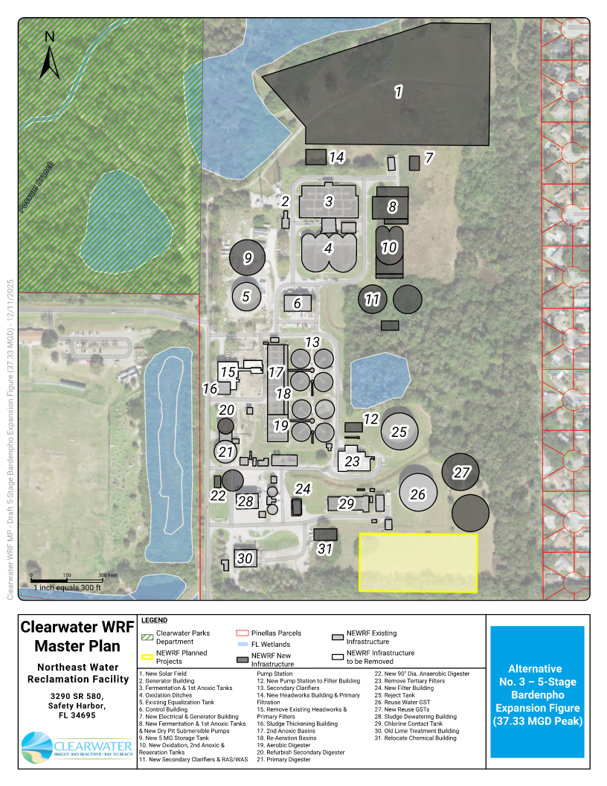
Figure 7-2 NEWRF Expansion Site Layout

Future WRF Strategies Technical Memorandum

Existing System Evaluation Technical Memorandum

Future Improvements Technical Memorandum

Control Building Expansion Evaluation Technical Brief

Alternative No. 1 Base Case (5-Stage Bardenpho) – 32 MGD Peak Flow Project Summary

Alternative No. 2 – MOB System (Nuvoda) Expansion – 32 MGD Peak Flow Project Summary

Capital Improvement Plan Project Sheets

NEWRF CIP Site Planning

