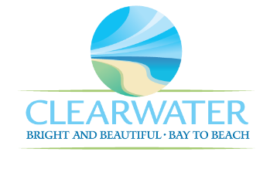
WRF-CA-1: Dewatering/Solids Handling R&R
Project Duration | 2026 – 2030 (5 Years)
Project Description | Replace the following assets as part of planned removal and replacement (R&R) due to asset end of useful life:  Chopper Mixing Pumps (PMP-033, PMP-034), Chopper Mixing Pump Motors (MTR-079, MTR-080), Rotamix Pumps (PMP-031, PMP-032), MCC-13, Sub Pump (PMP-035), Poly Feed Pumps (PMP-043, PMP-044, PMP-045), Poly Feed Pump Motors (MTR-046, MTR-047, MTR-048)
Existing Asset Information | - PMP-033: 100 HP | 4000 GPM  - PMP-034: 100 HP | 4000 GPM  - MTR-079: 5 HP | 1750 RPM | 460 V | 6.6 A  - MTR-080: 5 HP | 1750 RPM | 460 V | 6.6 A  - PMP-031: N/A  - PMP-032: N/A  - PMP-035: N/A  - PMP-043/NEWRF-CFS-PFB-FP1: 1 HP | 1750 RPM | 90 V | 4.8 A  - PMP-044/NEWRF-CFS-PFB-FP2: 0.5 HP | 1750 RPM | 90 V | 4.8 A  - PMP-045/NEWRF-CFS-PFB-FP3: 0.5 HP | 1750 RPM | 90 V | 4.8 A  - MTR-046/NEWRF-CFS-PFB-FP1-M: 1 HP | 1750 RPM | 90 V | 10 A  - MTR-047/NEWRF-CFS-PFB-FP2-M: N/A  - MTR-048/NEWRF-CFS-PFB-FP3-M: 0.5 HP | 1750 RPM | 90 V
Project Costs | Total Construction Costs | $1,948,600
Project Costs | Scope Contingency Cost (60%) | $1,169,200
Project Costs | Engineering Costs (20%) | $623,600
Project Costs | Total Project Cost | $3,741,400
Record Drawing References | - NORTHEAST ADVANCED POLLUTION CONTROL FACILITY CLEARWATER, FLORIDA, 1992, 92016  - NEWRF DEWATERING CENTRIFUGE, 2014, FIM03  - NORTHEAST WRF IMPROVEMENTS PROJECT, 2022, 19-0029-UT

