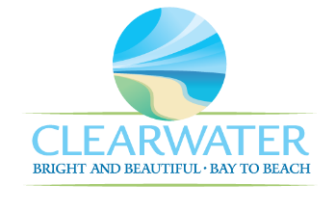
WRF-CA-2: FOG Removal R&R
Project Duration | 2026 – 2030 (5 Years)
Project Description | Replace the following assets as part of planned removal and replacement (R&R) due to asset end of useful life:  Odor Control Pump (PMP-080), FOG Pump 1 (PMP-077), Red Pump 1 and 2 (PMP-078, PMP-079), East Tank B (TNK-017)
Existing Asset Information | - PMP-077: 15 HP | 1765 RPM  - PMP-078: 150 GPM  - PMP-079: 150 GPM  - PMP-080: 16 MGD  - TNK-017/NEWRF-FOGRS-ST2: 19,800 gallons | Steel
Project Costs | Total Construction Costs | $5,883,400
Project Costs | Scope Contingency Cost (60%) | $3,530,000
Project Costs | Engineering Costs (20%) | $1,882,700
Project Costs | Total Project Cost | $11,296,100
Record Drawing References | - NORTHEAST WRF - DIGESTER GAS TO ELECTRICITY COGENERATION FACILITY, 2012, FIM04

