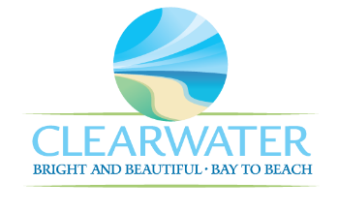
WRF-CA-3: In-Plant Pump Station R&R
Project Duration | 2026 – 2030 (5 Years)
Project Description | Replace the following assets as part of planned removal and replacement (R&R) due to asset end of useful life:  Pump Station #2 Sub Pump 1 and 2 (PMP-029, PMP-030), Pump Station #3 Pump 1, 2, and 3 Motors (MTR-059, MTR-095, MTR-096), Pump Station #3 Pumps 1, 2, and 3 (PMP-061, PMP-062, PMP-063)
Existing Asset Information | - PMP-029/NEWRF-IPLS-IPLS2-SP2: 20 HP | 900 GPM  - PMP-030/NEWRF-IPLS-IPLS2-SP1: 20 HP | 900 GPM  - PMP-061/NEWRF-IPLS-IPLS1-SP1: 40 HP | 1775 RPM | 460 V | 46 A | 300 GPM  - PMP-062/NEWRF-IPLS-IPLS1-SP2: 40 HP | 1775 RPM | 460 V | 46 A | 300 GPM  - PMP-063/NEWRF-IPLS-IPLS1-SP3: 40 HP | 1775 RPM | 460 V | 46 A | 300 GPM  - MTR-059/NEWRF-IPLS-IPPS3-SP1: 40 HP | 1775 RPM | 460 V | 92 A  - MTR-095/NEWRF-IPLS-IPPS3-SP2: 40 HP | 1775 RPM | 460 V | 96 A  - MTR-096: 40 HP | 1775 RPM | 460 V | 92 A
Project Costs | Total Construction Costs | $2,221,500
Project Costs | Scope Contingency Cost (60%) | $1,332,900
Project Costs | Engineering Costs (20%) | $710,900
Project Costs | Total Project Cost | $4,265,300
Record Drawing References | - NORTHEAST ADVANCED POLLUTION CONTROL FACILITY CLEARWATER, FLORIDA, 1992, 92016

G

