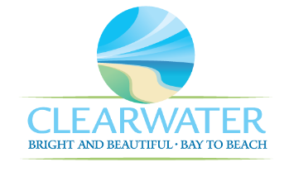
WRF-CA-6: Generators and Fuel Storage R&R
Project Duration | 2026 – 2030 (5 Years)
Project Description | Replace the following assets as part of planned removal and replacement (R&R) due to asset end of useful life:  North Twin Electrical (ELEC-003)
Existing Asset Information | - ELEC-003/NEWRF-B-NT-E: 1800 RPM | 480 V | 1128 A
Project Costs | Total Construction Costs | $844,300
Project Costs | Scope Contingency Cost (60%) | $506,600
Project Costs | Engineering Costs (20%) | $270,200
Project Costs | Total Project Cost | $1,621,100
Record Drawing References | - N/A

G

