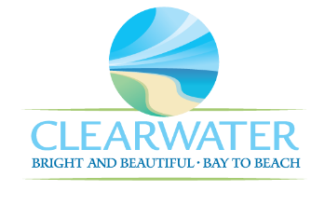
WRF-CA-14: Secondary Treatment Clarifiers R&R
Project Duration | 2031 – 2035 (5 Years)
Project Description | Replace the following assets as part of planned removal and replacement (R&R) due to asset end of useful life:  North and South Pump House (PIPE-003, PIPE-004), RAS South (MTR-023, PMP-018, MTR-024, PMP-019), WAS North (PMP-012, PMP-013, MTR-015, MTR-016)
Existing Asset Information | - MTR-023/NEWRF-ST-RWPS-SPH-RASP1A-M: 50 HP | 1185 RPM | 460 V | 120 A  - PMP-018/NEWRF-ST-RWPS-SPH-RASP1A-P: 50 HP | 1190 RPM | 4700 GPM | 12 x 12 x 15  - MTR-024/NEWRF-ST-RWPS-SPH-RASP2A-M: 50 HP | 1185 RPM | 460 V | 120 A  - PMP-019/NEWRF-ST-RWPS-SPH-RASP2A-P: 50 HP | 1190 RPM | 4700 GPM | 12 x 12 x 15 | 60 PSI  - PMP-012/NEWRF-ST-RWPS-NPH-WASP1A-P: 10 HP | 1700 RPM | 230 V | 20 A | 200 GPM  - PMP-013/NEWRF-ST-RWPS-NPH-WASP2A-P: 10 HP | 1760 RPM | 230 V | 25 A | 200 GPM  - MTR-015/NEWRF-ST-RWPS-NPH-WASP2A-M: 10 HP | 1760 RPM | 460 V | 25 A  - MTR-016/NEWRF-ST-RWPS-NPH-WASP1A-M: 10 HP | 1700 RPM | 460 V | 25 A
Project Costs | Total Construction Costs | $410,800
Project Costs | Scope Contingency Cost (60%) | $246,500
Project Costs | Engineering Costs (20%) | $131,500
Project Costs | Easements, Land Acquisition and Other Costs | $300
Project Costs | Total Project Cost | $789,100
Record Drawing References | - NORTHEAST WRF IMPROVEMENTS PROJECT, 2022, 19-0029-UT  - CLEARWATER CLARIFIER REHABILITATION, 2010, 12-0025-UT

G

