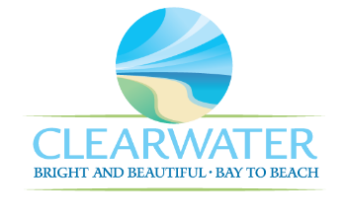
WRF-CA-16: Dewatering and Solids Handling R&R
Project Duration | 2031 – 2035 (5 Years)
Project Description | Replace the following assets as part of planned removal and replacement (R&R) due to asset end of useful life:  Centrifuge Panels (ELEC-031), Pump 1 and 2 (PMP-027, PMP-028), Electrical Panels (ELEC-010)
Existing Asset Information | - ELEC-010: N/A  - ELEC-031/NEWRF-DW-C-CP: N/A  - PMP-027: 7.5 HP | 50 GPM  - PMP-028: 7.5 HP | 50 GPM
Project Costs | Total Construction Costs | $134,400
Project Costs | Scope Contingency Cost (60%) | $80,600
Project Costs | Engineering Costs (20%) | $43,000
Project Costs | Total Project Cost | $258,000
Record Drawing References | - NEWRF DEWATERING CENTRIFUGE, 2014, FIM03

