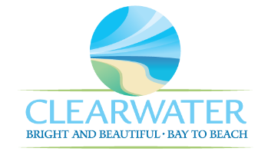
WRF-CA-18: Effluent R&R
Project Duration | 2031 – 2035 (5 Years)
Project Description | Replace the following assets as part of planned removal and replacement (R&R) due to asset end of useful life:  Plant Reuse Pump Station Piping (PIPE-009) and Reuse Storage Tank (TNK-013)
Existing Asset Information | - TNK-013/NEWRF-E-S-RST: 5 MG | Concrete
Project Costs | Total Construction Costs | $7,579,800
Project Costs | Scope Contingency Cost (60%) | $4,547,900
Project Costs | Engineering Costs (20%) | $2,425,500
Project Costs | Easements, Land Acquisition and Other Costs | $900
Project Costs | Total Project Cost | $14,554,100
Record Drawing References | - NORTHEAST ADVANCED POLLUTION CONTROL FACILITY IMPROVEMENTS, 2003

G

