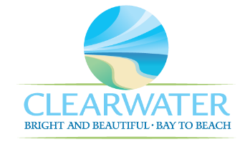
WRF-CA-20: Generators & Fuel Storage R&R
Project Duration | 2031 – 2035 (5 Years)
Project Description | Replace the following assets as part of planned removal and replacement (R&R) due to asset end of useful life:  Belt Press Generator (ELEC-030, FUEL-005, ELEC-029), Filter Backup Generator (ELEC-009, FUEL-004, ELEC-028), North Twin (FUEL-002, FUEL-003, G1395, G1396), Oxi Bldg Gen (PIPE-001), Gates (GATE-025, GATE-026, GATE-027).
Existing Asset Information | - ELEC-030/NEWRF-GFS-BP-G: N/A  - FUEL-005/NEWRF-GFS-BP-G: N/A  - ELEC-029/NEWRF-GFS-BP-G-R: N/A  - ELEC-009: 1860 RPM | 480 V | 8.9 A  - FUEL-004/NEWRF-GFS-FB-G: N/A  - ELEC-028: N/A  - FUEL-002/NEWRF-GFS-NT-FS1: N/A  - FUEL-003/NEWRF-GFS-NT-FS2: 2000 gal  - G1395/NEWRF-GFS-NT-G1: N/A  - G1396/NEWRF-GFS-NT-G2: N/A
Project Costs | Total Construction Costs | $1,600,600
Project Costs | Scope Contingency Cost (60%) | $960,400
Project Costs | Engineering Costs (20%) | $512,200
Project Costs | Total Project Cost | $3,073,200
Record Drawing References | - HEADWORKS SCREENING AND GRIT REMOVAL IMPROVEMENTS FOR THE NORTHEAST, MARSHALL ST, AND EAST ADVANCED POLLUTION CONTROL FACILITIES, 2010, 05-0063-UT  - NORTHEAST WRF IMPROVEMENTS PROJECT, 2022, 19-0029-UT  - NORTHEAST WASTEWATER TREATMENT FACILITY, 1975

G

