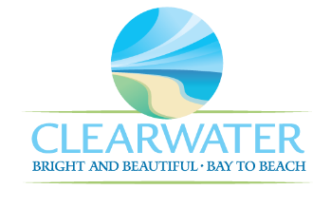
WRF-CA-21: Blower Building R&R
Project Duration | 2036 – 2040 (5 years)
Project Description | Replace the following assets as part of planned removal and replacement (R&R) due to asset end of useful life:  Blower Building MCC (MCC-12)
Existing Asset Information | - MCC-12: 150 HP | 3560 RPM | 460 V | 164 A | 724 lb.
Project Costs | Total Construction Costs | $105,800
Project Costs | Scope Contingency Cost (60%) | $63,500
Project Costs | Engineering Costs (20%) | $33,900
Project Costs | Total Project Cost | $203,200
Record Drawing References | - NORTHEAST ADVANCED POLLUTION CONTROL FACILITY CLEARWATER, FLORIDA, 1992, 92016

G

