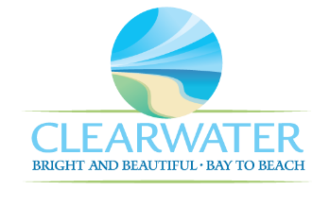
WRF-CA-23: Secondary Treatment Clarifiers R&R
Project Duration | 2036 – 2040 (5 Years)
Project Description | Replace the following assets as part of planned removal and replacement (R&R) due to asset end of useful life:  North Clarifiers (CLRF-001, CLRF-003, CLRF-004), South Clarifiers (CLRF-005, CLRF-006, CLRF-007, CLRF-008), RAS North Pump House (STRC-003) civil work and building rehabilitation
Existing Asset Information | - CLRF-001/NEWRF-ST-C-N-C1: 75-FT diameter | 336 LF weir | 4418 SF surface area  - CLRF-003/NEWRF-ST-C-N-C3: 75-FT diameter | 336 LF weir | 4418 SF surface area  - CLRF-004/NEWRF-ST-C-N-C4: 75-FT diameter | 336 LF weir | 4418 SF surface area  - CLRF-005/NEWRF-ST-C-S-C5: 75-FT diameter | 336 LF weir | 4418 SF surface area  - CLRF-006/NEWRF-ST-C-S-C6: 75-FT diameter | 336 LF weir | 4418 SF surface area  - CLRF-007/NEWRF-ST-C-S-C7: 75-FT diameter | 336 LF weir | 4418 SF surface area  - CLRF-008/NEWRF-ST-C-S-C8: 75-FT diameter | 336 LF weir | 4418 SF surface area  - STRC-003: N/A
Project Costs | Total Construction Costs | $2,813,000
Project Costs | Scope Contingency Cost (60%) | $1,687,800
Project Costs | Engineering Costs (20%) | $900,200
Project Costs | Total Project Cost | $5,401,400
Record Drawing References | - NORTHEAST WRF IMPROVEMENTS PROJECT, 2022, 19-0029-UT  - CLEARWATER CLARIFIER REHABILITATION, 2010, 12-0025-UT

G

