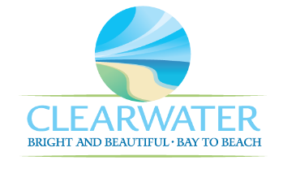
WRF-CA-24: Dewatering/Solids Handling R&R
Project Duration | 2036 – 2040 (5 Years)
Project Description | Replace the following assets as part of planned removal and replacement (R&R) due to asset end of useful life:  Thickening Building – Civil – Structural Components (STRC-021)
Existing Asset Information | - STRC-021/NEWRF-B-TB-SA: N/A
Project Costs | Total Construction Costs | $705,000
Project Costs | Scope Contingency Cost (60%) | $423,000
Project Costs | Engineering Costs (20%) | $225,600
Project Costs | Total Project Cost | $1,353,600
Record Drawing References | - HEADWORKS SCREENING AND GRIT REMOVAL IMPROVEMENTS FOR THE NORTHEAST, MARSHALL ST, AND EAST ADVANCED POLLUTION CONTROL FACILITIES, 2010, 05-0063-UT  - NORTHEAST WRF IMPROVEMENTS PROJECT, 2022, 19-0029-UT  - NORTHEAST WASTEWATER TREATMENT FACILITY, 1975

G

