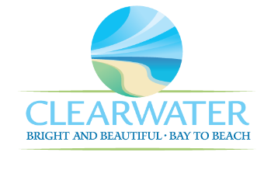
WRF-CA-25: In-Plant Pump Stations R&R
Project Duration | 2036 – 2040 (5 Years)
Project Description | Replace the following assets as part of planned removal and replacement (R&R) due to asset end of useful life:  In-Plant Pump Station Wet Well (STRC-020)
Existing Asset Information | - STRC-020: 6-FT DIA
Project Costs | Total Construction Costs | $230,200
Project Costs | Scope Contingency Cost (60%) | $138,100
Project Costs | Engineering Costs (20%) | $73,700
Project Costs | Total Project Cost | $442,600
Record Drawing References | - HEADWORKS SCREENING AND GRIT REMOVAL IMPROVEMENTS FOR THE NORTHEAST, MARSHALL ST, AND EAST ADVANCED POLLUTION CONTROL FACILITIES, 2010, 05-0063-UT  - NORTHEAST WRF IMPROVEMENTS PROJECT, 2022, 19-0029-UT  - NORTHEAST WASTEWATER TREATMENT FACILITY, 1975

G

