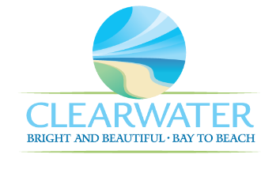
WRF-CA-28: Disinfection R&R
Project Duration | 2036 – 2040 (5 Years)
Project Description | Replace the following assets as part of planned removal and replacement (R&R) due to asset end of useful life:  Chlorine Contact Chamber (BSN-018)
Existing Asset Information | - BSN-018/NEWRF-E-CCC1: N/A
Project Costs | Total Construction Costs | $351,200
Project Costs | Scope Contingency Cost (60%) | $210,700
Project Costs | Engineering Costs (20%) | $112,400
Project Costs | Total Project Cost | $674,300
Record Drawing References | - NORTHEAST ADVANCED POLLUTION CONTROL FACILITY IMPROVEMENTS, 2003

G

