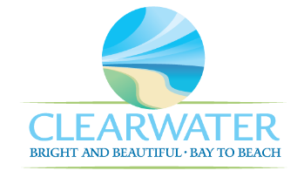
WRF-CA-29: Dewatering/Solids Handling R&R
Project Duration | 2041 – 2045 (5 Years)
Project Description | Replace the following assets as part of planned removal and replacement (R&R) due to asset end of useful life:  Pumps (PMP-081, PMP-082), Sludge Blending Tank Mixer (MIX-037).
Existing Asset Information | - PMP-081: 15 HP | 50 GPM  - PMP-082: 15 HP | 50 GPM  - MIX-037/NEWRF-SB-SBT2-MA: 20 HP
Project Costs | Total Construction Costs | $884,100
Project Costs | Scope Contingency Cost (60%) | $530,500
Project Costs | Engineering Costs (20%) | $282,900
Project Costs | Total Project Cost | $1,697,500
Record Drawing References | - NORTHEAST WRF IMPROVEMENTS PROJECT, 2022, 19-0029-UT  - NEWRF SLUDGE THICKENING, 1999

G

