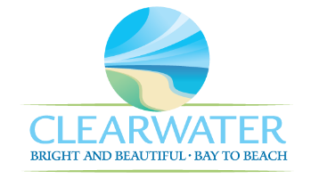
WRF-CA-34: Dewatering/Solids Handling R&R
Project Duration | 2046 – 2050 (5 Years)
Project Description | Replace the following assets as part of planned removal and replacement (R&R) due to asset end of useful life:  Dewatering Building (STRC-024) civil work and building rehabilitation
Existing Asset Information | - STRC-024/NEWRF-B-SDB-SA: N/A
Project Costs | Total Construction Costs | $1,573,500
Project Costs | Scope Contingency Cost (60%) | $944,100
Project Costs | Engineering Costs (20%) | $503,500
Project Costs | Total Project Cost | $3,021,100
Record Drawing References | - NORTHEAST ADVANCED POLLUTION CONTROL FACILITY CLEARWATER, FLORIDA, 1992, 92016  - NEWRF DEWATERING CENTRIFUGE, 2014, FIM03

G

