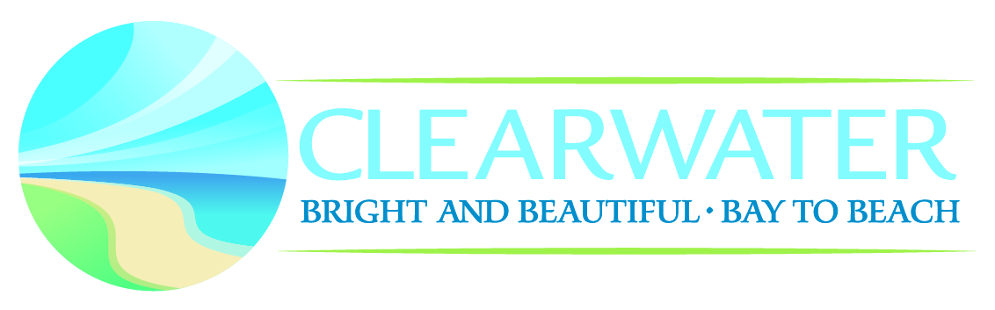
CITY OF CLEARWATER
PLANNING & DEVELOPMENT DEPARTMENT
100 S MYRTLE AVE, CLEARWATER, FL 33756
727-562-4567 epermit@myclearwater.com

“No Access Letter”

- Contractor Name & License # ______________________________________________
- Name of Company _______________________________________________________
- Permit Number __________________________________________________________
- Complete Description of Work ______________________________________________
__________________________________________________________________________
__________________________________________________________________________
- Address of Project ________________________________________________________
- Customer Name __________________________________________________________
I, ____________________________________ have made three (3) attempts to gain access for inspections at the above project address. The attempts were made as listed below.
- Letter sent - Date: ________________________
- Letter sent – Date: ________________________
- Copy of Certified Letter and Green Postal Card “returned” – Date: ___________________
As a licensed contractor in the State of Florida, I hereby certify that all work done on this project meets 20___ FL Building Code or NFPA 20___ code requirements. This affidavit and copy of the certified letter and green receipt card from the Postal Service will be made part of the permanent records for this property.

STATE OF FLORIDA
COUNTY OF PINELLAS
Before me the undersigned, an Officer duly commissioned by the laws of the State of Florida, on the ______ day of ____________, 20____
Sworn to and subscribed before me in full understanding signed this affidavit.

Signed ________________________________ License Holder ___________________________

Notary Public Signature__________________________________ Date __________________

